Word ladders - Answers
Lewis Carroll (real name Charles Dodgson) enjoyed making up word games. One was called doublets or word ladders.
There is often more than one way to get from one word to another, here is the way we completed the ladders.
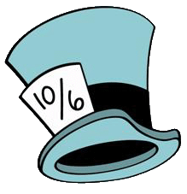
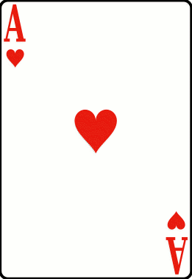
Age
Hat
Bat
Ban
Bun
Run
Ace
Ice
...........Try another one………..
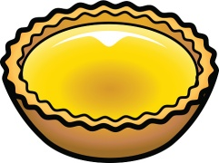
Tart
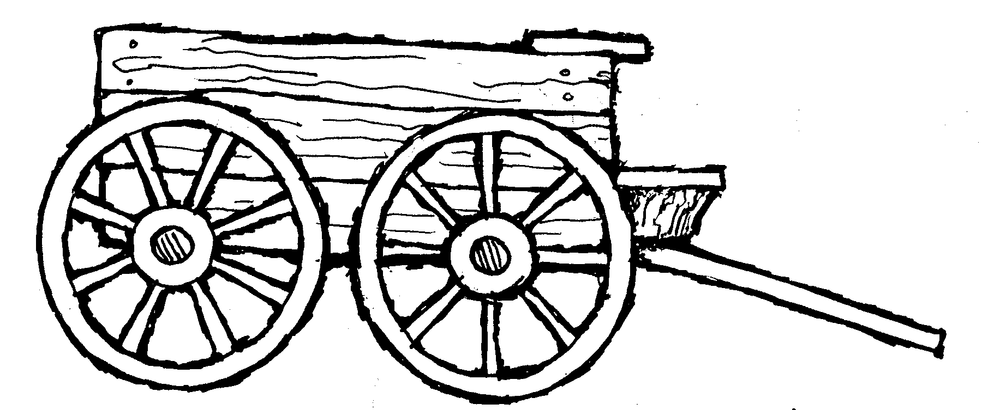
Your turn!
Why not make up a word ladder in the space below? Give it to a friend or relative to do.
________________

________________
Cart

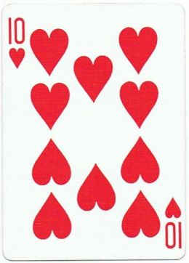
Card

Book
Boot
Boat
Coat

