Lovelace Neighbourhood Plan Referendum
Information Statement

About this statement
A referendum on whether to adopt the Lovelace Neighbourhood Plan will be held for residents of the Lovelace Neighbourhood Area on 6 May 2021. Lovelace Neighbourhood Area covers Lovelace ward, which encompasses the parishes of Ripley, Ockham and Wisley.
This statement provides more information about the referendum, for example who can take part and how.
The neighbourhood plan referendum
The question that will be asked at the referendum is:
Do you want Guildford Borough Council to use the neighbourhood plan for Lovelace to help it decide planning applications in the neighbourhood area?
The referendum asks you to vote ‘yes’ or ‘no’ to this question.
For this question, you will receive a ballot paper, which you may use to record your vote.
If a majority of the votes received are in favour, the Lovelace Neighbourhood Plan will become part of the Development Plan for Guildford borough (see below) and help the Council and other planning decision makers to make decisions on planning applications in the Lovelace Neighbourhood Area.
The planning system
The UK has a plan-led system of town and country planning. Local (borough, district and unitary) authorities and other decision makers, like planning inspectors, make planning decisions based on policies in the local Development Plan, national policy, and other material considerations. The Development Plan is the starting point for determining any planning application so the planning policies within it help to decide how much and what type of development happens, what it looks like and where it goes. Guildford borough’s Development Plan consists of:
- the Local Plan: Strategy and Sites 2015-2034
- the remaining policies of the Guildford Borough Local Plan 2003,
- waste and minerals plans produced by Surrey County Council,
- Policy NRM6 of the South East Plan, and
- any neighbourhood plans that have passed a referendum.

Neighbourhood plans
Neighbourhood plans are produced in consultation with local communities by parish or town councils or, in areas without a parish, by forums of residents and businesses. When a neighbourhood plan passes a local referendum it becomes part of the statutory Development Plan and its policies must be used to help determine planning applications within the designated neighbourhood area. Neighbourhood plans therefore allow communities considerable influence over development in their own areas.

Lovelace Neighbourhood Plan
The Lovelace Neighbourhood Plan was produced by Ripley and Ockham parish councils in consultation with Lovelace residents and other stakeholders. It sets planning policies for the Lovelace Neighbourhood Area.
The parish councils held a consultation on the draft Neighbourhood Plan before submitting it to Guildford Borough Council. The Council then held a further consultation, before sending the Plan and the consultation representations to an independent examiner to examine the Plan.
The examiner recommended a number of modifications to the Plan to ensure that it complies with the basic conditions and other legislative requirements and that, if modified, the plan should then proceed to a referendum. The Council agreed with the examiner’s recommendations. The Referendum Version of the Plan is the final version of the Plan and includes the recommended modifications.
How to view the Neighbourhood Plan and other documents
The Plan and other specified documents, as listed below, can be viewed online at https://www.guildford.gov.uk/lovelace. The Council offices and the borough’s libraries are currently closed to visitors due to Covid. However, paper copies of these documents will be available to view at the following locations if the Covid restrictions are lifted before the referendum date:
- Main reception, Guildford Borough Council, Millmead House, Millmead, Guildford, Surrey GU2 4BB
(open 9am to 5pm Monday to Friday).
- Guildford Library, 77 North Street, Guildford, Surrey GU1 4AL
(open Monday, Wednesday and Friday 9.30am–5.30pm, Tuesday and Thursday 9.30am–7pm, Saturday: 9.30am–5pm).
- Horsley Library, Parade Court, Ockham Road south, East Horsley, Surrey KT24 6QR
(open Monday 2pm–5pm, Tuesday, Thursday and Friday 10am–1pm & 2pm–5pm, Saturday: 10am–4pm).
The specified documents are:
- The Lovelace Neighbourhood Plan (Referendum Version);
- The report made by the examiner on the Lovelace Neighbourhood Plan;
- Representations received during the Council’s consultation, which were submitted to the examiner;
- The Council’s Basic Conditions and Compliance statement; and
- A statement setting out general information as to town and country planning and the referendum (this information is contained within this Information Statement).

The referendum area and eligibility to vote
The referendum area can be seen on the map at the end of this statement. The referendum area is the Lovelace Neighbourhood Area. It follows the boundary of Lovelace ward, which is the same area as the parishes of Ripley, Ockham and Wisley.
A person is entitled to vote in the referendum if on Thursday 6 May 2021:
- he or she is entitled to vote in a local government election in the referendum area, and
- his or her qualifying address for the election is in the referendum area.
A person’s qualifying address is, in relation to a person registered in the register of electors, the address in respect of which he or she is entitled to be registered. This means that he or she must live in the address at which they are registered, and that this is the address that they are entitled to register for the purpose of voting (usually their main address).
Applications to be included on the register of electors for this referendum must be received no later than 23:59 on Monday 19 April 2021.
You can check whether you are registered to vote by calling 01483 444 115.
Individuals, bodies and groups may campaign for a ‘yes’ or ‘no’ vote. There is a legal limit to the amount of money that can be spent campaigning. The referendum expenses limit is £2475.75. This limit was calculated based on the number of persons entitled to vote in the referendum as of 1 March 2021, which was 1928.
The referendum will be conducted in accordance with procedures that are similar to those used at local government elections.

How and where can I vote?
There are three ways to vote: in person, by post or by proxy.

In person
Vote at the polling station at
- All Saints Church, Ockham Road North, Ockham, Woking, GU23 6NL
- Former Ripley C of E Primary School, Wentworth Close, Ripley, GU23 6ED
between 7am and 10pm on 6 May 2021.

By post
Fill in an application form and send it to The Electoral Registration Officer, Guildford Borough Council, Millmead House, Millmead, Guildford, Surrey, GU2 4BB by 5pm on Tuesday 20 April 2021.
Ballot papers can be sent overseas, but you need to think about whether you will have time to receive and return your postal vote by Thursday 6 May 2021, in these cases a proxy is recommended.
You should receive your postal vote about a week before polling day. If it doesn’t arrive in time, you can get a replacement up to 5pm on Thursday 6 May 2021. Replacement of spoilt or lost postal ballot papers can be obtained from Thursday 29 April 2021. For more information please call 01483 444 115.

By proxy
You may be able to vote by proxy. This means allowing somebody you trust to vote at your polling station on your behalf. The deadline to submit your proxy vote application is 5pm on Tuesday 27 April 2021.
Postal and Proxy vote application forms are available from the Elections team on 01483 444 115 or can be downloaded from the Electoral Commission website at www.aboutmyvote.co.uk.
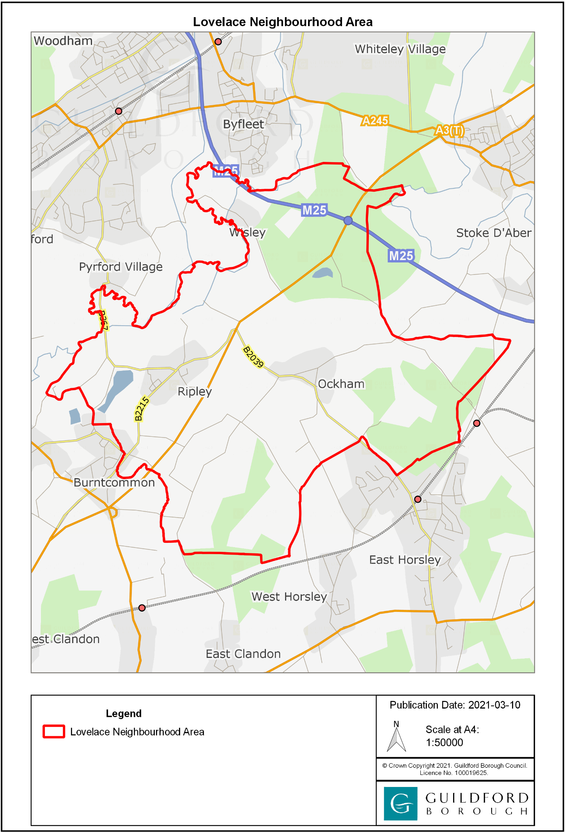
To see a more detailed map of the Lovelace Neighbourhood Area, please visit https://www.guildford.gov.uk/lovelace.

This statement is required by regulations 4(3)(a) and 4(3)(b)(v) of the Neighbourhood Planning (Referendum) Regulations 2012 (as amended).
Contained in Schedule 4B paragraph 8(2) of the Town and Country Planning Act 1990
Specified in regulation 4(3)(b) of the Neighbourhood Planning (Referendum) Regulations 2012 (as amended).

