Equality, Diversity and Inclusion Strategy
2025 - 2027

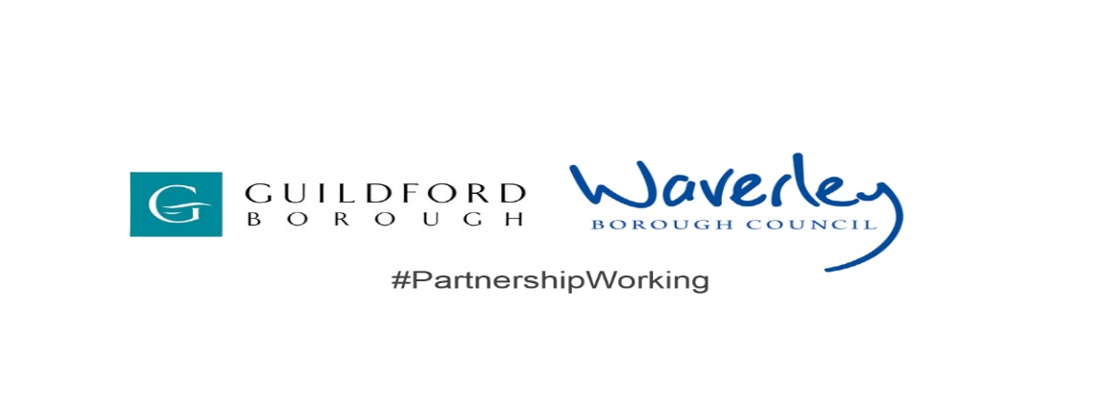



Contents

Foreword 4

Executive summary 6

Aims of the strategy 7

Strengths & achievements 7

Meeting national standards and accreditations
Cultural shift and collaboration
Learning and development
Recruitment
Working Environment
Addressing hate crime
Community engagement and heritage projects
Accessibility & Digital Inclusion
Positive employee perception
Workforce profile (July 2025)
Protected characteristics under the Equality Act

Pillars and key initiatives 13
Visible leadership and commitment
Workforce and culture
Evidence and data based
Community engagement
Positive commercial arrangements
Accessible and fair service
Accreditations

Legal framework 17

National and international context 17

Local context 18

Local Government Reorganisation

Next Steps 19

Appendix - Delivery plan – 2025/2027

DOCUMENT INFORMATION AND GOVERNANCE
Origination/author: Joint Assistant Director - People
This document replaces: Waverley & Guildford EDI Policies
Date of consultation: October 2025
Date of Council approval: January 2026
Date policy is effective from: February 2026
Last reviewed: February 2026
Next review date: February 2028

If you require this document in another format or language, or any other support in accessing the guidance, please contact the People & OD team at

Supporting statement:

Guildford and Waverley Borough Council recognises that some sections of society experience prejudice and discrimination. The Equality Act 2010 specifically recognises the protected characteristics of age, disability, sex, race, religion, and belief (or lack thereof), sexual orientation, gender reassignment, pregnancy and maternity, and marital and civic partnership status. The Equality act also requires regard to socio-economic factors.

The Council is committed to promoting and advancing equality and removing and reducing discrimination and harassment and fostering good relations between people that hold a protected characteristic and those that do not, both in the provision of services, and in our role as a major employer. The Council believes that all people have the right to be treated with dignity and respect and is committed to the elimination of unfair and unlawful discriminatory practices.

Guildford and Waverley Borough Council also is aware of its legal duties under the Human Rights Act 1998. Section 6 of the Human Rights Act requires all public authorities to uphold and promote Human Rights in everything they do. It is unlawful for a public authority to perform any act which contravenes the Human Rights Act.

Foreword


We are proud to present our Equality, Diversity and Inclusion Strategy (EDI) 2025 – 2027 for Guildford Borough Council and Waverley Borough Council.

One of our five key priorities in our respective Corporate Strategies is for both Guildford and Waverley to be more inclusive boroughs.

Our goal is simple: to make Guildford and Waverley places where everyone feels welcome, included and supported and can bring their whole selves to work. A place where everyone in our communities can be authentic, can contribute to the wellbeing and success of their community, can have a voice and be heard. We want our Councils and communities to be fair, inclusive and representative of the people who live and work here.

We are so proud of our boroughs: our people and places and all they have to offer. As leaders of the Councils, we are working to improve the lives of everyone who calls Guildford and Waverley boroughs home.

We recognise the value and worth of everyone who lives and works in our respective boroughs. This strategy sets out our commitment as an employer, community leader and provider of services to actively promote equality, diversity and inclusion and commit to equal opportunities for all, upholding the provisions of the Equality Act 2010. The Public Sector Equality Duty (PSED) is a legal obligation under the Equality Act 2010 that requires all public bodies in the UK to have “due regard” to the need to eliminate discrimination, advance equality of opportunity, and foster good relations between people with protected characteristics when carrying out their functions.
In the last year we have achieved Disability Confident Employer – level 2 status and aspire to achieve level 3 in the next four years. Both Councils are signatories to the Armed Forces Community Covenant - Guildford Borough Council is a silver award holder for the Defence Employer Recognition Scheme, whilst Waverley Borough Council is a bronze award holder, demonstrating both commitment and support to the armed forces community. We have signed up to the Mental Health Charter and continue to train and recruit Mental Health First Aiders within the organisation.

We would like to build on these achievements, and our strategy provides a structure based on seven pillars to support this:-

- Visible leadership and commitment
- Workforce and Culture
- Data-based decision making
- Strong community engagement
- Positive commercial arrangements
- Accessible and fair service
- Accreditations

We are proud of the work that we have done to date, but we know there is more we can do to advance the local EDI agenda. We will champion this work and take action to deliver meaningful, sustainable change for everyone.

This strategy provides the context to explain how we developed the priorities and outcomes we would like to see. It is supported by a detailed action plan setting out what we will do.

Thank you for taking the time to read our strategy. We look forward to working across both Councils to ensure that we reach our goals.

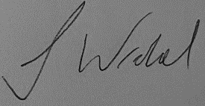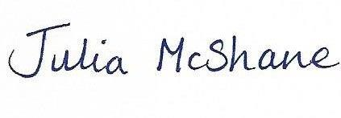

Executive Summary

Guildford Borough Council and Waverley Borough Council (the Council) are working closely to make the most of our collective resources, to work more efficiently, and to improve services for our residents. We are two local authorities that focus on the local. Everything we do is for the benefit of our residents, and putting people at the heart of our work is critical to our future success. We are committed to fostering a culture of collaboration, growth, and inclusivity, where every member of staff feels valued, empowered and inspired to do their best.
This strategy is to renew and strengthen our commitment to fairness, dignity and equal opportunity for everyone who works with or is served by our Councils. By promoting equality, diversity and inclusion, we aim to build stronger, more connected communities.

The strategy outlines clear and actionable objectives, aligning with legal obligations under the Equality Act 2010 and addressing the specific needs of Guildford and Waverley communities and employees of both Councils. This strategy is a key policy for the Councils and, as such, it provides a framework for all policies, plans and services. It will shape the Council’s approach and priorities and will be implemented across all levels of the Councils.

Equality underpins the Council’s guiding principles of fairness, dignity, respect and equality of opportunity and it is a key enabler in supporting our shared values of collaboration, wellbeing, trusted, value for money and professionalism.

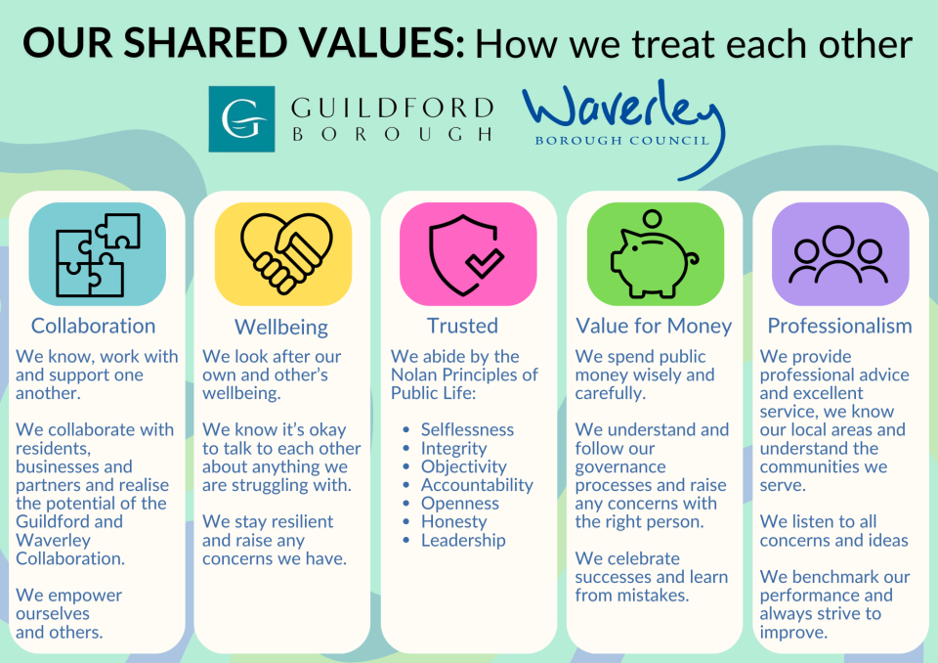

The strategy sets out the national and local context, and describes the key aims and objectives and sets out our Delivery Plan.

Aims of the strategy

Our aims are to:-

- To re-affirm our commitment to Equality, Diversity and Inclusion (EDI):
Strengthen the Council’s commitment to EDI, and to foster an organisational culture that is inclusive and equitable.

- Legal compliance and obligations: Guarantee compliance with relevant legislation and fulfil our obligations within the Equality Act 2010 and the Public Sector Equality Duty.

- Recognising and celebrating achievements: Proactively identify, acknowledge and celebrate our achievements in promoting EDI within both Councils, recognising both significant milestones and incremental progress.

- Setting strategic priorities: Define clear goals and focus areas to guide our Council’s initiatives and actions from 2025 to 2027, ensuring a comprehensive and structured approach towards fostering equality and inclusivity.

Strengths and achievements

We embark on our two-year strategy to 2027 from a position of strength and confidence which stems from our past achievements as described below.

We have made a number of neurodiversity improvements, led by our Housing Team and we now have an Autism Champion at the Council.

Meeting national standards and accreditations

We are actively taking steps to improve accessibility on our website, intranet and all documents. We have:

- Gained Disability Confident Employer status and are working towards level 3 (Disability Confident Lead).
- Signed the Armed Forces Covenant (silver for Guildford and bronze for Waverley)
- Trained Mental Health First Aiders and joined the Mental Health Charter.

‘Without the support and helpful actions of the MHFA who spoke to me I might be in a very different place now’ - employee.

Cultural shift and collaboration

Both Councils are proud to have fostered genuine commitment from Elected Councillors and staff, and engagement with employee networks such as the Young Employees’, Womens’, Pride, Neurodiversity, and Ability and Beyond Networks help to promote and encourage our ‘just and learning culture’.

A ‘just and learning culture’ concentrates on the culture and leadership elements of our Councils, and how they support our people to grow compassion in the workplace, modelled by our senior leaders. It also emphasises working with our Unison partners, employee engagement and health and wellbeing leads.

Learning and development

We are developing an annual EDI training plan consisting of mandatory core training and specialist courses. We have delivered bespoke recruitment training including EDI, sickness absence management training, and training on Equality Impact Assessments. We have and continue to support a number of apprentices who, following their training, have gone on to work here permanently and progress their career.

‘After joining as an apprentice with little to no experience in my field, I was given the tools to quickly progress to a full-time role via the apprenticeship scheme’ – ICT Infrastructure Officer.

‘If I was to look back at myself when I first joined the Council, it would be hard to stand there and see myself where I am today’ – Head Gardener Parks and Streetscene.

Recruitment

Both Councils will operate fair and inclusive recruitment and employment practices to achieve our operational needs and will seek to maintain a diverse workforce that reflects the diversity of the communities that we serve.

Our terms and conditions of employment will not apply unjustifiable requirements. We will take care to ensure that our policies and procedures do not include elements which will or could unfairly or adversely impact on individuals or certain groups of staff or service users.

Working environment

All efforts will be made to make adjustments wherever reasonably practicable for disabled staff, applicants for posts, or any staff member making a reasonable request. Both Councils aim to have a working environment and culture where everyone feels comfortable and treated with dignity and respect.

Addressing hate crime

We will continue to develop systems to encourage the reporting of hate crimes and incidents against staff and ensuring that all appropriate action is taken. We have a “zero -tolerance” approach to bullying and harassment in the workplace and have a harmonised policy to protect employees, maintain a safe and respectful environment, and fulfil legal duties of care.

Community engagement and heritage projects

Both Councils are committed to reaching out to our most vulnerable residents including the elderly and the young. Our Community Hub in Guildford, The Hive, is a warm and welcoming space which is open daily for groups and people of all ages to use. It provides activities and events to provide opportunities for learning, exercising and socialising including tailored activities that meet a range of social, physical and emotional needs. Activities include breast-feeding clinics, Alzheimer’s and dementia support, craft making and music activities.
We support people, groups and organisations to strengthen the communities that make Guildford a place where everyone is valued.
‘It's such a privilege to have the resources to make a positive impact on people's lives and it feels great to work within teams where everyone is ultimately here because they genuinely want to help one another.’

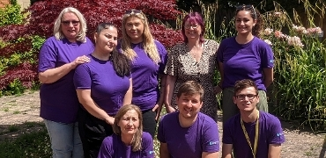

Some heritage events include heritage open days where tours are conducted in historic building that are usually closed to the public (e.g. Guildford Almshouses) outreach to schools including ‘Playtime’ at the Museum, learning events based on the Borough’s history and, until very recently, our Victorian Schoolroom Experience for school aged children.

Within Waverley, there is partnership working to support disability arts through the work of DAiSY, an umbrella organisation that promotes and celebrates the work of deaf, disabled and neurodiverse artists and disability arts organisations.

The Borough is a leading player in Arts Partnership Surrey, which funds and supports a diverse range of Surrey artists and arts organisations to shape and deliver arts opportunities in Waverley which are tailored to the specific needs of vulnerable groups and communities including children and adults with mental health needs, individuals with caring responsibilities, older adults at risk of social isolation and for those whose first language is not English. Farnham Maltings and Cranleigh Arts Centre receive funding through Waverley’s Thriving Communities Commissioning Fund. This enables them to provide a varied programme of regular creative wellbeing activities, opportunities for children and young people to enjoy and take part in the arts and to deliver arts activity and events in areas of multiple deprivation. In partnership with others, we support the sector by providing networking opportunities as well as mentorship, peer support and funding for early career and advancing artists.

Accessibility and Digital Inclusion

Accessibility is of great importance to us, ensuring everyone can use Council services and information, regardless of disability or circumstance. This is legally required under the Public Sector Bodies (websites and mobile applications) Accessibility Regulations 2018.

For digital inclusion, our ambition is to remove all barriers so all residents can benefit from digital public services, skills, connectivity, accessible web interfaces, and adaptive technologies.

Both Councils are committed to making its websites and digital services as accessible as possible, including assistive technologies like hearing loops and accessible forms.

There are different types of accessibility –
- Visual
- Hearing
- Physical
- Speech
- Cognitive

We have achieved so much over the last 12 months –
- As part of our legal responsibility, we have published (via a link on our website footer) our accessibility statement, highlighting where we are not compliant and how to get support.
- Quarterly reviews of the accessibility statement ensuring it is up to date.
- We continue to work on technical accessibility fixes.
- Conducted a content audit to ensure content and accessibility standard are consistent and meets our best practice guidelines.
- Worked with Web Usability, a strategic user experience consultancy, to test our platforms for accessibility issues, and provide practical long and short-term changes to make our digital services easier to use and accessible for all our residents.
- Smarter Digital Services at Waverley are used for training and support, accessibility audits and user testing.
- Published our content and accessibility guidelines on our website.
- Web editor training (new and refresher) and third-party training on accessibility.
- Created a new web page to help everyone get online to support digital inclusion.

Positive employee perception

We take pride in creating an environment where every individual, regardless of their background, experiences fairness, dignity, respect and equality of opportunity.

Results from our 2024 staff survey show that:-
86% of our staff care about the future of the Council’s
72% of our staff feel 72% of our staff feel that people of all backgrounds are respected and valued at work
makes them want to 73% of staff feel that working here makes them want to do the best job they can

Workforce profile (2024 – 2025)

Our workforce is broadly representative of the residents of our boroughs. The table below gives a moment in time using the data that has been recorded:

Gender |  |  | Sexual Orientation
Male  56% GBC)  37.9% (WBC | Female  44% (GBC)  62.1% (WBC) |  | Undisclosed  36% (GBC)  29.5% (WBC) | Gay, Lesbian, Bi-sexual  3% (GBC)  2.2% (WBC | Heterosexual  61% (GBC)  68.4% (WBC)
Working hours |  |  | Disability
WBC  75% full time  25% part time  Of the 25% part time  81% female  19% male | GBC  85% full time  15% part time  Of the 15% part time  81.5% female  18.5% male |  | Undisclosed  27% (GBC)  30.2% (WBC) | Disabled  3% (GBC)  7% (WBC) | Not disabled  70% (GBC)  62.8% (WBC)
Ethnicity
Undisclosed  18.5% (GBC)  20.5% (WBC) | White  75% (GBC)  73.9% (WBC) |  | Black African / Caribbean  2% (GBC)  1.9% (WBC) | Asian  2.5% (GBC)  2.2% (WBC) | Other  2% (GBC)  1.4% (WBC)
Age groups
20 – 29 years  8% (GBC)  9.9% (WBC) | 30 – 39 years  17% (GBC)  15% (WBC) |  | 40 – 49 years  24.5% (GBC)  26.6% (WBC) | 50 – 59 years  30% (GBC)  30.9% (WBC) | 60 – 69 years  19% (GBC)  15.7% (WBC)
70 + years 1.5% (GBC) 1.4% (WBC)

Protected characteristics under the Equality Act 2010

The protected characterises shown below are the nine aspects of a person’s identity that are protected by law from discrimination, harassment, and disadvantage.

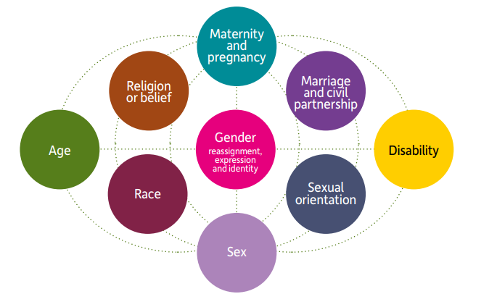

We also recognise that other groups and communities not included in the above may experience discrimination, disadvantage or less positive experiences while using our services or while working for us. These include:-

- Carers
- Gypsy and traveller communities
- Ex-armed forces or part of the wider armed forces community
- Asylum seekers
- Refugees and immigrants
- Less-advantaged communities.

We have dedicated staff to liaise with the travelling community and provide help and support where needed. Both Councils are signatories to the Armed Forces Covenant with Guildford being Silver award holders and Waverley Bronze award holders with the Ministry of Defence Silver Employers Recognition Award Scheme. Both Councils recognise and uphold our statutory duties under the armed forces covenant. We have a task force to help and support refugees, immigrants and asylum seekers including those from Ukraine.
Pillars and key initiatives

This strategy is underpinned by seven key pillars which form the foundation and framework for specific activity. Each pillar guides how we put equality, diversity and inclusion into action.

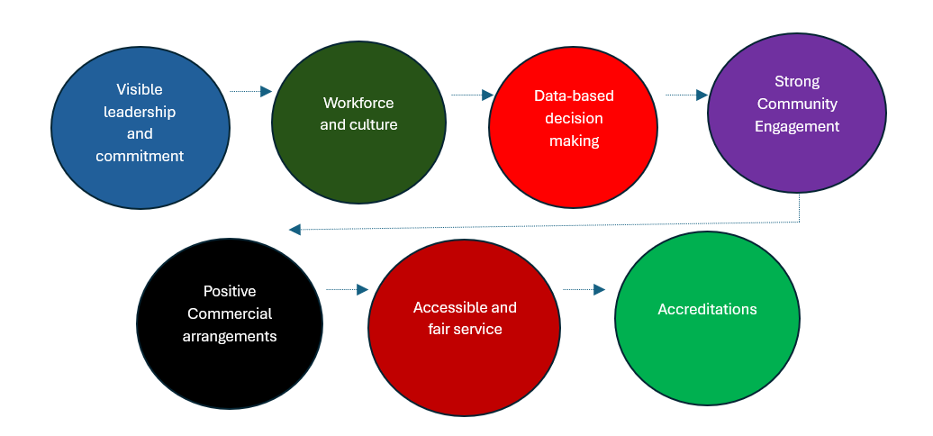

Visible leadership and commitment

This action ensures that senior leaders, Councillors and employees demonstrate visible and robust leadership and decision making with focused targets and outcomes on equality, diversity and inclusion matters.

- Clear EDI Vision & Strategy: an articulated vision and strategy for EDI providing the guiding principles that align with the Council’s overall organisational goals.
- Lead Councillors: Both Councils have Lead Councillors for communities and equality who champion EDI issues. The intranet has more detailed information.
- Directors Leadership and Commitment: Senior leaders lead on specific EDI issues or task groups. For example, sponsors of our network groups.
- Member development and leadership: All Members of the Council commit to personal development and leadership on EDI.
- Departmental Targets: Setting up specific and measurable targets within each department creates a roadmap for progress and accountability.
- Governance Framework: The Councils maintain a robust governance framework for EDI, and will be developing a Corporate Equalities Board, as well as developing the networks that will feed into the Equalities Board on a quarterly basis.
- Equality Impact Assessments: all key decisions of the Council are informed by clear equality impact assessments.
- EDI Annual Reports: we aim to produce an annual report of the Council’s work on Equality, Diversity and Inclusion.
- EDI Budget: the Councils will identify a budget for specific EDI work linked to our networks and initiatives.

Workforce and culture

This action underscores the importance of a workforce that reflects the diversity of the Guildford and Waverley communities, requiring intentional efforts in recruitment, development, and retention. It is also about creating a workforce culture which embraces and values diversity and seeks to eliminate bullying, harassment, and discrimination.

- Inclusive Policies & Practices: policies and practices must evolve to keep pace with societal changes, embodying inclusivity and fairness with inclusive language used in all documents.
- Developmental programmes: approaches such as mentoring, coaching and reverse mentoring will be used to encourage and enable professional development and breaking of “glass ceilings”.
- Learning & Development Plan: a robust plan ensures that employees have access to continuous learning opportunities that promote EDI awareness and skills.
- Reasonable Adjustments Passport (RAPs): reducing the demand on an employee to repeatedly explain their needs and automatically be provided with necessary adjustments. Enabling the Councils to influence other organisations in both boroughs to introduce RAPs so that they become commonplace across employers in Surrey.
- Big Conversations: creating spaces for open dialogues that promote understanding, addresses concerns, and cultivates an inclusive culture. This perspective focuses on an individual’s skills and talents, advocating for the removal of barriers and implementing inclusive practices to enable full participation.
- Hate Incidents: policies and procedures with clear reporting processes to respond robustly and fairly to allegations of discrimination, bullying and harassment in the workplace and our local communities.
- Network Groups: fostering and supporting network groups within the organisation creates a secure space for employees to freely express their thoughts and opinions without the fear of criticism. These groups also serve as valuable platforms for sharing innovation ideas and discovering new career opportunities.

Evidence and data based

This initiative will enhance data capture mechanisms, ensuring accurate and comprehensive information on the demographics of the Council’s workforce, service users, and communities.

- Ethnicity & Gender Pay Gap Reporting: regular reporting on pay gaps provide transparency and accountability in addressing disparities.
- Equality Pay Audit: we will conduct bi-annual audits to ensure fairness in compensation and to identify and rectify any unjust discrepancies.
- Workforce Profile: we will continuously monitor and analyse the workforce composition to identify under-representation.
- Data Collection and Analysis: ensure a proportionate approach to the collection and analysis of personal and sensitive data is reflected in the Council’s policy and practice.
- Mandatory EDI Training Completion Rates: making EDI training (including refresher) mandatory reinforces the importance of continuous education and awareness.
- Staff Survey Feedback: regular feedback through surveys helps gauge employees’ experiences, identify concerns, and measure the effectiveness of EDI initiatives.
- Recruitment Data: scrutinising recruitment data helps assess the success of diversity initiatives and informs adjustments, as necessary.
- Service Data: equality monitoring of take up of services
- Consultation Data: equality monitoring of participation in public consultations.

Community engagement

A commitment to external community engagement serves as a cornerstone in building relationships and fostering inclusivity.

- Build Honest Relationships with Groups of and for People with Protected Characteristics:
Nurturing robust ties with diverse community groups ensures that the Council’s strategy is informed by the unique needs and perspectives of various communities.
- Promote & Celebrate Contribution of Diverse Groups to Guildford and Waverley: recognising and celebrating the diverse contributions of various groups enhances community cohesion and fosters a sense of belonging.
- Participation in Community Events: active involvement in community events demonstrates the Council’s commitment to understanding, respecting, and celebrating the cultural richness of Guildford and Waverley.
- Establishing a collaborated and linked Community Engagement Process across departments: creating a coordinated and linked community engagement process promotes cohesion, planning, and ensures that engagement efforts across departments align with overarching goals and strategies.

Positive commercial arrangements

The Council’s commitment to positive commercial arrangements extends the influence of the EDI strategy into the business sector. This includes the Procurement Act 2023 and Social Value that has introduced a simpler and more transparent system with improved accessibility for Small and Medium-sized Enterprises (SMEs) and Voluntary, Community and Social Enterprises (VCSEs) which are non-governmental organisations that work towards a social, environmental, or cultural purpose.

- Ensure Suppliers have EDI commitments: requiring EDI commitments from suppliers through the Procurement and Social Value process promotes a broader culture of inclusion throughout the supply chain.
- Encourage Local Businesses to adopt EDI Good Practice: the EDI strategy seeks to influence local businesses, encouraging them to adopt EDI best practices and contribute to a more inclusive local economy by developing a Social Value Strategy.
- Public Sector Partnerships: collaborating with other public sector partners extends the Council’s collective impact, fostering a united front in advancing EDI initiatives.

Accessible and fair services

The Councils prioritise accessible and fair services as a fundamental element of the EDI strategy.

- Accessibility Assessments: conducting regular assessments of public facilities, websites, and communication channels to identify and eliminate barriers, ensuring universal access for all residents.
- Inclusive Communication Practices: developing and adhering to inclusive communication practices, including the use of multiple languages, and communication aids, to ensure information reaches and serves diverse community members.
- Flexible Service Delivery Models: exploring and implementing, where possible, flexible service delivery models, such as online services, mobile outreach, and extended service hours, to cater to varying schedules and preferences and enhance accessibility for everyone.
- Neurodiversity in the workplace: creating inclusive environments, offering reasonable adjustments, and adapting communication and physical spaces to accommodate different needs. This will foster greater innovation problem-solving, and productivity by leveraging the diverse talents of all employees.

Accreditations

Accreditations signify the Council’s commitment to external standards and benchmarks, guiding continuous improvement. Rather than mere checkboxes, they serve as yardsticks against national and international standards, challenging the Councils to continually enhance its performance. As accreditations prompt validation and analysis, they spur ongoing improvement efforts, ensuring that the Councils remain accountable and responsive to evolving standards and expectations. It is important that accreditation and external validation is not seen as an end itself. The Councils will continue to review the value and benefits of external accreditation.

- Disability Confident: the Council’s journey involves progressing to higher levels of Disability Confident status, demonstrating commitment to creating a disability-friendly workplace.
- Race at Work Charter: the Council’s participation in the Race at Work Charter signifies the Council’s commitment to race equality in the workplace.
- Achieve Menopause Friendly Accreditation: acknowledging the importance of being a Menopause Friendly employer, the Council’s commitment is shown through its intent to see accreditation in 2025 and beyond.

Legal Framework

The Council works within a robust legal framework designed to safeguard and champion EDI. Central to this framework are the Equality Act (the Act) 2010, and the Human Rights Act 1998, which collectively set out the rights and protections afforded to individuals and groups. They guide everything we do as an employer and public body. We use Equality Impact Assessments to make sure policies and services treat everyone fairly.

In practical terms, this duty requires a comprehensive evaluation of how the Council’s functions, policies, and services impact diverse groups. The overarching goal is to mitigate or eradicate disadvantages stemming from protected characteristics, promoting greater public life participation for those facing disproportionate barriers. Beyond service provision, the duty extends to the Council’s role as an employer, ensuring fair treatment for both staff and those involved in work-related activities.

Equality Impact Assessments: The Council uses a robust Equality Impact Assessment (EIA) approach to assess the potential impact of any changes in policy or practice on those with protected characteristics. Each EIA is owed by the responsible service manager and includes an action plan to mitigate against any potential negative impact.

Human Rights Act 1998: The Human Rights Act 1998 sets up a framework for fundamental rights and freedoms applicable to all individuals. These rights protect individuals from the power of the state and thus are of key significance to local government. In the context of the Council this is considered by all functions.

National and international context

National and international developments have shaped and influenced the work of the Councils and their strategic approach to EDI. The Black Lives Matter movement, founded in the USA rose to prominence in the aftermath of the murder of George Floyd, created momentum to re-examine issues of institutional racism within all public bodies.

The Covid pandemic affected everyone worldwide and particularly adversely impacted older and disabled people, especially those residing in care homes. In addition, the impact on mental health following the pandemic presented itself through social isolation, and there is now an increased number of people with physical disabilities: ‘long covid’, respiratory conditions and chronic pain.

The Commission for Race and Ethnic Disparity report (2021) argued that issues of participation, family life, trust between institutions and communities, were as important as overt racism in overcoming barriers to genuine inclusivity and fairness. The national agenda was also shaped by Baroness Casey review into the standards of behaviour and internal culture of the Metropolitan Police in 2023. This report, commissioned following the murder of Sarah Everard, found systematic evidence of homophobia, misogyny, and racism. It was a lesson for all public bodies to remain vigilant on these issues.

There have also been Government announcements and high-profile legal cases relating to gender identity, womens’ rights, and freedom of expression. This is a complex and evolving area where different rights and values may come into conflict. The Council remains committed to recognising the right to express one’s own gender identity, whilst protecting the safety of women and the right to freedom of expression.

There have been recent changes in UK legislation including a significant Supreme Court ruling in April 2025 that defined “sex” in the Equality Act 2010 as biological sex, impacting the interpretation of single-sex spaces and creating a distinction between legal gender and biological sex for the purposes of the Act. In parallel, the UK government is moving to introduce a trans-inclusive ban on conversion therapy, and the two bills are currently going through the House of Commons.

Finally, the Council has responded to international conflicts, such as the ongoing situation in Ukraine, and the Council has been pleased to support over 700 Ukrainians to settle in the County through the Homes for Ukraine scheme.

Local context:

As the Councils prepare for devolution and Local Government Reorganisation, we need to ensure that the research into inequalities faced by local communities informs strategic planning for the new authorities. We also need to ensure that we continue to be a compassionate and inclusive employer as we prepare for staff to transition to the future working arrangements.

Appendix 1
Delivery Plan – 2025 – 2027

- Visible leadership and commitment
- Workforce and Culture
- Data-based decision making
- Strong community engagement
- Positive commercial arrangements
- Accessible and fair service
- Accreditations

Pillar | Target | Actions | What will be different?
Visible Leadership and commitment | Clear EDI Strategy | Develop and publish the EDI strategy and Delivery Plan | Clear direction and alignment with Council’s objectives and values  EDI is a core element of the Council’s transformation work
Visible Leadership and commitment | Directors and managers leadership and commitment | Embed EDI principles in the day-to-day management activities and foster an environment that promotes equity, fairness and transparency | Enhanced departmental focus on EDI issues
Visible Leadership and commitment | Member development and leadership | Provide developmental and learning opportunities for Members | Enhanced Member understanding and leadership
Visible Leadership and commitment | Equality Impact Assessments | Conduct impact assessments for all key Council decisions and policies | Informed decision-making that considers EDI implications
Visible Leadership and commitment | EDI annual reports | Compile and publish a bi-annual report on EDI activities | Transparency and accountability in EDI efforts
Workforce and Culture | Positive Health & Wellbeing culture  Delivering equality outcomes | Link positive conversations and wellbeing checks into regular 1-1 meetings and daily working routines.  Encourage the uptake of wellbeing initiatives.  Undertake regular assessments of the training, learning and development needs of members and officers | There is a positive health and wellbeing culture throughout all levels and areas of the organisation which supports all employees sense of identify and self-esteem.  Members and Officers understand their equality duties and take action to deliver equality outcomes.
Workforce and Culture | Inclusive People & OD policies and practices | Review and update People & OD Policies as part of the Policy Review Programme.  Develop a People & Organisational Development Strategy.  Ensure all other policies that have a people impact are inclusive and follow the same principles. | A strategy and suite of policies that reflect inclusivity and fairness with the ambition to achieve greater diversity of the Council’s workforce so that staff reflect the community they serve.
Workforce and Culture | Developmental programmes | Implement mentoring, coaching and reverse mentoring programmes | Professional development and breaking of “glass ceilings”
Workforce and Culture | Learning & development plans | Develop and update a comprehensive EDI learning and development plan that includes (not exhaustive):  - Menopause Awareness  - Inclusive Recruitment  - Neurodiversity Awareness  - Disability Awareness  - Inclusive Leadership  - LGBQT+ inclusion | Continuous learning opportunities for EDI awareness and skills
Workforce and Culture | Reasonable Adjustment Passports | Develop an inclusive process for anyone with health needs, impairments, or disability. | Removes the need to repeat reasonable workplace adjustments throughout the employee lifecycle, make it easier to start the conversation, reduce stress and simplify changing roles.
Workforce and Culture | Big conversations | Facilitate open dialogue sessions across the two Councils | Enhanced understanding and inclusive culture
Workforce and Culture | Network groups | Support and foster employee network groups that support the implementation of the EDI Delivery Plan, with attendance at a quarterly EDI Group.  Ensure Network Sponsors support the network voices to be heard at a senior level. | Secure spaces for employee expression and innovation. Supporting internal policy decision making, advising on how to make all aspects of recruitment and internal processes more accessible, and to better support people in work.
Workforce and Culture | Facilitating flexible working | Review the policy and promote flexible working across both Councils | Removing barriers to optimising work, enable a wider range of employees and make the Council’s more attractive.
Workforce and Culture | Supporting working partners | Review the Shared Parental Leave provision and encourage fathers to take up the available leave and time off. | Supporting working fathers and reducing gender inequalities around caring responsibilities,
Data-based decision making | System development | Review the fields and system structures in both Business World and iTrent | Systems are in place to collect and analyse employment data across a range of practices – recruitment, training, leavers, grievance and disciplinaries etc.
Data-based decision making | Ethnicity & Gender Pay Gap Reporting | Conduct and publish yearly ethnicity and gender pay gap reports | Transparency and accountability in addressing pay disparities
Data-based decision making | Data collection & analysis | Enhance mechanisms for data collection and analysis | Accurate, relevant and comprehensive workforce and service user demographics
Data-based decision making | Staff Survey feedback | Conduct regular employee surveys to gather feedback through Improvement Groups, Networks and yearly staff survey. | Insights into employee experiences and EDI initiative effectiveness
Data-based decision making | Staff training | Conduct Information Governance training (GDPR) for staff collecting and analysing data | Ensure only relevant and accurate data is collected, analysed, stored and used for the intended purpose
Strong community engagement | Build honest relationships with groups of and for people with protected characteristics | Foster relationships with diverse community groups | Informed and inclusive EDI strategy, policies and decisions
Strong community engagement | Participation in community events | Actively participate in community events | Demonstrated commitment to community engagement and cultural understanding
Positive commercial arrangements | Ensure suppliers have EDI commitments | Develop a set of EDI criteria and commitments that stakeholders must meet as prerequisites for working with the Council’s ensuring alignment with organisational EDI goals, the Procurement Act 2023 and the Social Value Strategy. | Broader culture of inclusion in the supply chain
Positive commercial arrangements | Standardised agreements / contracts | Develop a Social Value Strategy outlining stakeholder’s commitments to EDI principles and practices before engaging in partnerships or collaborations | To ensure uniform and consistent approach to the Council’s EDI requirements
Positive commercial arrangements | Encourage local businesses to adopt EDI good practice | Promote EDI best practices among local businesses | More inclusive local economy
Positive commercial arrangements | Support and guidance to Small and Medium Sized Enterprises (SMEs) | Provide support and guidance for SMEs to help them understand and implement EDI best practices effectively | More inclusive local economy
Accessible and fair service | Accessibility Assessments | Conduct regular accessibility assessments including Council’s digital platforms, recruitment portal and buildings | Address barriers faced by residents and staff with disabilities or language barriers  All Council’s workplaces are accessible and inclusive for all where possible
Accessible and fair service | Inclusive communication practices | Develop and implement inclusive communication practices | Address barriers faced by residents and staff
Accessible and fair service | Interpretation & Translation Services | Ensure availability of interpretation and translation services | Fair access to services for non-English speakers and BSL users.
Accreditations | Attain level 3 Disability Confident | Implement steps to achieve level3 Disability Confident Lead status | Staff are able to discuss their adjustment requirements at the initial stages of recruitment.
Accreditations | Race at Work Charter | Ensure compliance with Race at Work Charter commitments | Recognition of commitment to race equality in the workplace
Accreditations | Menopause Friendly Accreditation | Implement steps to achieve Menopause Friendly Accreditation | Support work environment for menopausal employees including training and workplace discussions.

