Using BRE Green Guide Ratings

# Introduction

This is an informal note that describes how to access the environmental ratings for construction methods and materials in the online Green Guide to Specification (the ‘Green Guide’) database provided by the Building Research Establishment (‘BRE’). This note has no status in the planning system and is not a consideration in planning decisions.

# Background

Planning conditions are often applied that require applicants to submit information regarding the embodied carbon and environmental impact of construction materials.

The Climate Change, Sustainable Design, Construction and Energy SPD states:

“5.55 The level of information provided should be proportional to the scale of the application. It is sufficient for applicants for non-major developments to provide information from the BRE Green Guide. The Green Guide provides ratings for different elements (components) of a building using different construction approaches (e.g. a brick and block cavity wall, a timber pitched roof with clay tiles). The BRE Green Guide element ratings are free to access after registering. The Council encourages the use of A and A+ ratings to optimise the embodied environmental impact of specification selection.

5.56 The following information should be provided:

* + description of the element (e.g. ‘external wall’, ‘ground floor’, ‘flat roof’),
  + reference number for the element (a number 10 digits long)
  + rating and description of different building elements from the BRE Green Guide.”

The following section sets out the steps to access and record the information described above.

# How to access and provide environmental ratings in the Green Guide

1. Go to the BRE Green Guide website at: [Green Guide to Specification : BRE Group](https://tools.bregroup.com/greenguide/podpage.jsp?id=2126)
2. Register as a user if not registered already. This is free.
3. Once registered and logged in, click “Green Guide Ratings” from the sidebar:

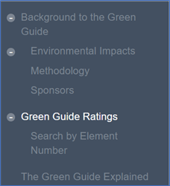

1. Navigate through the menus on the main part of the screen to find the matching element type for each of the main building elements in the proposed scheme:

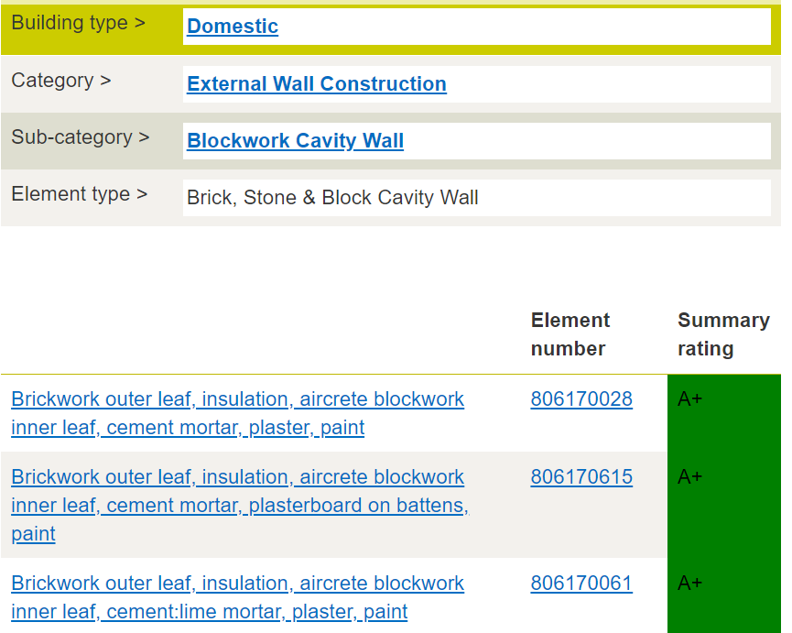

1. For each main building element, record the description, element number and rating. For example:

|  |  |  |  |
| --- | --- | --- | --- |
| **Element** | **Description** | **Element number** | **Rating** |
| Pitched Roof | Timber trussed rafters and joists with insulation, roofing underlay, counterbattens, battens and reclaimed clay tiles | 812410013 | A+ |
| Flat roof | Vapour control layer, insulation, timber joists, plywood (temperate EN 636-2) decking, Polyurethane cold applied liquid waterproofing membrane system. | 1212520009 | A |
| External wall | Brickwork outer leaf, insulation, aircrete blockwork inner leaf, cement mortar, plaster, paint | 806170028 | A+ |

END