
2025 Air Quality Annual Status Report (ASR)
In fulfilment of Part IV of the Environment Act 1995 Local Air Quality Management, as amended by the Environment Act 2021
Date: June 2025

Information | <Local Authority Name> Details
Local Authority Officer | Anjana Papnai, Gary Durrant
Department | Regulatory Services
Address | Guildford Borough Council  Millmead House  Millmead  GU2 4BB
Telephone | 01483 505050
E-mail | regulatoryservices@guildford.gov.uk
Report Reference Number | ASR GBC 2025
Date | June 2025

Local Responsibilities and Commitment
This ASR was prepared by the Regulatory Services, Environmental Protection Team of Guildford Borough Council with the support and agreement of the following officers and departments:
Anjana Papnai, Environmental Health Officer, Regulatory Services
Gary Durrant, Lead Environmental Protection Specialist, Regulatory Services
Martin Knowles, Programme Lead (Transport and Infrastructure), Strategic Services

The other services who have assisted in this report are Guildford Planning Policy – Transport; Commercial Services, Climate Change – Organisational Development, Surrey Highways and Transport.
The ASR has been approved by the Joint Assistant Regulatory Services, the Joint Strategic Director Economy Planning and Place and Councillor Merel Rehorst- Smith Portfolio Holder for Democracy and Regulatory Services. The Public Health Team at Surrey County Council under the Director of Public Health, work closely with Surrey Air Alliance including District and Borough Council as partners responsible for submitting Annual Statement Reports (ASR) on air quality within their area; to develop initiatives, air quality action plans, and implement actions to improve air quality across the county of Surrey.

This ASR has been approved by:
This ASR has not been formally approved by a Director of Public Health, but the completed report has been reviewed in consultation with the Public Health Representative.
If you have any comments on this ASR please send them to Gary Durrant, Lead Environmental Protection Specialist at:
Guildford Borough Council, Millmead House, Millmead Guildford, Surrey, GU2 4BB
Tel: 01483 505050;
Email: regulatoryservices@guildford.gov.uk

Executive Summary: Air Quality in Our Area
In 2024–25, Guildford Borough Council reaffirmed its commitment to improving air quality, safeguarding public health, and advancing sustainable transport. Through enhanced monitoring, strategic interventions, and strong partnerships, the Council continued to address air pollution across the borough.
Key achievements include the expansion of the air quality monitoring network, enabling more precise identification of pollution hotspots and evidence-based resource allocation. Nitrogen dioxide (NO₂) levels remained below the annual air quality objective in the Compton and Shalford AQMAs for the fifth consecutive year. However, exceedances persist at Park Street (site TC6) in the Guildford Town Centre AQMA, highlighting the need for continued focus.
Phase one of the Guildford Town Centre and Shalford Economic Feasibility Study for Air Quality Improvement concluded in September 2024, with phase two now underway. Notable infrastructure improvements included the completion of the Ash Road Bridge, the successful rollout of the Beryl e-bike hire scheme, and the expansion of on-street EV charging points.
The planning system played a pivotal role, with the Council requiring air quality assessments, sustainable transport plans, EV infrastructure, and design with due consideration of air quality issues, for major developments. Ongoing collaboration with developers ensured effective integration of mitigation measures.
A revised Air Quality Strategy was approved in draft form by the Executive Committee and is pending final adoption following stakeholder consultation. Additionally, the first draft of the Air Quality Chapter for the Joint Strategic Needs Assessment, developed jointly by the Surrey Air Alliance, aims to align air quality, transport, health, and demographic data for improved strategic planning.
Public engagement was a core focus, with the Council supporting national campaigns such as Clean Air Night and hosting Guildford Cleaner Air Day to raise awareness and promote behavioural change.
While significant progress has been made, challenges remain—particularly in securing sustainable funding and resources to maintain momentum.

Air Quality in Guildford Borough Council
Breathing in polluted air affects our health and costs the NHS and our society billions of pounds each year. Air pollution is recognised as a contributing factor in the onset of heart disease and cancer and can cause a range of health impacts, including effects on lung function, exacerbation of asthma, increases in hospital admissions and mortality.
Air pollution particularly affects the most vulnerable in society, children, the elderly, and those with existing heart and lung conditions. Low-income communities are also disproportionately impacted by poor air quality, exacerbating health and social inequalities.
Table ES 1 provides a brief explanation of the key pollutants relevant to Local Air Quality Management and the kind of activities they might arise from. The key pollutant of concern in Guildford Borough Council is NO₂ emissions from road transport, particularly the observed exceedances of annual average objective levels in certain hotspots in our existing air quality management areas.
Table ES 1 - Description of Key Pollutants
Pollutant | Description
Nitrogen Dioxide (NO₂) | Nitrogen dioxide is a gas which is generally emitted from high-temperature combustion processes such as road transport or energy generation.
Sulphur Dioxide (SO₂) | Sulphur dioxide (SO₂) is a corrosive gas which is predominantly produced from the combustion of coal or crude oil.
Particulate Matter  (PM₁₀ and  PM_{2.5}) | Particulate matter is everything in the air that is not a gas.  Particles can come from natural sources such as pollen, as well as human made sources such as smoke from fires, emissions from industry and dust from tyres and brakes.  PM₁₀ refers to particles under 10 micrometres. Fine particulate matter or PM_{2.5} are particles under 2.5 micrometres.

Guildford Borough and Existing infrastructure
Population and Health Context
As of mid-2023, the estimated population of Guildford Borough stands at 149,176, based on data from the 2021 Census. According to Surrey’s Health and Wellbeing Strategy (2022 update), several areas within the borough—specifically Westborough, Bellfields and Slyfield Ward, and Ash Wharf Ward—have been identified as ‘Key Neighbourhoods’ experiencing some of the poorest health outcomes in Surrey. Of these, Westborough and Bellfields and Slyfield are among the top five initial priority areas. Despite these health disparities, nitrogen dioxide (NO₂) levels in these locations are not expected to exceed national air quality objective thresholds.
Transport Infrastructure
Guildford benefits from a diverse and extensive transport infrastructure. Rail services form a vital component of the borough's connectivity, with 12 stations serving the area. Guildford railway station functions as a major interchange, linking the Portsmouth Direct Line, the New Guildford Line, the North Downs Line, and the Ascot to Guildford Line. In 2011, 12.6% of commuting residents used rail to travel to work.
However, a 2013 assessment highlighted several shortcomings in the rail network, including overcapacity, weak interconnectivity with other Surrey hubs, and insufficient access between new developments and existing stations. In response, two new stations have been proposed: Guildford West (Park Barn, Scheme NR2) and Guildford East (Merrow, Scheme NR3). Guildford West, in particular, is strategically located to serve high-density and economically significant areas such as the Royal Surrey County Hospital, the University of Surrey’s Manor Park campus, Surrey Sports Park, and the Surrey Research Park.
Road Network
Guildford is traversed by key Strategic Road Network (SRN) routes, including:
- The M25 motorway, which enters the borough at the Wisley interchange (Junction 10 with the A3).
- The A3 trunk road, linking London to Portsmouth and bisecting the borough from the northeast to the southwest.
To mitigate poor air quality along the A3 corridor through Guildford, Guildford Borough Council has collaborated with National Highways. Measures implemented include grant schemes for replacing diesel vans with electric vehicles and active travel initiatives for local businesses. National Highways has also explored larger-scale solutions, such as installing air quality barriers. Recent monitoring indicates air quality has improved along most sections of the A3, with only one stretch of footway (from Egerton Road to the A31 junction) exceeding legal pollution limits. Their current proposed action is therefore, to close this non-compliant section of the footway until air quality improves, redirecting people to alternative routes.
The local road network is anchored by several major 'A' roads radiating from Guildford:
- A320 to Woking
- A322 to the M3
- A323 to Ash, Tongham, and Aldershot
- A25 to Dorking
- A246 to Leatherhead and Epsom
- A3100 to Godalming
- A281 to Cranleigh
- A31 to the A331
Within Guildford town centre, four of these major roads—A31 Farnham Road, A322 Onslow Street, A281 Millbrook, and A3100 Portsmouth Road—converge at the central one-way gyratory system. Additional key urban roads include the A246 York Road and A3100 High Street. This convergence point is also the location of the town centre Air Quality Management Area (AQMA).
The urban road network, particularly the principal radial routes into the town centre, experiences significant congestion. These roads handle an average daily flow of 15,630 vehicles, with around 18% of that traffic occurring during peak hours (08:00–09:00 and 17:00–18:00, Surrey County Council, 2011). The one-way gyratory and its approaches remain the most heavily congested segments.
To address these challenges, a need for a comprehensive strategy was identified to reduce congestion, support sustainable mobility, and improve air quality across Guildford Borough. This must include:
- Demand management
- Integrated land use and transport planning
- Network and traffic management
- Freight and goods regulation
- Behavioural change initiatives
- Strategic road capacity enhancements, where justified by robust business cases

Air quality in Guildford and comparison with national trends
Nationally in 2022, the vast majority of nitrogen oxides (NOx) emissions originated from fuel combustion, with road transport accounting for 30%, other transport 20%, and power stations and industry contributing 10% and 8% respectively—primarily from diesel vehicles. Particulate matter (PM₁₀ and PM_{2.5}) emissions also remain heavily traffic-related, with diesel engines producing significantly more particulates per kilometre than petrol. Industrial PM emissions are dominated by construction and quarrying (over 70%), while residential emissions have risen due to increased wood burning, offsetting declines from reduced coal use.
In Guildford, road traffic is the primary source of NO₂ emissions, consistent with national patterns. The borough has 32 permitted industrial processes, including vehicle respraying, cement batching, and small-scale waste incineration at the Pirbright Institute and Guildford Crematorium. While exact figures are unavailable, woodburner use has risen in recent years, reflected in growing complaints about smoke and odour.
Guildford’s air quality monitoring network includes nitrogen dioxide diffusion tube sites but lacks real-time particulate monitoring; however, a borough-wide modelling study was completed in 2019 and is scheduled for an update in 2026. Long-term background monitoring indicates a steady decline in NO₂ levels, aligning with national trends.

A contributing factor is likely to be the shift in vehicle fuel types: in Guildford and Waverley, diesel car registrations peaked at 34.4% in 2017 and have since declined, while hybrid and electric vehicle registrations have steadily increased, supporting improvements in local air quality.
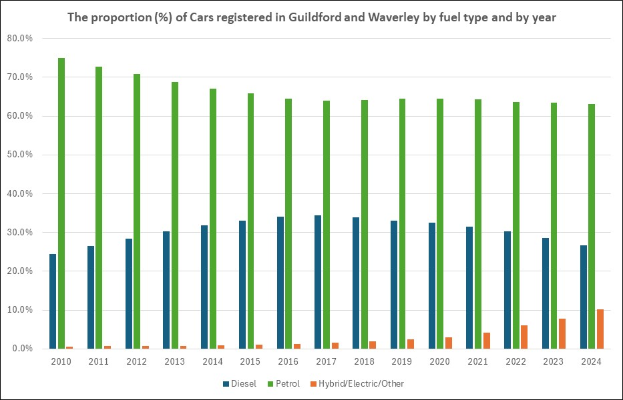
Source: Department for Transport, Table VEH0105
Note: The data is for Quarter 2 in each year.

Actions to Improve Air Quality
Whilst air quality has improved significantly in recent decades, there are some areas where local action is needed to protect people and the environment from the effects of air pollution.

The key actions in 2024-25 were:
- Our 2024 diffusion tube monitoring network comprised of 51 locations, 2 of which were in triplicates, collocated with the A3 and Godalming automated monitoring system (AMS).
- The first stage of economic feasibility of Guildford Town centre’s draft Air Quality Action Plan is now completed. It comprised of desktop review of lessons from Clean Air Zones (CAZs) and Low Emission Zones (LEZs) across UK cities, examining their relevance to Guildford. It evaluated benefits such as improved air quality and increased sustainable transport uptake, as well as challenges including public perception, social equity, and the design of exemptions.
The study also reviewed Guildford’s Park and Ride (P&R) usage at key sites including Artington and Merrow. Phase 2 of the study is currently underway, with findings to be presented in the next annual report.
- easitGuildford Network: This membership offers all staff access to various schemes that promote active and sustainable transportation. Some of the benefits include discounted public transport tickets, Enterprise Car Club, bike loans, access to additional grant schemes and easitSHARE, an online portal to enable shared car journeys.
Currently, 134 staff members have registered on the website, using discounts and initiatives. Additionally, 9 staff members have registered for easitSHARE program.

- ETCI Guildford scheme (Electric Town and Cities Initiative): Funded by the National Highways, the scheme began with three parts:
i) Funding to the businesses for swapping diesel vans with electric vans if they undertake 150 trips through the A3 Guildford stretch. This grant scheme did not run for the two years as was planned and closed on 24 September 2025. 73 grants were issued under the scheme.
ii) Fully funded Active travel and salary sacrifice schemes to the businesses whose employees travel to work on the A3 as it passes through Guildford. As of June 2025, 25 members have joined the network, with total number of employees estimated to be over 8500. As part of this Easit network, 677 users have registered on the bespoke car share portal, easitShare and 1204 users are benefitting from travel incentives
iii) Charging infrastructure for electric vans: Existing rapid charge facilities at Midleton Road Industrial Estate have been upgraded in order to accommodate electric vans under the Electric Towns and Cities Initiative.
- The Ash Road Bridge, now officially named Chester Bridge, was completed and opened, easing congestion and improving air quality by rerouting traffic away from sensitive receptors. It was an important infrastructure project to improve connectivity for the new homes in Ash. Following its completion, the level crossing is now permanently closed for vehicles reducing traffic congestion in the area.

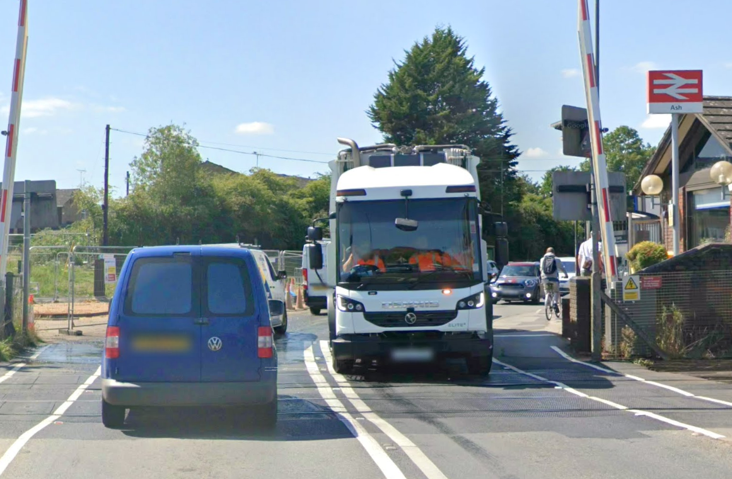
Figure 1 Level crossing at Ash Railway Station

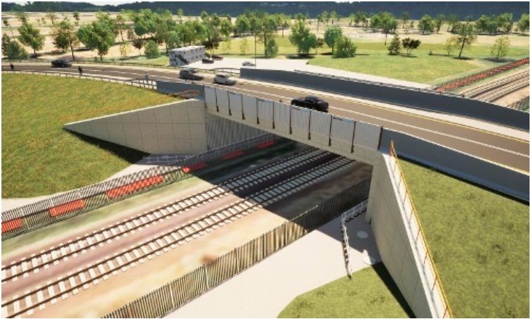
Figure 2 New Ash Bridge, removing the need of level crossing for vehicles

- Works on the new Guildford town centre bus facility and North Street redevelopment, has initiated. The development will deliver, in addition to new homes, 2.2 acres of public realms featuring a wellness garden and a new town square; pedestrianisation of North Street, projected to improve air quality in the area.

- A borough-wide e-bike hire scheme was launched, encouraging low-emission travel alternatives. The map below shows the location of Beryl bike bays. The scheme has introduced 200 ebikes as well as pedal bikes to hire, spread into 40 Beryl parking bays across Guildford. Teaming up with the University of Surrey, Beryl is offering a discount of 25% to all students.
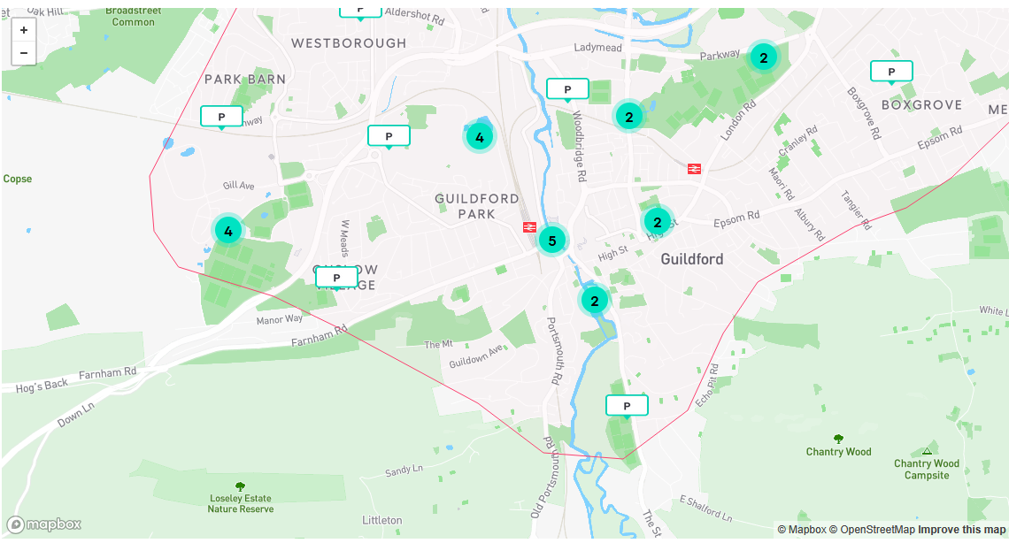
Figure 3 map showing Beryl parking bays

The 2024 Guildford Rider Report found that Guildford has one of the highest student usage than any Beryl scheme. The top two purpose of the bike hire were cited as university and work commute.

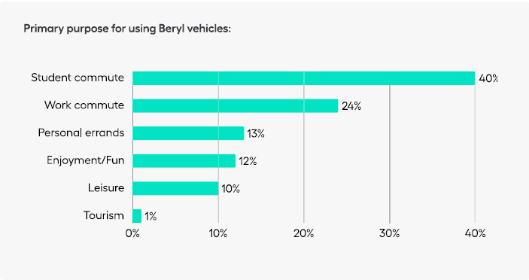
- Surrey County Council expanded its on-street EV charging infrastructure, now totalling 250 charging points countywide.

- As a member of the Surrey Air Alliance, the Council has progressed several collaborative initiatives, including:
- Preparing for an updated Surrey-wide air quality model (due in 2026),
- Developing an Air Quality chapter for the Joint Strategic Needs Assessment (JSNA), integrating environmental and health data on asthma, COPD, and cardiovascular conditions. The first draft of the chapter has been prepared using the air quality information provided by all the Surrey’s districts and boroughs. Health data on asthma, COPD, and cardiovascular rates, available at the primary care level, is being analysed for plotting. Also, efforts are being made to correlate the transport chapter with the air quality and health data.

- Guildford Borough Council reviewed and updated its Air Quality Strategy 2025–2030, which was approved by the Council’s Executive on 19 June 2025 as a draft prior to stakeholder consultation. The strategy aligns with national policy and the borough’s Climate Change Strategy.

- Surrey County Council’s Travel Planning Team continued to promote sustainable travel in schools, with a growing number producing Travel Plans. The Annual Eco-Summit engaged 24 delegates and 100 schools, highlighting strong educational outreach and increasing awareness of air quality issues among young people.

- 20mph zones in Shalford and Compton are likely to be put in place from Summer of 2025, either within the AQMA or in proximity. The council will closely monitor any impact on the existing air quality as a result.

- Working with the planning services and developers to ensure that air quality is an important consideration in any development. Medium and large scale developments are required to complete an Air Quality Assessment and proposed mitigation measures. A notable example is the demolition of the former Debenhams building on the A281, where construction traffic was diverted to protect the Shalford AQMA, demonstrating proactive planning to safeguard air quality.

Following are the pictures/screenshots of the Clean Air Night Campaign and the Guildford Cleaner Air Day 2024.
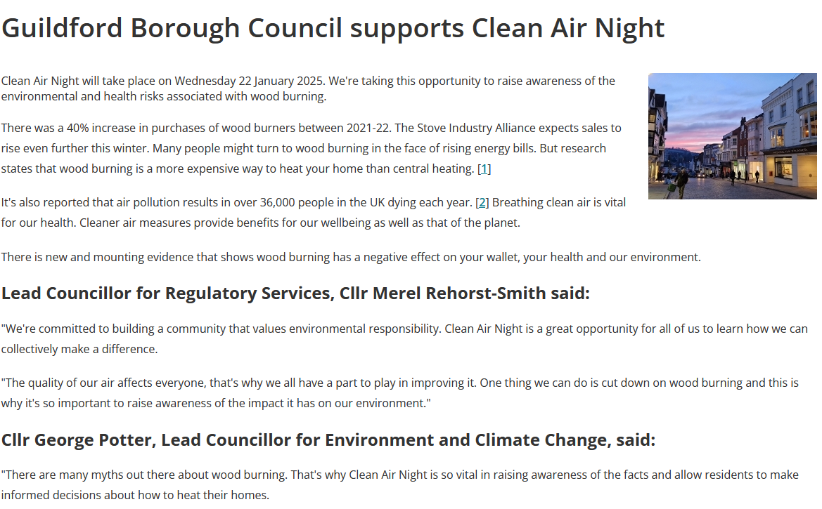



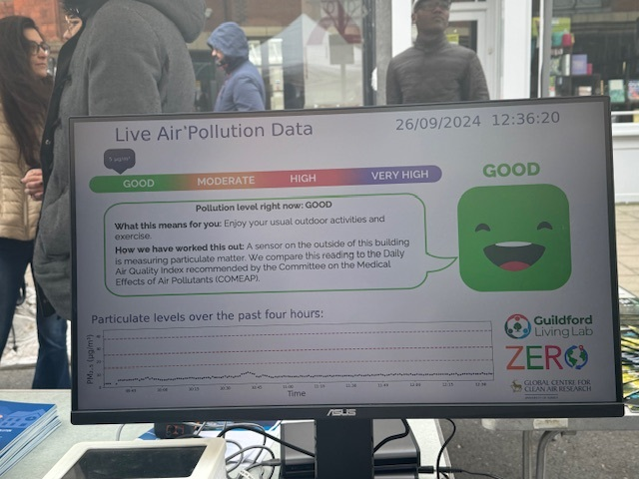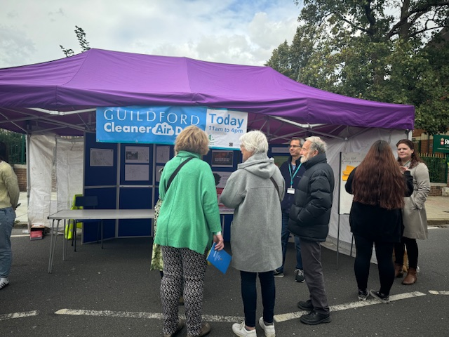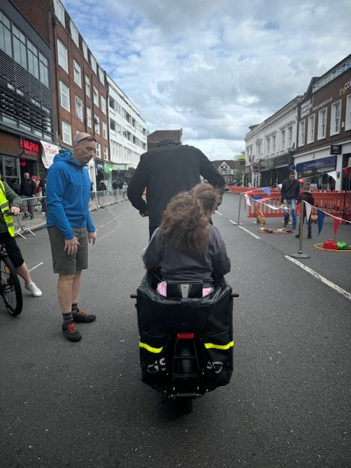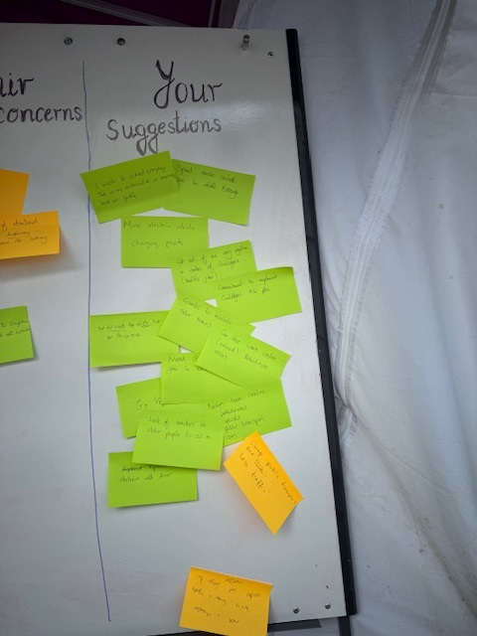
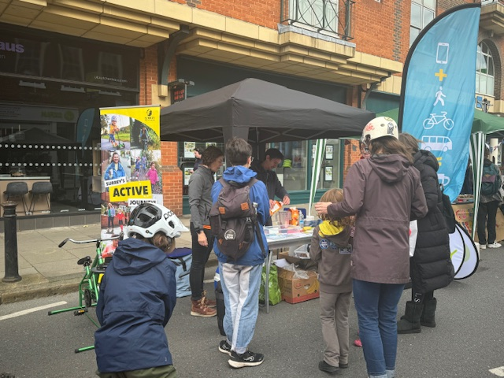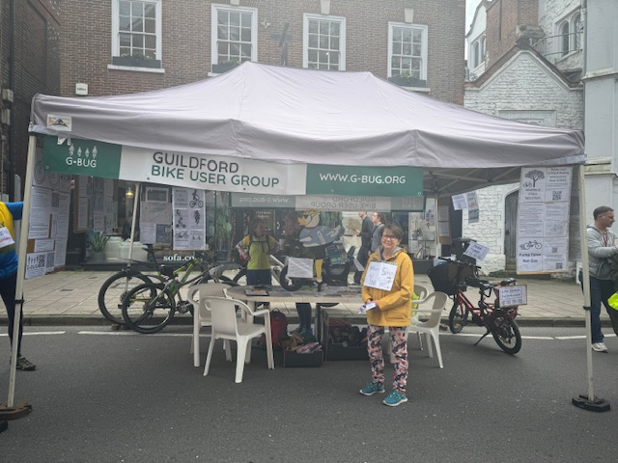

Conclusions and Priorities

Priorities for 2025-2026:
- The completion of a feasibility study for the implementation of a low emission zone or equivalent along with a study on efficient operation of the existing Park and Ride facilities in Guildford remains the Council’s priority.
- Finalising AQAP for Town Centre AQMA following completion of the economic feasibility study and publishing following DEFRA approval.
- Adopt a Motor Vehicle No Idling policy for staff, contractors and visitors on Council premises, and staff using a vehicle for conducting Council business.
- Improve the Council’s communications on air quality, particularly the air pollution concentrations in the Borough and the benefits of clean air.
- Continued collaboration with National Highways and Surrey County Council on implementation of ETCI (Electric Towns and Cities Initiatives) schemes.
- As part of Surrey Air Alliance (SAA), continue to work on priority projects such as: Clean Air Night campaign, school projects (Eco schools, promotion of school travel plans, air quality campaigns such as anti-idling, run interactive education programs for raising awareness on health risks of air quality), progress the implementation of DEFRA funded EV taxi project, and set up a Solid Fuel Working Group.
- Finalise the Council’s Air Quality Strategy 2025-2030 following the stakeholder’s consultation and implementation of the actions identified.
- Review the status of the AQMAs in Compton and Shalford in the context of the preceding years and current nitrogen dioxide monitoring results.

There are challenges expected which will affect the shape and form in which Guildford Town Centre AQAP can be implemented:
- The vibrancy of the town centre is important for Guildford’s economic growth and the AQAP should therefore not have negative impact on the economy.
- The increased cost of living will have impact on various national and local initiatives such as heating homes by burning solid fuels, delay in fleet renewal, etc.
- There are capacity and air quality issues on A3 in Guildford. The delivery of new Guildford West Station which will serve the residential area of Park Barn and economically active area of Guildford (including Royal Surrey Hospital, University of Surrey campuses including Surrey Sports Park and Surrey Research Park) will relieve some pressure off the A3. However, this is a long-term project.
- Council has a priority to meet the need and welfare demands of its residents and often the resources must be matched to meet those demands.
- Funding and resources constraints
- To get more people to use sustainable mode of transport, there is a need for improved cycle network and safe cycling infrastructure, adequate bus transport and economical park and ride facility etc. However, a lot of investment in walking and cycling infrastructure has taken place in the recent years.

How to get Involved

Communicating air quality progress and challenges in Guildford through this ASR is essential for informing residents, businesses, experts, and other interested parties. From choosing sustainable modes of transport to using cleaner fuel sources, everyone can contribute to reducing air pollution. Residents and interested parties are encouraged to share their concerns, suggestions, or valuable feedback on air quality initiatives through the online webform.
Everyone has a role and can contribute to air quality improvement in many of the following ways:
- Are there alternatives to use of personal car? Consider alternatives to using the car. There are now several car free cycle routes, and you can use a journey planner to plan your journey. Google maps are very handy to plan journeys by train, on foot or bike.
- Can you avoid taking car for short journeys and instead walk or cycle?
- Are you aware of Guildford car club? Guildford has 7 cars and 1 van in the club with designated parking bays in a convenient location. Club cars are accessible to members 24 hours a day, 365 days a year. You can book them online, via a smart phone app or over the phone. The club cars comprise either low or ultra-low emission vehicles. The residents in Guildford can benefit from the promotional offer of first year membership fee of £10 (https://www.guildford.gov.uk/carclubs
- Turn off the car engine when stationary. Leaving an engine idling causes unnecessary emission into the air. The children and parents walking along the path near parked cars are the recipient to any emission from cars idling near schools.
- By choosing using woodburning stoves less frequently, using seasoned woods, smokeless fuels or those certified as ‘Ready to Burn’.
- Explore other heating alternatives in place of using a wood stove.

Table of Contents
Local Responsibilities and Commitment i
Executive Summary: Air Quality in Our Area iii
Air Quality in Guildford Borough Council iv
Guildford Borough and Existing infrastructure v
Air quality in Guildford and comparison with national trends vii
Actions to Improve Air Quality ix
Conclusions and Priorities xvii
How to get Involved xviii
1 Local Air Quality Management 1
2 Actions to Improve Air Quality 2
2.1 Air Quality Management Areas 2
2.2 Progress and Impact of Measures to address Air Quality in Guildford Borough Council 5
2.3 PM_{2.5} – Local Authority Approach to Reducing Emissions and/or Concentrations 14
3 Air Quality Monitoring Data and Comparison with Air Quality Objectives and National Compliance 17
3.1 Summary of Monitoring Undertaken 17
3.1.1 Automatic Monitoring Sites 17
3.1.2 Non-Automatic Monitoring Sites 17
3.2 Individual Pollutants 18
3.2.1 Nitrogen Dioxide (NO₂) 18
Appendix A: Monitoring Results 25
Appendix B: Full Monthly Diffusion Tube Results for 2024 41
Appendix C: Supporting Technical Information / Air Quality Monitoring Data QA/QC 45
New or Changed Sources Identified Within Guildford Borough During 2024 45
Additional Air Quality Works Undertaken by Guildford Borough Council During 2024 47
QA/QC of Diffusion Tube Monitoring 47
Diffusion Tube Annualisation 49
Diffusion Tube Bias Adjustment Factors 50
NO₂ Fall-off with Distance from the Road 52
Appendix D: Map(s) of Monitoring Locations and AQMAs 54
Appendix E: Summary of Air Quality Objectives in England 69
Glossary of Terms 70
References 71

Figures
Figure A.1 – Trends in Annual Mean NO₂ Concentrations 37
Figure D.1 – Map of Non-Automatic Monitoring Site 54
Tables
Table 2.1 – Declared Air Quality Management Areas 3
Table 2.2 – Progress on Measures to Improve Air Quality 8

Table A.2 – Details of Non-Automatic Monitoring Sites 25
Table A.4 – Annual Mean NO₂ Monitoring Results: Non-Automatic Monitoring (µg/m³) 32
Table B.1 – NO₂ 2024 Diffusion Tube Results (µg/m³) 41

Table C.1 – Annualisation Summary (concentrations presented in µg/m³) 50
Table C.2 – Bias Adjustment Factor 51
Table C.3 – Local Bias Adjustment Calculation 51
Table C.4 – Non-Automatic NO₂ Fall off With Distance Calculations (concentrations presented in µg/m³) 53
Table E.1 – Air Quality Objectives in England 69

Local Air Quality Management
This report provides an overview of air quality in Guildford Borough during 2024. It fulfils the requirements of Local Air Quality Management (LAQM) as set out in Part IV of the Environment Act (1995), as amended by the Environment Act (2021), and the relevant Policy and Technical Guidance documents.
The LAQM process places an obligation on all local authorities to regularly review and assess air quality in their areas, and to determine whether or not the air quality objectives are likely to be achieved. Where an exceedance is considered likely the local authority must declare an Air Quality Management Area (AQMA) and prepare an Air Quality Action Plan (AQAP) setting out the measures it intends to put in place in order to achieve and maintain the objectives and the dates by which each measure will be carried out. This Annual Status Report (ASR) is an annual requirement showing the strategies employed by Guildford Borough Council to improve air quality and any progress that has been made.
The statutory air quality objectives applicable to LAQM in England are presented in Table E.1.

Actions to Improve Air Quality
  - Air Quality Management Areas
Air Quality Management Areas (AQMAs) are declared when there is an exceedance or likely exceedance of an air quality objective. After declaration, the authority should prepare an Air Quality Action Plan (AQAP) within 18 months. The AQAP should specify how air quality targets will be achieved and maintained and provide dates by which measures will be carried out.
A summary of AQMAs declared by Guildford Borough Council can be found in Table 2.1. The table presents a description of the three AQMAs that are currently designated within Guildford Borough. Appendix D: Map(s) of Monitoring Locations and AQMAs provides maps of AQMAs and also the air quality monitoring locations in relation to the AQMAs. The air quality objectives pertinent to the current AQMA designations are as follows:
- NO₂ annual mean

Table 2.1 – Declared Air Quality Management Areas

AQMA Name | Date of Declaration | Pollutants and Air Quality Objectives | One Line Description | Is air quality in the AQMA influenced by roads controlled by Highways England? | Level of Exceedance: Declaration | Level of Exceedance: Current Year |  | Number of Years Compliant with Air Quality Objective | Name and Date of AQAP Publication | Web Link to AQAP
The Street, Compton, Surrey  (Compton AQMA) | 01/02/2018 | NO₂ Annual Mean | Section of B3000 to its northern end, encompassing 3 residential properties in Compton | NO | 43.8 µg/m3 | 28.2 | 5 years |  | Guildford Borough Council Air Quality Action Plan - Compton Village, 05/07/2019 | https://www.guildford.gov.uk/article/21335/Guildford-air-quality-management-areas
A281, The Street, Shalford, Guildford, Surrey  (Shalford AQMA | 05/07/2019 | NO₂ Annual Mean | Section of A281, The Street, Shalford | NO | 50 µg/m3 | 27.1 | 5 years |  | Guildford Borough Council Shalford Air Quality Action Plan, 01/09/2019 | https://www.guildford.gov.uk/media/30621/Shalford-Draft-Air-Quality-Consultation/pdf/Draft_Air_Quality_Report_for_consultation_-_19.9.2019.pdf?m=637044877947270000
Guildford Town Centre | 22/10/2021 | NO₂  Annual Mean | incorporates section of A281 Millbrook, A31 Farnham Road, A3100 Portsmouth Road; Onslow Street,  Park Street, North Street, Commercial Road, Guildford Park Road and Woodbridge Road | YES | 41.3 µg/m3 | 42 | 0 years |  | Draft AQAP approved in December 2022; The AQAP will be finalised following completion of economic feasibility study | https://www.guildford.gov.uk/media/34555/Draft-Air-Quality-Action-Plan/doc/Draft_Air_Quality_Action_Plan.docx?m=637921975406600000
☒ Guilford Borough Council confirm the information on UK-Air regarding their AQMA(s) is up to date.
☒ Guildford Borough Council confirm that all current AQAPs have been submitted to Defra.

  - Progress and Impact of Measures to address Air Quality in Guildford Borough Council
Defra’s appraisal of last year’s ASR accepted the conclusions drawn in the report and concluded that the report was well structured, detailed, and provided the information specified in the Guidance. The following comments were provided to help inform future reports:
- The Council have correctly applied QA/QC protocols for annualisation and have selected an appropriate bias adjustment factor using a national factor.
- The Council have demonstrated consistency between the ASR submission and the supplementary Excel ASR Table – The DEFRA has this year made changes to the ASR reporting and Excel counterpart is not required to be submitted. This is a welcomed decision for table 2.2 specifically, which often get updated as the ASR drafting progresses, resulting in inconsistency between the excel table and ASR document.
- The graphical trends showing the changes in annual mean NO₂ concentrations from non-automatic monitoring are well presented and accurately demonstrate the annual mean concentrations compared against the corresponding air quality objective for NO₂.
- 1 Exceedance has been identified within the Local Authority Area. This site, TC6 is located within the Guildford Town Centre AQMA.
- It may be useful for the reader to have Map D.1 labelled with the diffusion tube IDs, adjusting the zoom ratio of the image may help in this regard to allowing the labels to be visible if introduced – suggestion implemented in this years map; maximum possible zoom has been applied to ensure that all the diffusion tubes in the network are included, while the site labels remain legible.

Guildford Borough Council has taken forward a number of direct measures during the current reporting year of 2024 in pursuit of improving local air quality. Details of all measures completed, in progress or planned are set out in Table 2.2. 29 measures are included within Table 2.2, with the type of measure and the progress Guildford Borough Council have made during the reporting year of 2024 presented. Where there have been, or continue to be, barriers restricting the implementation of the measure, these are also presented within Table 2.2.
Guildford Borough Council expects the following measures to be completed over the course of the next reporting year:
- Completion of the Economic Feasibility Study for Towncentre and Shalford Air Quality Action Plan;
- Adoption of Guildford’s Air Quality Strategy 2025-2030
- Updated Surrey wide CERC modelling for key pollutants
- A3 Active travel plan for businesses using the National Highways funding. It is expected that the businesses will continue to self-fund the scheme after that.
Guildford Borough Council worked to implement these measures in partnership with the following stakeholders during 2024:
- Surrey County Council – Highways
- Surrey County Council – Travel Planning Team
- Guildford Borough Council’s Planning Policy
- Guildford Borough Council’s Web and Communications Team
- Neighbouring Local Authorities, in particular Waverley Borough Council
- Other Surrey Local Authorities through Surrey Air Alliance (SAA)
- National Highways

The principal challenges and barriers to implementation that Guildford Borough Council anticipates facing are: Insufficient staffing and financial commitment, lengthy council’s procurement procedure, reliance on third parties for completion of studies, other council’s priorities to meet the welfare demand and reactive statutory duties are identified as challenges.
Progress on the following measures has been slower than expected due to:
- Progress in Economic Feasibility Study for the Towncentre and Shalford AQMA due to delays in procurement.
- Defra funded EV project granted to Surrey Air Alliance due to procurement procedures of participating Surrey Authorities and changes in the project specifications since it was first approved for grant.
Guildford Borough Council anticipates that the measures stated above and in Table 2.2 will help to contribute towards compliance, however, it is acknowledged that further additional measures not yet prescribed may be required in subsequent years to achieve compliance and enable the revocation of Town Centre AQMA.

Table 2.2 – Progress on Measures to Improve Air Quality
Measure No. |  | Measure Title | Category | Classification | Year Measure Introduced in AQAP | Estimated / Actual Completion Date |  | Organisations Involved | Funding Source | Funding Status | Estimated Cost of Measure | Measure Status |  | Reduction in Pollutant / Emission from Measure | Key Performance Indicator | Progress to Date | Comments / Barriers to Implementation
1 | Air quality is a consideration at pre- application and application stage to allow effective use of planning conditions |  | Policy Guidance and Development Control | Air Quality Planning and Policy Guidance | 2018 |  | ongoing | GBC; SCC Highways | GBC | Not Funded | < £10k | Implementation | Reduced vehicle emissions |  | Number of developments where air quality has been assessed and actioned | Service Level Agreement between Planning Development and Regulatory Services with quarterly monitoring meetings. | For medium and large scale development, the Council recommends air quality assessment as pre-requisite emphasising on consideration of good design practices, mitigation measures and travel plan; Developers are made aware of the Institute of Air Quality Management Guidance: https://iaqm.co.uk/text/guidance/air-quality-planning-guidance.pdf; Standard condition for EV charging facility is attached to all relevant planning permissions; Condition for low emission NRMM also recommended to relevant planning applications
2 | Green scheme parking fees for electric vehicles in GBC car parks |  | Promoting Low Emission Transport | Priority parking for LEV's | 2018 |  | Scheme in place | GBC | GBC | Funded | £10k - 50k | Implementation | Reduction in Emission |  | uptake of Green Parking Scheme | Implementation on-going | Green parking scheme continues to operate at 13 car parks in Guildford: https://www.guildford.gov.uk/article/25380/Where-can-I-park.
3 | Education in communities and businesses to change behaviours |  | Promoting Travel Alternatives | Promotion of cycling | 2017 |  | ongoing | GBC | GBC/SCC | Not Funded | £100k - £500k | Implementation | reduction of emissions |  | reduction in cars on road and increase in uptake of bikes/scooters | Implementation on-going | Guildford Cleaner Air Day 2024 was successfully concluded on 29th September 2024;The next event is scheduled for 28th September 2025.
4 | Electric buses for all Park and Ride |  | Promoting Low Emission Transport | Public Vehicle Procurement -Prioritising uptake of low emission vehicles | 2019 |  | 2025 | GBC and SCC | SCC | Partially Funded | £500k - £1 million | Study currently progressing | Less emissions |  | Number of buses | Assessment of improvements currently in process | Since the pandemic, the service from the Spectrum Leisure Centre has remained suspended. As part of the Town Centre AQAP /economic feasibility study, assessment of P&R is included.
5 | Active Travel incentives for GBC staff |  | Promoting Travel Alternatives | Workplace Travel Planning | 2018 |  | 2024 | GBC | GBC and SCC | Funded | < £10k | Implementation | Reduced vehicle emissions |  | numbers of staff uptake of sustainable travel initiative. | Council employees have the opportunity to avail discounted travel initiatives from Easit Guildford: https://www.easit.org.uk/network/easitGUILDFORD-23; The scheme is regularly publicised via the Council’s fortnightly newsletter | Uptake of the initiatives
6 | Schools Initiative |  | Promoting Travel Alternatives | School Travel Plans | 2017 |  | ongoing | GBC and SCC | GBC and SCC | Partially Funded | £10k - 50k | Implementation | Reduced vehicle emissions |  | Take up by schools | Implementation on-going | Detailed in section 2.2 of the ASR
7 | Promote alternative travel to work at the Council |  | Promoting Travel Alternatives | Workplace Travel Planning | 2018 |  | 2024 | GBC and SCC | GBC and SCC | Funded | £10k - 50k | Completed | Reduced vehicle emissions |  | Working from home | Fully implemented; Issue of mobiles and laptops has enabled GBC employees to work flexibly and remotely, reducing the unnecessary car journeys to the Council offices. | With the merger of the management of Guildford and Waverley Councils, they may be additional challenges including relocation of offices and the Woking Road Depot to Slyfield Industrial Estate.
8 | Car Clubs in Guildford Town Centre |  | Alternatives to private vehicle use | Car Clubs | 2015 |  | 2024 | GBC, SCC and Enterprise | SCC | Partially Funded | £10k - 50k | Implementation | Reduced vehicle emissions |  | Car clubs increase | The Enterprise Car Club membership is available to Guildford residents at reduced price. There are 7 club cars and 1 van available, some of which fully electric. Some of the new locations have been introduced as part of planning process at new development locations. | Resident's awareness and usage of the scheme; Limitation - limited car clubs outside Guildford Town Centre; new locations are likely to be associated with planning developments.
9 | Smoke control order compliance |  | Promoting Low Emission Plant | Regulations for fuel quality for low emission fuels for stationary and mobile sources | 2021 |  | 2024 | GBC | DEFRA, New burdens funding | funded | < £10k | Implementation | Reduce household emissions |  | number of complaints of smoke | Implementation on-going; A map of the Guildford Smoke Control Areas is available on the website for information of the residents. No proactive monitoring takes place; only reactive; recently seen a rise in complaints of smoke due to woodburners. | With the introduction of new framework for implementation on the AQ strategy including PM_{2.5} targets, officer resource needs reallocation. DEFRA has issued £11,710 funding via the section 31 grant and payment scheme.
10 | Service delivery review to reduce public journeys to Council premises where appropriate |  | Promoting Travel Alternatives | Personalised Travel Planning | 2020 |  | 2025 | GBC and SCC | GBC and SCC | Not Funded | < £10k | Implementation | Reduced vehicle emissions |  | Less car mileage claimed | Implementation on-going | Guildford BC's website has up and running online access to all the council services through MyGuildford Account for residents. Meetings are available virtually through Microsoft Teams.
11 | Improve sustainable transport opportunities |  | Policy Guidance and Development Control | Other policy | 2018 |  | 2024 | GBC | GBC; SCC | Funded | > £10 million | Implementation | Reduced vehicle emissions |  | Use of alternative travel modes | Implementation on-going | Discussed in detail in section 2.2 of this ASR
12 | Electric charging points in public areas and residential streets |  | Promoting Low Emission Transport | Procuring alternative Refuelling infrastructure to promote Low Emission Vehicles, EV recharging, Gas fuel recharging | 2019 |  | 2024 | GBC and SCC | SCC | Not Funded | £50k - £100k | Implementation | Reduced vehicle emissions |  | number installed | Implementation on-going | The number of public chargepoints is growing and has increase to 40 locations in Guildford. The details are available here: https://www.surreycc.gov.uk/roads-and-transport/sustainable-driving/electric-vehicles#section-2
13 | Adopt SCC Electric Vehicle Charging Policy |  | Promoting Low Emission Transport | Procuring alternative Refuelling infrastructure to promote Low Emission Vehicles, EV recharging, Gas fuel recharging | 2019 |  | 2024 | GBC and SCC | GBC and SCC | Partially Funded | £10k - 50k | Implementation | Reduced vehicle emissions |  | Infrastructure detail | Implementation on-going | Every development has a condition for EV charging facility as per the SCC's Electric Vehicle Strategy and planning guidance,
14 | New Railway station at Park Barn Guildford |  | Transport Planning and Infrastructure | Public transport improvements-interchanges stations and services | 2021 |  | 2030 | Network Rail, | unknown | Not Funded | > £10 million | Planning | Reduced vehicle emissions |  | use of train instead of car | Guildford West Station is a new station promoted by GBC, which will provide improved access to the Royal Surrey County Hospital, Surrey Research Park, Surrey Sports Park and Park Barn residential area; It is one of the priority Highway and Transport Scheme, critical for the delivery of Guildford Local Plan; A site has been allocated for the station in the Local Plan | This project is currently on hold
15 | Shaping Guildford's Future |  | Traffic Management | UTC, Congestion management, traffic reduction | 2021 |  | 2030 | GBC | GBC | Funded | £1 million - £10 million | Planning | Reduced vehicle emissions |  | Traffic flow | The stage 1(Preparation of detailed scope & briefs);  Procurement of Consultant team, High Level Strategic Appraisal including constraint analysis, Planning Strategy) and Stage 2 (Development of concept Master Plan, Stakeholder consultation, Data collection, Preparation of Strategic Outline Case, Preparation of Grant applications) of the Shaping Guildford's Future are completed and the council is ready to move to stage 3. | Lengthy Timescale;
16 | Junction 10 |  | Transport Planning and Infrastructure | Public transport improvements-interchanges stations and services | 2021 |  | 2025 | NH, SCC and GBC | NH | Funded | > £10 million | Implementation | Reduced vehicle emissions |  | Traffic flow | The work to upgrade the junction with the A3 Wisley Interchange to reduce congestion is currently underway | The project end date is Summer 2025
17 | Ash Railway Bridge |  | Traffic Management | Other | 2020 |  | 2025 | GBC | Homes England and GBC | Funded | > £10 million | completed | Reduced vehicle emissions |  | monitoring after construction | Implementation on-going | The bridge is now open for vehicles; NO₂ diffusion tube monitoring has been set up to measure any changes as a result.
18 | Sustainable Movement Corridor |  | Transport Planning and Infrastructure | Cycle network | 2019 |  | 2024 | GBC and SCC | GBC and SCC | Partially Funded | £1 million - £10 million | Implementation | Reduced vehicle emissions |  | Improved infrastructure and increased usage of cycle path | Implementation on-going | Partly implemented; discussed in detail in section 2.2
19 | LCWIP |  | Promoting Travel Alternatives | Promotion of cycling and Walking | 2019 |  | 2024 | GBC and SCC | GBC and SCC | Funded | £500k - £1 million | Planning | increase in walking/cycling |  | Cycle counts | Completed and accepted in August 2024 | Guildford Borough Council will use this LCWIP as a basis to seek contributions from developments where appropriate. Surrey CC will use it for investments in walking and cycling in the borough.
21 | Electric vehicle trial project for taxis |  | Promoting Low Emission Transport | Taxi emission incentives | 2021 |  | 2025 | GBC and SAA | DEFRA | Funded | £50k - £100k | Planning | Reduced vehicle emissions |  | take up by taxis | SAA bid of amount £256k was successful to be implemented in 2021 facilitating EV taxi trials. Currently in procurement of the supplier. | This project has faced delays due to pandemic; then changes in match funding situation and currently delays in procurement.
22 | GBC Air Quality Strategy |  | Policy Guidance and Development Control | Air Quality Planning and Policy Guidance | 2017 |  | 2024 | GBC | GBC | Not Funded | < £10k | Implementation | Reduction in vehicle emissions |  | measures adopted | Implementation on-going | Draft Air Quality Strategy prepared which will be published following a full stakeholder’s consultation.
23 | TC Clean Air Zone Feasibility Study |  | Policy Guidance and Development Control | Air Quality Planning and Policy Guidance | 2022 |  | 2024 | GBC | GBC | Funded | £50k - £100k | implementation | to be estimated in the feasibility study |  | completion of feasibility study | Phase 1 desktop study was completed in 2024. Currently, in Phase 2 of the Economic Feasibility Study. | Due to be completed by September 2025. Implementation of the identified measures will require collaboration with SCC Highway partners and financial commitment.
24 | E Bike hire scheme |  | Promoting Travel Alternatives | Promotion of cycling | 2021 |  | 2024 | GBC, SCC, University of Surrey | GBC, UKSPF | Funded | £500k - £1 million | Planning | Alternative Transport |  | usage | Implemented and Beryl bikes are in use. | Cycling infrastructure for wider uptake; hiring cost; currently available at discounted rates for the University of Surrey students.
25 | A3 Guildford - ETCI |  | Promoting Travel Alternatives | Intensive active travel campaign & infrastructure | 2023 |  | 2025 | GBC, SCC, NH | NH | Funded | > £10 million | Implementation | EV vehicle transformation; sustainable travel planning and car sacrifice schemes for businesses |  | uptake of ETCI scheme | The Electric van grant scheme was stopped in September 2024 due to poor uptake. 73 grants were awarded under the scheme. The Active Travel scheme for business in progress. | Poor uptake of the EV grant scheme
26 | Incident management and effective contingency planning to minimise traffic disruption and unnecessary congestion |  | Traffic Management | UTC, Congestion management, traffic reduction | 2023 |  | 2025 | GBC, SCC | unknown | Not Funded |  |  |  |  |  | Awaiting feasibility study outcome | TC AQAP measure
27 | HGV ban around the gyratory during peak and interpeak hours |  | Freight and Delivery Management | Quiet & out of hours delivery | 2023 |  | 2025 | GBC, SCC | unknown | Not Funded |  |  |  |  |  | Awaiting feasibility study outcome | TC AQAP measure; subject to feasibility study
28 | Electric vehicle (EV) deliveries, local delivery hubs |  | Promoting Low Emission Transport | Other | 2023 |  | 2026 | GBC | unknown | Not Funded |  |  |  |  |  | Awaiting feasibility study outcome | TC AQAP measure, will require appropriate site, planning process; subject to feasibility study
29 | A Clean Air Zones (CAZ) and/or Low Emission Zone (LEZ) for buses + HGVs, including an assessment of existing park and ride facilities to identify potential for improvements |  | Promoting Low Emission Transport | Low Emission Zone (LEZ) | 2023 |  | 2026 | SCC/GBC | unknown | Not Funded |  |  |  |  |  | Awaiting feasibility study outcome | TC AQAP measure; subject to feasibility study

  - PM_{2.5} – Local Authority Approach to Reducing Emissions and/or Concentrations
As detailed in Policy Guidance LAQM.PG22 (Chapter 8) and the Air Quality Strategy, local authorities are expected to work towards reducing emissions and/or concentrations of fine particulate matter (PM_{2.5})). There is clear evidence that PM_{2.5} (particulate matter smaller 2.5 micrometres) has a significant impact on human health, including premature mortality, allergic reactions, and cardiovascular diseases.
Guildford currently has no monitoring program for PM_{2.5}. The background annual mean for most of the Guildford Borough as per the DEFRA background maps, for 2023 was modelled to be 6-8µg/m³.
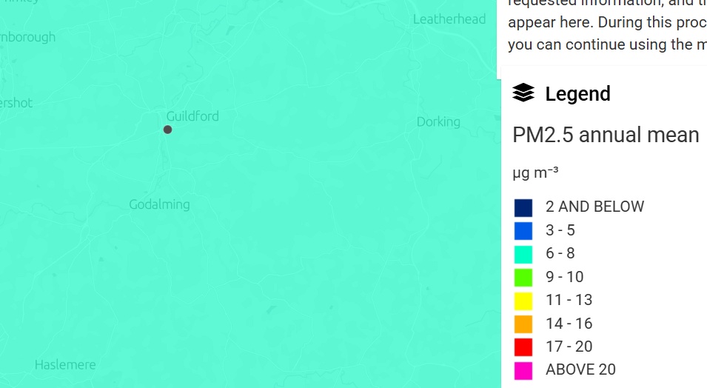
Guildford Borough Council is taking the following measures to address PM_{2.5}:
- Incorporating the Air Quality Strategy: Framework for Local Authority Delivery into our air quality strategy. A draft Air Quality Strategy 2025-2030, has been produced, which has yet to undergo stakeholder consultation. The draft AQS has actions to address smoke control areas, indoor air quality and domestic woodburning, emissions from non-road mobile machineries at the construction sites.
- CERC modelling: The Surrey wide modelling study for particulate matters and Nitrogen dioxide is planned to be updated using the 2024 traffic data. The study will be delivered in 2025-26.

- Guildford Borough has five Smoke Control Areas (SCA) which were declared in the 1960s and 1970s covering approximately 12 square kilometres of the urban area. An indicative map is shown as Figure 1 on page iv on the ASR Appendix 1. These smoke control areas are still relevant to the areas of highest modelled PM_{2.5} concentrations. The plans to review the boundary of existing SCA is still a priority although work on this has not progressed yet due to resource constraint.

- Guildford Borough Council (GBC) supported the Clean Air Night for the second year, which was celebrated on 22nd January 2025 (Clean Air Night).
The campaign was well publicised and following is a rundown of actions to promote the campaign:
  - News release sent to local media and published on our website.
  - Cllr George Potter, the Lead Councillor for Environment and Climate Change was interviewed by That’s TV off the back of our news release.
  - We ran a series of social media posts on Facebook to support the campaign.
  - The campaign was featured in our staff briefings, staff newsletters and Councillor updates

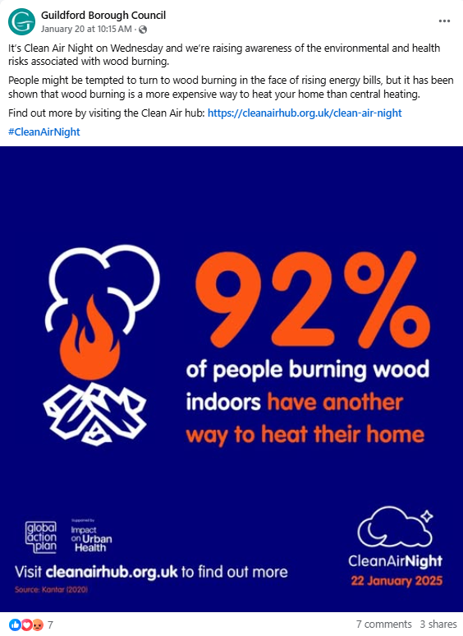

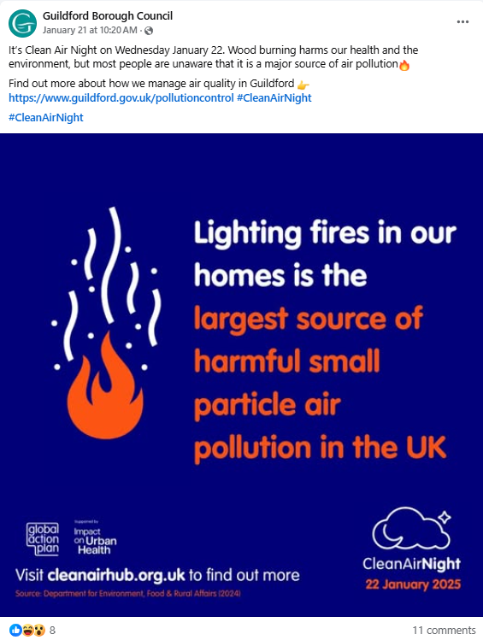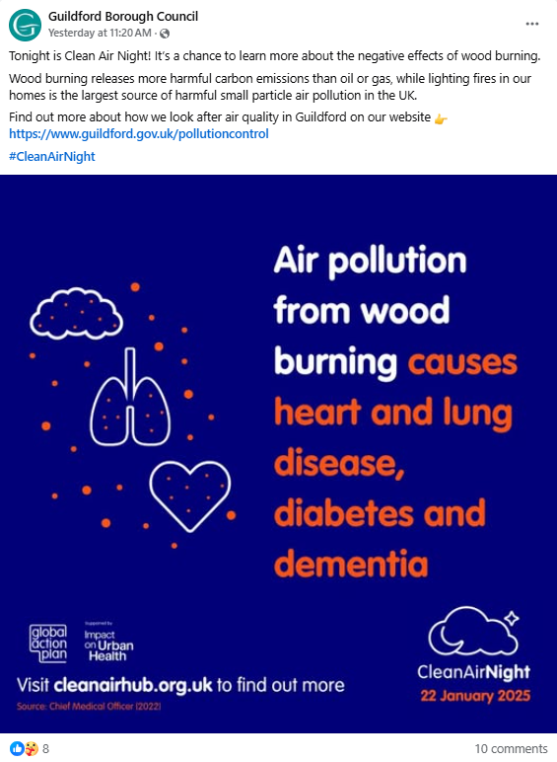

Air Quality Monitoring Data and Comparison with Air Quality Objectives and National Compliance
This section sets out the monitoring undertaken within 2024 by Guildford Borough Council and how it compares with the relevant air quality objectives. In addition, monitoring results are presented for a five-year period between 2020 and 2024 to allow monitoring trends to be identified and discussed.
  - Summary of Monitoring Undertaken

Automatic Monitoring Sites
Guildford Borough Council do not have any automated monitoring sites in their control within the borough.

Non-Automatic Monitoring Sites
Guildford Borough Council undertook non- automatic (i.e. passive) monitoring of NO₂ at 51 sites during 2024. Table A.2 in Appendix A presents the details of the non-automatic sites.
Maps showing the location of the monitoring sites are provided in Appendix D. Further details on Quality Assurance/Quality Control (QA/QC) for the diffusion tubes, including bias adjustments and any other adjustments applied (e.g. annualisation and/or distance correction), are included in Appendix C.
  - Individual Pollutants
The air quality monitoring results presented in this section are, where relevant, adjusted for bias, annualisation (where the annual mean data capture is below 75% and greater than 25%), and distance correction. Further details on adjustments are provided in Appendix C.

Nitrogen Dioxide (NO₂)
Table A.3 and Table A.4 in Appendix A compare the ratified and adjusted monitored NO₂ annual mean concentrations for the past five years with the air quality objective of 40µg/m³. Note that the concentration data presented represents the concentration at the location of the monitoring site, following the application of bias adjustment and annualisation, as required (i.e. the values are exclusive of any consideration to fall-off with distance adjustment).
For diffusion tubes, the full 2024 dataset of monthly mean values is provided in Appendix B. Note that the concentration data presented in Table B.1 includes distance corrected values, only where relevant.
The 2024 monitoring and 5 year monitoring trend of NO₂ shows that:
- The annual mean NO₂ objective of 40 µg/m3 was exceeded at three monitoring locations (TC6 Park Street, A3-10 and A3-20 along the A3 Guildford stretch). Of these only TC6 Park Street exceeded at the relevant exposure location after distance correction.
- The monitoring along A3 has shown considerable reduction in NO₂ concentrations at roadside locations since 2021, with reduction between 28 - 34%.
- The monitoring locations in the Shalford were well below the 10% of NO₂ objective level for the 5th consecutive year. Traffic data was requested from the SCC Highways to understand the reduction in the NO₂ levels over past 5 years. The traffic data shows that the flows have reduced very slightly post pandemic (5-6%), when compared with the data from the period 2011-2014. Another contributory factor is likely to be the change in vehicle engine performance and fuel type. The data available from the Department from Transport has indicated that proportions of cars with diesel engines has reduced in Guildford, while hybrid or electric vehicles have increased to 10%. Proportion of petrol cars has remained relatively stable at around 64% since 2016.
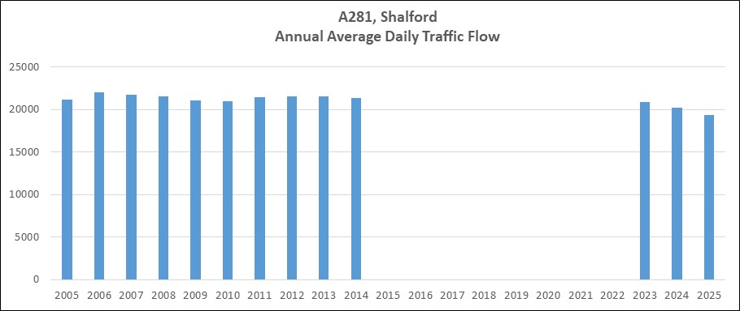

- Similar to Shalford, Compton monitoring locations have remained compliant for 5 consecutive years. It is likely to be a combination of small reduction in traffic flow, compliance to the no right turn ban at Down Lane and the change in vehicle engine composition to cleaner vehicles. The analysis of traffic data for Compton AQMA is presented below:

Traffic data for AQMA Annual Status Report

Trend in Annual Average Daily Traffic
Below is a graph showing the AADT for every year 2016 – 2025 (except for 2017)
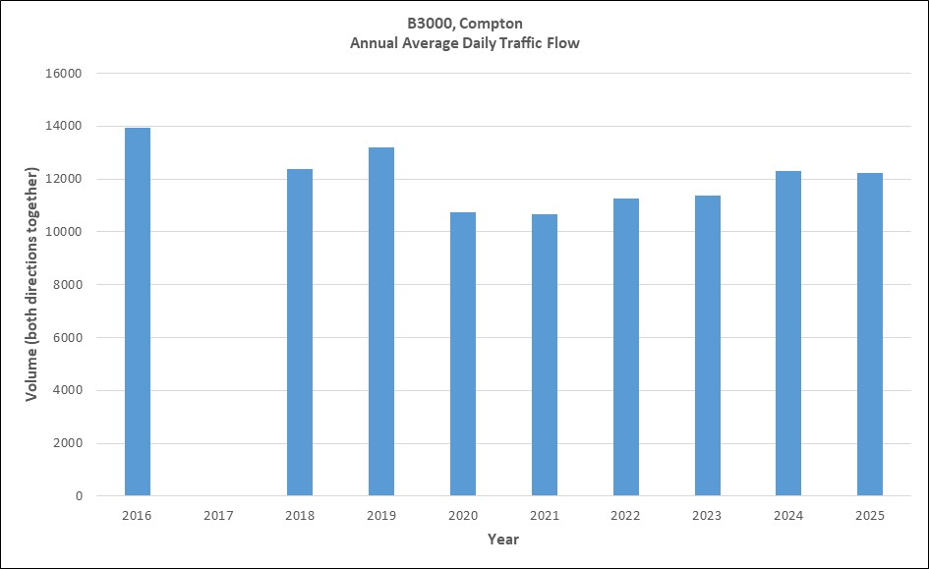
Source: SCC Transport Studies team

AADT is annual average daily traffic flow across all the days of the week, including weekends. It is the flow of vehicles on a stretch of road in both directions. The effect of the pandemic can be seen together with the gradual recovery. In 2024, average daily volumes were back to an average of over 12,300 vehicles using the B3000. It is too early in the year to be sure of the average for 2025, but it is likely again to be over 12,000 vehicles per day. Please note, the data for 2016 was captured over just 1 month (September), which is likely to explain, at least in part, why the AADT is relatively high.
The counter is on B3000 The Street, close to the junction with Polsted Lane, shown on the map below by the red line:
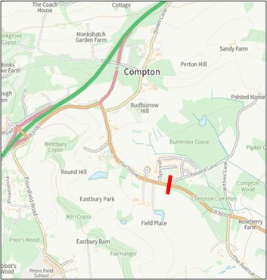
Source: SCC
Licence: SCC © Crown copyright [and database rights] OS AC0000813791

As the volumes increase, speed decreases, and this is most evident at the 85th percentile level:

A one day 12 hour (07:00-19:00) count from September 2024 at the roundabout junction of The Street with the A3 southbound off-slip found that the percentage of HGVs using The Street was 4.3%.
Down Lane no right turn ban compliance:
The same survey (September 2024) also captured turning movements at the junction with Down Lane. While non-compliance was evident, some 438 drivers used the roundabout just to the north to U-turn and then turn left into Down Lane. Some 184 drivers chose to ignore the sign, but the survey indicates that most drivers, 70%, did conform to the restriction over the 12-hour period of the survey.

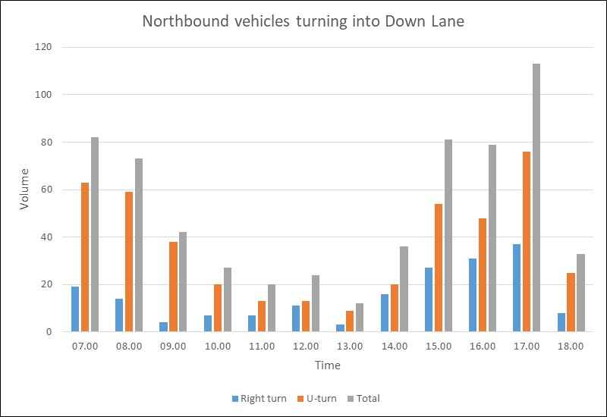
Source: SCC Transport Studies: turning count survey, September 2024

This graph illustrates that the demand to turn right into Down Lane is heaviest during the peaks, but at the same time shows that a significant proportion of drivers do obey the banned turn and u-turn at the roundabout followed by a left turn into Down Lane. This indicates that the banned turn is likely to have had a positive effect on air quality by reducing northbound queuing caused by drivers waiting to turn right into Down Lane and consequently smoothing the flow of the northbound stream of traffic.

It is unlikely that the banned turn on its own will have resulted in the improvement in air quality, but it is probable to have been a contributory factor. However, it is difficult to say how much of the improvement will have been due to this measure.

Appendix A: Monitoring Results
Table A.2 – Details of Non-Automatic Monitoring Sites

Diffusion Tube ID | Site Name | Site Type | X OS Grid Ref (Easting) | Y OS Grid Ref (Northing) | Pollutants Monitored | In AQMA? Which AQMA? | Distance to Relevant Exposure (m) ⁽¹⁾ | Distance to kerb of nearest road (m) ⁽²⁾ | Tube Co-located with a Continuous Analyser? | Tube Height (m)
GD2 | York Road | Roadside | 499799 | 149934 | NO₂ | No | 12.0 | 1.5 | No | 2.6
GD6 | Chantries | Rural | 500385 | 148342 | NO₂ | No | 0.0 | 120.0 | No | 2.0
GD10 | The Garth | Urban Background | 488629 | 150032 | NO₂ | No | 0.0 | 132.6 | No | 2.2
GD16 | Sandfields | Roadside | 499761 | 149914 | NO₂ | No | 2.5 | 2.0 | No | 2.5
GD18 | Josephs Road | Urban Background | 499665 | 150720 | NO₂ | No | 2.4 | 1.0 | No | 2.4
TC4 | Stoke Mews | Kerbside | 499822 | 150010 | NO₂ | No | 3.1 | 1.7 | No | 2.4
TC5 | Mangles Court | Other | 499486 | 149951 | NO₂ | Yes, Air Quality Management Area (No 3) 2021, Guildford Towncentre AQMA | 0.0 | 7.5 | No | 2.4
TC6 | 18 Park Street | Kerbside | 499299 | 149466 | NO₂ | Yes, Air Quality Management Area (No 3) 2021, Guildford Towncentre AQMA | 1.0 | 0.5 | No | 2.4
TC17 | Whittingtons, Park Street | Kerbside | 499308 | 149453 | NO₂ | Yes, Air Quality Management Area (No 3) 2021, Guildford Towncentre AQMA | 0.0 | 3.8 | No | 2.5
TC8 | 13-21 Hi St, Wagama | Kerbside | 499493 | 149402 | NO₂ | Yes, Air Quality Management Area (No 3) 2021, Guildford Towncentre AQMA | 23.0 | 2.4 | No | 2.5
TC9 | The Mount | Kerbside | 499241 | 149257 | NO₂ | No | 0.0 | 78.0 | No | 2.4
TC11 | YMCA | Urban Centre | 499308 | 149505 | NO₂ | Yes, Air Quality Management Area (No 3) 2021, Guildford Towncentre AQMA | -2.0 | 5.3 | No | 2.5
TC13 | Weatherspoon | Kerbside | 499406 | 149584 | NO₂ | Yes, Air Quality Management Area (No 3) 2021, Guildford Towncentre AQMA | 1.5 | 0.5 | No | 2.6
TC14 | ACM | Kerbside | 499369 | 149577 | NO₂ | Yes, Air Quality Management Area (No 3) 2021, Guildford Towncentre AQMA | 0.0 | 2.1 | No | 2.5
TC15 | Weatherspoon/Popworld | Kerbside | 499382 | 149567 | NO₂ | Yes, Air Quality Management Area (No 3) 2021, Guildford Towncentre AQMA | -0.4 | 1.9 | No | 2.5
TC18 | 11 Guildford Park Road | Roadside | 499087 | 149503 | NO₂ | No | 0.0 | 4.2 | No | 2.5
TC19 | 39 Guildford Park Road | Kerbside | 499045 | 149574 | NO₂ | No | 1.9 | 1.9 | No | 2.6
TC20 | 16A Park Street | Kerbside | 499304 | 149458 | NO2 | Yes, Air Quality Management Area (No 3) 2021, Guildford Towncentre AQMA | 0.0 | 1.6 | No | 2.2
TC21 | 106 Stoke Road | Roadside | 499798 | 150682 | NO2 | No | 0.0 | 3.8 | No | 2.4
TC22 | 185 Stoke Road | Roadside | 499780 | 150670 | NO2 | No | 0.0 | 5.8 | No | 2.1
A281-1 | The Legion | Kerbside | 499624 | 149278 | NO2 | Yes, Air Quality Management Area (No 3) 2021, Guildford Towncentre AQMA | 1.7 | 0.5 | No | 2.5
C4 | Little Cottage, Compton | Kerbside | 495437 | 147288 | NO2 | Yes, AQMA Order (No. 1) 2018, Compton AQMA | 0.0 | 1.5 | No | 2.4
C9 | Moors Cottage | Kerbside | 495442 | 147270 | NO2 | Yes, AQMA Order (No. 1) 2018, Compton AQMA | 3.0 | 1.0 | No | 2.3
SH1 | Oppo Sea Horse pub | Kerbside | 500046 | 147604 | NO2 | No | 4.0 | 1.0 | No | 2.4
SH2 | 36 The Street | Kerbside | 499978 | 147704 | NO2 | Yes, AQMA Order (No. 2) 2019, Shalford AQMA | 0.0 | 2.0 | No | 2.3
SH3 | Nr Shalford Lane | Kerbside | 500003 | 147670 | NO2 | No | 2.3 | 1.0 | No | 2.4
SH4 | A281 Oppo Bahamia Court | Kerbside | 500086 | 147521 | NO2 | No | 6.0 | 1.2 | No | 2.4
SH6 | A281, Bridge House | Kerbside | 499955 | 148018 | NO2 | No | 0.0 | 3.2 | No | 2.4
SH8 | 28, The Street, Shalford | Kerbside | 499723 | 146759 | NO2 | Yes, AQMA Order (No. 2) 2019, Shalford AQMA | 0.0 | 2.0 | No | 2.3
RP4 | Newark Lane | Kerbside | 505150 | 156741 | NO2 | No | 0.0 | 0.5 | No | 2.3
RP6 | Ripley High Street | Kerbside | 505374 | 156883 | NO2 | No | 0.0 | 1.7 | No | 2.0
RP7 | Lamp 48, Nr The Anchor | Kerbside | 505159 | 156705 | NO2 | No | 0.0 | 1.7 | No | 2.1
FRH2 | 38 Farnham Road | Roadside | 499078 | 149414 | NO2 | No | 0.0 | 5.0 | No | 2.0
FRH6 | 22 Farnham Road | Roadside | 499102 | 149421 | NO2 | Yes, Air Quality  Management Area (No 3) 2021, Guildford Town Centre AQMA | 0.0 | 6.0 | No | 2.0
PR1 | Wycliffe Building, Portsmouth Rd | Kerbside | 499305 | 149168 | NO2 | No | 0.0 | 1.0 | No | 2.1
PR3 | Oppo Cannon | Kerbside | 499360 | 149326 | NO2 | Yes, Air Quality  Management Area (No 3) 2021, Guildford Town Centre AQMA | 2.9 | 2.8 | No | 2.6
A3-4 | Beckingham Road | Roadside | 498133 | 150648 | NO2 | No | 0.0 | 4.0 | No | 2.7
A3-6 | Ash Grove | Other | 498217 | 150649 | NO2 | No | 0.0 | 19.5 | No | 2.0
A3-7 | Kendale Court | Other | 498653 | 150790 | NO2 | No | 0.0 | 15.0 | No | 2.4
A3-8 | Noise barrier, Cathedral Hill | Roadside | 497777 | 149774 | NO2 | No | 19.0 | 7.0 | No | 2.0
A3-9 | Lamp post 513-12 | Kerbside | 497736 | 149590 | NO2 | No | 24.0 | 1.0 | No | 2.5
A3-10 | Raymond Crescent, lamp 513-002 | Kerbside | 497876 | 150000 | NO2 | No | 19.0 | 1.0 | No | 2.5
A3-12 | Onslow school Reception block | Other | 497610 | 149263 | NO2 | No | 0.0 | 14.0 | No | 3.0
A3-13 | Onslow School Reception play | Other | 497592 | 149251 | NO2 | No | 0.0 | 10.0 | No | 1.8
A3-14 | Onslow School Football court | Other | 497636 | 149271 | NO2 | No | 0.0 | 30.0 | No | 3.2
A3-15 | Onslow School Bug Hotel | Other | 497637 | 149303 | NO2 | No | 0.0 | 8.0 | No | 1.6
A3-16 | 119 Raymond Cres | Other | 497883 | 149998 | NO2 | No | 16.0 | 9.0 | No | 1.8
A3-17 | Wilderness Road | Roadside | 497743 | 149559 | NO2 | No | 7.2 | 12.0 | No | 2.3
A3-18, A3-19, A3-20 | HE AMS3 | Kerbside | 497715 | 149494 | NO2 | No | 18.0 | 2.5 | Yes | 2.1
WTC3 | Walnut Tree Close WTC-3 | Kerbside | 499257 | 149601 | NO2 | No | 1.0 | 1.4 | No | 2.2
Godalming AMS 1, Godalming AMS 2, Godalming AMS 3 | Godalming AMS | Urban Centre | 496711 | 143705 | NO2 | No | NA | 2.0 | Yes
Notes:
(1) 0m if the monitoring site is at a location of exposure (e.g. installed on the façade of a residential property).
(2) N/A if not applicable.
Table A.4 – Annual Mean NO₂ Monitoring Results: Non-Automatic Monitoring (µg/m³)
Diffusion Tube ID | X OS Grid Ref (Easting) | Y OS Grid Ref (Northing) | Site Type | Valid Data Capture for Monitoring Period (%) ⁽¹⁾ | Valid Data Capture 2024 (%) ⁽²⁾ | 2020 | 2021 | 2022 | 2023 | 2024
GD2 | 499799 | 149934 | Roadside | 90.6 | 90.6 | 21.7 | 23.4 | 29.9 | 22.1 | 18.0
GD6 | 500385 | 148342 | Rural | 100.0 | 100.0 | 8.1 | 10.1 | 11.4 | 9.4 | 8.1
GD10 | 488629 | 150032 | Urban Background | 90.6 | 90.6 | 10.0 | 14.8 | 15.0 | 12.2 | 11.3
GD16 | 499761 | 149914 | Roadside | 90.6 | 90.6 | 25.4 | 29.6 | 28.9 | 28.0 | 24.7
GD18 | 499665 | 150720 | Urban Background | 100.0 | 100.0 | 14.6 | 17.2 | 21.3 | 16.8 | 13.5
TC4 | 499822 | 150010 | Kerbside | 92.5 | 92.5 | 21.0 | 25.9 | 25.6 | 22.0 | 20.0
TC5 | 499486 | 149951 | Other | 100.0 | 100.0 | 16.0 | 20.5 | 21.5 | 18.7 | 16.7
TC6 | 499299 | 149466 | Kerbside | 83.0 | 83.0 | 42.7 | 50.5 | 46.6 | 49.4 | 42.8
TC17 | 499308 | 149453 | Kerbside | 100.0 | 100.0 |  | 27.2 | 26.8 | 24.4 | 21.3
TC8 | 499493 | 149402 | Kerbside | 100.0 | 100.0 |  | 34.3 | 34.4 | 27.6 | 26.4
TC9 | 499241 | 149257 | Kerbside | 100.0 | 100.0 |  | 26.1 | 24.3 | 20.2 | 18.7
TC11 | 499308 | 149505 | Urban Centre | 75.0 | 75.0 |  |  | 25.8 | 21.3 | 18.4
TC13 | 499406 | 149584 | Kerbside | 100.0 | 100.0 |  |  | 34.7 | 33.4 | 29.5
TC14 | 499369 | 149577 | Kerbside | 100.0 | 100.0 |  |  | 28.7 | 25.1 | 22.7
TC15 | 499382 | 149567 | Kerbside | 100.0 | 100.0 |  |  | 27.9 | 26.5 | 23.1
TC18 | 499087 | 149503 | Roadside | 100.0 | 100.0 |  |  |  | 22.8 | 20.7
TC19 | 499045 | 149574 | Kerbside | 100.0 | 100.0 |  |  |  | 27.6 | 23.6
TC20 | 499304 | 149458 | Kerbside | 100.0 | 100.0 |  |  |  |  | 33.7
TC21 | 499798 | 150682 | Roadside | 100.0 | 100.0 |  |  |  |  | 24.4
TC22 | 499780 | 150670 | Roadside | 75.0 | 75.0 |  |  |  |  | 20.0
A281-1 | 499624 | 149278 | Kerbside | 100.0 | 100.0 | 31.0 | 34.7 | 34.4 | 30.7 | 25.9
C4 | 495437 | 147288 | Kerbside | 100.0 | 100.0 | 33.3 | 37.3 | 38.8 | 33.2 | 28.8
C9 | 495442 | 147270 | Kerbside | 100.0 | 100.0 | 31.7 | 35.8 | 33.0 | 30.2 | 28.3
SH1 | 500046 | 147604 | Kerbside | 100.0 | 100.0 | 27.6 | 30.2 | 30.9 | 27.3 | 23.8
SH2 | 499978 | 147704 | Kerbside | 100.0 | 100.0 | 34.8 | 37.1 | 37.7 | 32.2 | 27.6
SH3 | 500003 | 147670 | Kerbside | 100.0 | 100.0 | 23.5 | 25.0 | 26.8 | 24.2 | 21.6
SH4 | 500086 | 147521 | Kerbside | 84.9 | 84.9 | 28.4 | 31.5 |  | 27.3 | 23.6
SH6 | 499955 | 148018 | Kerbside | 100.0 | 100.0 |  |  |  | 18.5 | 17.9
SH8 | 499723 | 146759 | Kerbside | 100.0 | 100.0 |  |  |  |  | 24.8
RP4 | 505150 | 156741 | Kerbside | 83.0 | 83.0 | 22.1 | 25.4 | 26.9 | 22.6 | 22.1
RP6 | 505374 | 156883 | Kerbside | 100.0 | 100.0 |  |  | 26.3 | 21.5 | 18.6
RP7 | 505159 | 156705 | Kerbside | 100.0 | 100.0 |  |  |  | 21.5 | 17.0
FRH2 | 499078 | 149414 | Roadside | 100.0 | 100.0 | 25.5 | 29.3 | 32.5 | 28.1 | 22.6
FRH6 | 499102 | 149421 | Roadside | 100.0 | 100.0 | 24.6 | 28.1 | 32.5 | 27.6 | 24.7
PR1 | 499305 | 149168 | Kerbside | 100.0 | 100.0 | 23.7 | 28.4 | 30.6 | 26.8 | 23.7
PR3 | 499360 | 149326 | Kerbside | 100.0 | 92.5 | 20.8 | 22.6 | 26.7 | 21.5 | 21.6
A3-4 | 498133 | 150648 | Roadside | 100.0 | 100.0 | 23.2 | 35.0 | 31.4 | 30.5 | 22.9
A3-6 | 498217 | 150649 | Other | 100.0 | 100.0 | 19.0 | 21.7 | 26.5 | 20.7 | 19.1
A3-7 | 498653 | 150790 | Other | 100.0 | 100.0 | 20.7 | 26.1 | 26.6 | 27.3 | 18.7
A3-8 | 497777 | 149774 | Roadside | 100.0 | 100.0 |  | 43.0 | 39.8 | 37.1 | 27.7
A3-9 | 497736 | 149590 | Kerbside | 100.0 | 100.0 |  | 49.2 | 49.3 | 41.3 | 35.1
A3-10 | 497876 | 150000 | Kerbside | 100.0 | 100.0 |  | 56.2 | 49.3 | 46.3 | 40.5
A3-12 | 497610 | 149263 | Other | 92.5 | 92.5 |  |  | 23.8 | 18.1 | 17.9
A3-13 | 497592 | 149251 | Other | 75.0 | 75.0 |  |  | 20.6 | 19.3 | 14.2
A3-14 | 497636 | 149271 | Other | 84.9 | 84.9 |  |  | 22.2 | 20.5 | 17.4
A3-15 | 497637 | 149303 | Other | 92.5 | 92.5 |  |  | 25.4 | 22.5 | 19.1
A3-16 | 497883 | 149998 | Other | 75.0 | 75.0 |  |  | 25.3 | 21.3 | 21.2
A3-17 | 497743 | 149559 | Roadside | 100.0 | 100.0 |  |  | 30.5 | 25.1 | 22.2
A3-18, A3-19, A3-20 | 497715 | 149494 | Kerbside | 100.0 | 100.0 |  |  |  | 50.7 | 44.7
WTC3 | 499257 | 149601 | Kerbside | 81.1 | 81.1 |  |  | 25.5 | 24.7 | 23.6
Godalming AMS 1, Godalming AMS 2, Godalming AMS 3 | 496711 | 143705 | Urban Centre | 75.0 | 75.0 |  |  |  | 19.3 | 16.3

☒ Annualisation has been conducted where data capture is <75% and >25% in line with LAQM.TG22 (.
☒ Diffusion tube data has been bias adjusted.
☒ Reported concentrations are those at the location of the monitoring site (bias adjusted and annualised, as required), i.e. prior to any fall-off with distance correction.
Notes:
The annual mean concentrations are presented as µg/m³.
Exceedances of the NO₂ annual mean objective of 40µg/m³ are shown in bold.
NO₂ annual means exceeding 60µg/m³, indicating a potential exceedance of the NO₂ 1-hour mean objective are shown in bold and underlined.
Means for diffusion tubes have been corrected for bias. All means have been “annualised” as per LAQM.TG22 if valid data capture for the full calendar year is less than 75%. See Appendix C for details.
Concentrations are those at the location of monitoring and not those following any fall-off with distance adjustment.
(1) Data capture for the monitoring period, in cases where monitoring was only carried out for part of the year.
(2) Data capture for the full calendar year (e.g. if monitoring was carried out for 6 months, the maximum data capture for the full calendar year is 50%).

Figure A.1 – Trends in Annual Mean NO₂ Concentrations

Appendix B: Full Monthly Diffusion Tube Results for 2024
Table B.1 – NO₂ 2024 Diffusion Tube Results (µg/m³)

DT ID | X OS Grid Ref (Easting) | Y OS Grid Ref (Northing) | Jan | Feb | Mar | Apr | May | Jun | Jul | Aug | Sep | Oct | Nov | Dec | Annual Mean: Raw Data | Annual Mean: Annualised and Bias Adjusted  (0.83) | Annual Mean: Distance Corrected to Nearest Exposure | Comment
GD2 | 499799 | 149934 | 27.0 | 26.0 | 24.0 | 21.0 | 18.0 | 18.0 | 14.0 | 15.0 | 23.0 | 24.0 | 30.0 |  | 21.8 | 18.0
GD6 | 500385 | 148342 | 12.0 | 10.0 | 11.0 | 10.0 | 9.0 | 8.0 | 7.0 | 7.0 | 12.0 | 9.0 | 13.0 | 9.0 | 9.8 | 8.1
GD10 | 488629 | 150032 | 18.0 | 14.0 | 14.0 | 12.0 | 10.0 | 11.0 | 9.0 | 9.0 | 18.0 | 14.0 | 22.0 |  | 13.7 | 11.3
GD16 | 499761 | 149914 | 33.0 | 34.0 | 32.0 | 27.0 |  | 30.0 | 23.0 | 28.0 | 31.0 | 29.0 | 35.0 | 27.0 | 29.9 | 24.7
GD18 | 499665 | 150720 | 23.0 | 17.0 | 18.0 | 19.0 | 15.0 | 13.0 | 9.0 | 9.0 | 21.0 | 15.0 | 20.0 | 17.0 | 16.3 | 13.5
TC4 | 499822 | 150010 | 30.0 | 26.0 | 22.0 | 23.0 | 23.0 | 19.0 | 28.0 | 16.0 |  | 24.0 | 32.0 | 23.0 | 24.2 | 20.0
TC5 | 499486 | 149951 | 26.0 | 22.0 | 22.0 | 19.0 | 21.0 | 16.0 | 14.0 | 12.0 | 23.0 | 22.0 | 26.0 | 19.0 | 20.2 | 16.7
TC6 | 499299 | 149466 |  | 56.0 | 61.0 | 54.0 |  | 46.0 | 32.0 | 45.0 | 62.0 | 51.0 | 60.0 | 51.0 | 51.8 | 42.8 | 36.8
TC17 | 499308 | 149453 | 35.0 | 29.0 | 28.0 | 30.0 | 23.0 | 22.0 | 15.0 | 19.0 | 30.0 | 23.0 | 32.0 | 24.0 | 25.8 | 21.3
TC8 | 499493 | 149402 | 41.0 | 30.0 | 28.0 | 30.0 | 32.0 | 31.0 | 17.0 | 24.0 | 49.0 | 28.0 | 42.0 | 31.0 | 31.9 | 26.4
TC9 | 499241 | 149257 | 29.0 | 24.0 | 23.0 | 22.0 | 21.0 | 20.0 | 15.0 | 16.0 | 29.0 | 23.0 | 29.0 | 20.0 | 22.6 | 18.7
TC11 | 499308 | 149505 |  | 24.0 |  | 22.0 | 22.0 | 19.0 | 17.0 | 18.0 | 28.0 |  | 28.0 | 22.0 | 22.2 | 18.4 | 19.3
TC13 | 499406 | 149584 | 44.0 | 41.0 | 23.0 | 38.0 | 34.0 | 39.0 | 28.0 | 35.0 | 41.0 | 39.0 | 34.0 | 32.0 | 35.7 | 29.5
TC14 | 499369 | 149577 | 35.0 | 28.0 | 43.0 | 27.0 | 28.0 | 27.0 | 19.0 | 22.0 | 25.0 | 24.0 | 32.0 | 20.0 | 27.5 | 22.7
TC15 | 499382 | 149567 | 35.0 | 31.0 | 28.0 | 23.0 | 26.0 | 27.0 | 19.0 | 23.0 | 33.0 | 28.0 | 36.0 | 26.0 | 27.9 | 23.1 | 23.7
TC18 | 499087 | 149503 | 32.0 | 28.0 | 30.0 | 25.0 | 21.0 | 20.0 | 17.0 | 20.0 | 28.0 | 26.0 | 30.0 | 23.0 | 25.0 | 20.7
TC19 | 499045 | 149574 | 35.0 | 33.0 | 29.0 | 24.0 | 28.0 | 27.0 | 19.0 | 20.0 | 32.0 | 31.0 | 37.0 | 28.0 | 28.6 | 23.6
TC20 | 499304 | 149458 | 52.0 | 49.0 | 35.0 | 31.0 | 27.0 | 47.0 | 23.0 | 38.0 | 52.0 | 46.0 | 47.0 | 42.0 | 40.8 | 33.7
TC21 | 499798 | 150682 | 31.0 | 26.0 | 51.0 | 44.0 | 42.0 | 22.0 | 13.0 | 18.0 | 28.0 | 27.0 | 31.0 | 22.0 | 29.6 | 24.4
TC22 | 499780 | 150670 | 32.0 | 25.0 |  |  | 25.0 | 23.0 |  | 19.0 | 27.0 | 22.0 | 25.0 | 20.0 | 24.2 | 20.0
A281-1 | 499624 | 149278 | 35.0 | 33.0 | 28.0 | 29.0 | 29.0 | 32.0 | 22.0 | 23.0 | 39.0 | 35.0 | 39.0 | 32.0 | 31.3 | 25.9
C4 | 495437 | 147288 | 39.0 | 36.0 | 33.0 | 36.0 | 35.0 | 38.0 | 27.0 | 30.0 | 42.0 | 35.0 | 36.0 | 31.0 | 34.8 | 28.8
C9 | 495442 | 147270 | 33.0 | 35.0 | 37.0 | 33.0 | 36.0 | 39.0 | 28.0 | 28.0 | 39.0 | 33.0 | 42.0 | 28.0 | 34.3 | 28.3
SH1 | 500046 | 147604 | 35.0 | 30.0 | 33.0 | 32.0 | 26.0 | 25.0 | 18.0 | 23.0 | 31.0 | 28.0 | 35.0 | 29.0 | 28.8 | 23.8
SH2 | 499978 | 147704 | 41.0 | 36.0 | 31.0 | 33.0 | 34.0 | 33.0 | 27.0 | 28.0 | 35.0 | 33.0 | 36.0 | 34.0 | 33.4 | 27.6
SH3 | 500003 | 147670 | 29.0 | 26.0 | 42.0 | 34.0 | 26.0 | 23.0 | 16.0 | 15.0 | 26.0 | 22.0 | 30.0 | 24.0 | 26.1 | 21.6
SH4 | 500086 | 147521 | 39.0 | 32.0 |  | 30.0 | 26.0 | 23.0 | 23.0 | 26.0 | 32.0 | 26.0 |  | 28.0 | 28.5 | 23.6
SH6 | 499955 | 148018 | 27.0 | 21.0 | 27.0 | 33.0 | 19.0 | 19.0 | 19.0 | 17.0 | 20.0 | 17.0 | 24.0 | 17.0 | 21.7 | 17.9
SH8 | 499723 | 146759 | 40.0 | 34.0 | 21.0 | 26.0 | 26.0 | 31.0 | 28.0 | 26.0 | 34.0 | 30.0 | 36.0 | 28.0 | 30.0 | 24.8
RP4 | 505150 | 156741 |  |  | 40.0 | 33.0 | 28.0 | 27.0 | 26.0 | 18.0 | 26.0 | 25.0 | 25.0 | 19.0 | 26.7 | 22.1
RP6 | 505374 | 156883 | 30.0 | 24.0 | 28.0 | 24.0 | 20.0 | 24.0 | 14.0 | 11.0 | 27.0 | 21.0 | 26.0 | 21.0 | 22.5 | 18.6
RP7 | 505159 | 156705 | 25.0 | 23.0 | 23.0 | 21.0 | 19.0 | 18.0 | 12.0 | 13.0 | 23.0 | 22.0 | 28.0 | 20.0 | 20.6 | 17.0
FRH2 | 499078 | 149414 | 35.0 | 34.0 | 24.0 | 28.0 | 30.0 | 28.0 | 28.0 | 24.0 | 30.0 | 24.0 | 13.0 | 30.0 | 27.3 | 22.6
FRH6 | 499102 | 149421 | 33.0 | 33.0 | 35.0 | 31.0 | 27.0 | 29.0 | 21.0 | 26.0 | 32.0 | 31.0 | 34.0 | 27.0 | 29.9 | 24.7
PR1 | 499305 | 149168 | 32.0 | 30.0 | 35.0 | 26.0 | 32.0 | 30.0 | 23.0 | 26.0 | 33.0 | 30.0 | 32.0 | 15.0 | 28.7 | 23.7
PR3 | 499360 | 149326 | 30.0 | 26.0 | 32.0 | 27.0 | 32.0 | 23.0 | 14.0 | 15.0 |  | 30.0 | 32.0 | 26.0 | 26.1 | 21.6
A3-4 | 498133 | 150648 | 36.0 | 38.0 | 24.0 | 30.0 | 5.0 | 26.0 | 15.0 | 23.0 | 34.0 | 34.0 | 39.0 | 28.0 | 27.7 | 22.9
A3-6 | 498217 | 150649 | 26.0 | 21.0 | 39.0 | 28.0 | 29.0 | 17.0 | 15.0 | 13.0 | 23.0 | 18.0 | 28.0 | 21.0 | 23.2 | 19.1
A3-7 | 498653 | 150790 | 27.0 | 25.0 | 21.0 | 21.0 | 20.0 | 23.0 | 18.0 | 17.0 | 23.0 | 26.0 | 30.0 | 21.0 | 22.7 | 18.7
A3-8 | 497777 | 149774 | 42.0 | 43.0 | 27.0 | 36.0 | 23.0 | 43.0 | 21.0 | 24.0 | 38.0 | 29.0 | 43.0 | 33.0 | 33.5 | 27.7
A3-9 | 497736 | 149590 | 46.0 | 43.0 | 45.0 | 45.0 | 38.0 | 42.0 | 34.0 | 33.0 | 52.0 | 39.0 | 57.0 | 36.0 | 42.5 | 35.1
A3-10 | 497876 | 150000 | 55.0 | 55.0 | 46.0 | 56.0 | 31.0 | 49.0 | 34.0 | 47.0 | 57.0 | 51.0 | 59.0 | 48.0 | 49.0 | 40.5 | 22.1
A3-12 | 497610 | 149263 | 27.0 | 20.0 |  | 24.0 | 41.0 | 19.0 | 13.0 | 15.0 | 23.0 | 14.0 | 23.0 | 19.0 | 21.6 | 17.9
A3-13 | 497592 | 149251 | 26.0 | 19.0 |  | 26.0 |  |  | 14.0 | 15.0 | 20.0 | 14.0 | 3.0 | 18.0 | 17.2 | 14.2
A3-14 | 497636 | 149271 | 28.0 | 20.0 |  | 25.0 | 18.0 | 18.0 |  | 14.0 | 23.0 | 16.0 | 27.0 | 22.0 | 21.1 | 17.4
A3-15 | 497637 | 149303 | 30.0 | 20.0 |  | 26.0 | 21.0 | 27.0 | 15.0 | 17.0 | 31.0 | 17.0 | 27.0 | 23.0 | 23.1 | 19.1
A3-16 | 497883 | 149998 | 32.0 | 24.0 | 53.0 | 30.0 | 19.0 |  | 16.0 | 19.0 |  |  | 17.0 | 21.0 | 25.7 | 21.2
A3-17 | 497743 | 149559 | 31.0 | 30.0 | 25.0 | 27.0 | 25.0 | 31.0 | 20.0 | 25.0 | 35.0 | 14.0 | 30.0 | 29.0 | 26.8 | 22.2
A3-18 | 497715 | 149494 | 54.0 | 57.0 | 64.0 | 52.0 | 56.0 | 59.0 | 36.0 | 54.0 | 70.0 | 54.0 | 57.0 | 51.0 | - | - |  | Triplicate Site with A3-18, A3-19 and A3-20 - Annual data provided for A3-20 only
A3-19 | 497715 | 149494 | 56.0 | 55.0 | 63.0 | 48.0 | 56.0 | 45.0 | 25.0 | 40.0 | 64.0 | 61.0 | 56.0 | 46.0 | - | - |  | Triplicate Site with A3-18, A3-19 and A3-20 - Annual data provided for A3-20 only
A3-20 | 497715 | 149494 | 58.0 | 57.0 | 64.0 | 51.0 | 58.0 | 59.0 | 32.0 | 58.0 | 68.0 | 59.0 | 51.0 | 52.0 | 54.1 | 44.7 | 26.6 | Triplicate Site with A3-18, A3-19 and A3-20 - Annual data provided for A3-20 only
WTC3 | 499257 | 149601 | 32.0 | 26.0 | 29.0 | 25.0 | 27.0 | 24.0 | 21.0 |  | 52.0 |  | 27.0 | 22.0 | 28.5 | 23.6
Godalming AMS 1 | 496711 | 143705 | 29.0 |  | 24.0 | 19.0 | 24.0 | 20.0 | 14.0 | 13.0 |  |  | 11.0 |  | - | - |  | Triplicate Site with Godalming AMS 1, Godalming AMS 2 and Godalming AMS 3 - Annual data provided for Godalming AMS 3 only
Godalming AMS 2 | 496711 | 143705 | 28.0 | 22.0 | 24.0 | 18.0 | 19.0 | 21.0 | 14.0 | 15.0 |  |  | 10.0 |  | - | - |  | Triplicate Site with Godalming AMS 1, Godalming AMS 2 and Godalming AMS 3 - Annual data provided for Godalming AMS 3 only
Godalming AMS 3 | 496711 | 143705 | 29.0 | 24.0 | 23.0 | 21.0 | 20.0 | 18.0 | 25.0 | 12.0 |  |  | 14.0 |  | 19.8 | 16.3 |  | Triplicate Site with Godalming AMS 1, Godalming AMS 2 and Godalming AMS 3 - Annual data provided for Godalming AMS 3 only
☒ All erroneous data has been removed from the NO₂ diffusion tube dataset presented in Table B.1.
☒ Annualisation has been conducted where data capture is <75% and >25% in line with LAQM.TG22.
☒ Local bias adjustment factor used.
☐ National bias adjustment factor used.
☒ Where applicable, data has been distance corrected for relevant exposure in the final column.
☒ Guildford Borough Council confirm that all 2024 diffusion tube data has been uploaded to the Diffusion Tube Data Entry System.
Notes:
Exceedances of the NO₂ annual mean objective of 40µg/m³ are shown in bold.
NO₂ annual means exceeding 60µg/m³, indicating a potential exceedance of the NO₂ 1-hour mean objective are shown in bold and underlined.
See Appendix C for details on bias adjustment and annualisation.

Appendix C: Supporting Technical Information / Air Quality Monitoring Data QA/QC

New or Changed Sources Identified Within Guildford Borough During 2024

- 21/P/02232 | Demolition of existing building and erection of two buildings comprising residential accommodation (Use Class C3), flexible retail floorspace (Use Class E) and cinema (Sui Generis), together with car and cycle parking, plant and all highways, landscaping and other associated works. | Debenhams, Millbrook, Guildford, GU1 3UU.
The demolition at Debenhams is currently underway at the time of writing this report.

- 23/P/01211 | A mixed use redevelopment on a site bounded by North Street, Leapale Road and including Commercial Road and part of Woodbridge Road, Guildford comprising: Demolition of existing buildings; A new bus interchange with new access junction arrangement, new canopy, waiting facilities, a hard and soft landscaped pedestrian public area and hardstanding; Erection of buildings ranging from 4 to 11 storeys comprising the following uses: residential dwellings with associated car parking, hard and soft landscaped communal areas, ancillary cycle storage, residents gym, concierge and management office (Use Class C3); flexible non-residential floor space (Class E) together with; Hard and soft landscaped areas to form pedestrianised streets and public spaces; Associated vehicular access, servicing arrangements, plant, highway works (including alterations to North Street, Leapale Road and Commercial Road; and junctions at Leapale Road / North Street; Leapale Road / Commercial Road / Woodbridge Road) and associated infrastructure; Land bounded by the Friary Centre Bus Station, North Street, Leapale Road, Guildford, GU1

The implementation of planning approval has begun which will deliver 471 sustainable new homes using the derelict brownfield site. The North Street will be pedestrianised as part of the development, all of the car parking with active EV charging infrastructure and the development will benefit from a new modernised bus station. The plan below shows the proposed development:
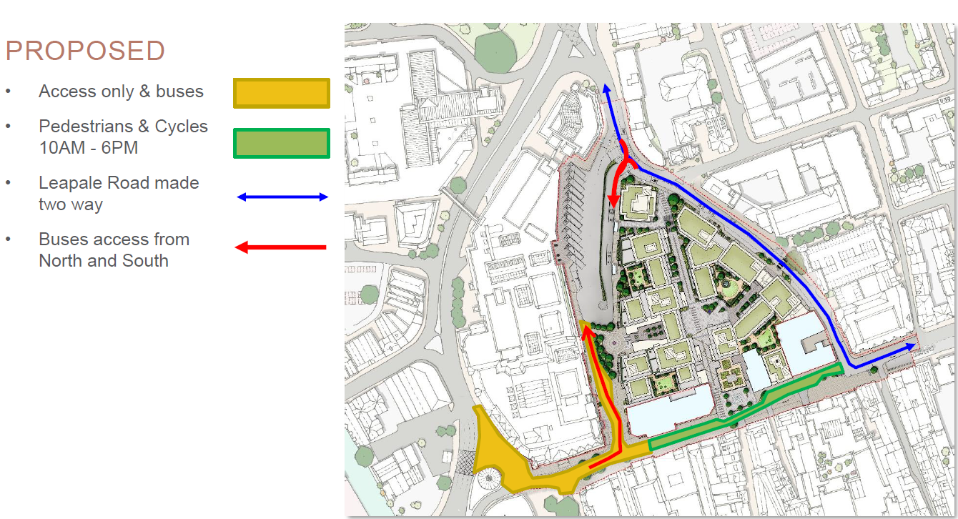
- 24/P/00563 & 24/P/00564: Surrey County Constabulary Police Headquarters Mount Browne, Sandy Lane, Guildford, GU3 1HG; The redevelopment will see a consolidation of services relocated to Mount Browne from elsewhere in Surrey, specifically the closure of the Police Station in Guilford Town Centre. A total of 267 operational vehicles (including response vehicles) would be based at the site, which is an additional 197 when compared to the existing fleet based at the site. The proposed redevelopment of Mount Browne would result in a net uplift of 147 two-way trips during the network AM peak hour and 181 during the PM peak hour.

Additional Air Quality Works Undertaken by Guildford Borough Council During 2024
Guildford Borough Council has not undertaken any additional works within reporting year of 2024.

QA/QC of Diffusion Tube Monitoring
The following details relate to the following aspects of non-automatic (i.e. passive) monitoring using diffusion tubes:
- Lambeth Scientific Services was the supplier used for diffusion tubes within 2024 and the method of preparation, was 50% TEA (triethanolamine) in acetone.
- Lambeth participated in NO2 Proficiency Testing Scheme (February 2023 – February 2025). AIR NO2 PT forms an integral part of the UK NO2 Network’s QA/QC and is a useful tool in assessing the analytical performance of those laboratories supplying diffusion tubes to Local Authorities for use in the context of Local Air Quality Management (LAQM). The following summary from the report shows the percentage of samples submitted for the study by Lambeth in 2024.

Lambeth has provided an explanation on the AIR-PT results 2024, which is as follows:
April to June 2024 - AR063 two results were satisfactory and two were questionable. The satisfactory range for two questionable samples were 0.86 to 1.16 and 0.87-1.17. The laboratory results of these two samples submitted were 1.20 and 1.23 which was slightly out of top range, hence was questionable and not ‘Unsatisfactory’. It’s difficult to find out exactly what is the root cause as two results of the same batch were satisfactory.
July to September 2024 (AR065) –two results were satisfactory and two were questionable, despite close monitoring of the procedure. The satisfactory range for two questionable sample was 0.70 to 0.94 and 0.71-0.95. The laboratory results of these two samples submitted were 1.00 and 1.01 which was slightly out of top range, hence was questionable and not ‘Unsatisfactory’. It’s difficult to find out exactly what is the root cause as two results of the same batch were satisfactory. It appears that guiding analyst to allow longer shaking after low extraction on two samples AR062, caused range to exceed slightly to round AR063 and AR065.
October to December 2024 (AR066) and Januray to February 2025 (AR068) all four results submitted were satisfactory, with results almost the same as the assigned value.
The bias factor for monthly Inter-Laboratory Scheme run by NPL for 2024 was 0.8 which was satisfactory.

- All the monitoring has been completed in adherence with the 2024 Diffusion Tube Monitoring Calendar. No divergences were necessary.
- The officers responsible for swapping diffusion tubes undergo training emphasizing the criticality of accuracy during tube replacements. They ensure that the correct batch number is matched (with the exposed tube typically belonging to the older batch), thereby maintaining consistency in sampling. Additionally, site labels are printed in alternating colours to facilitate easy differentiation between new and exposed tubes, enhancing accuracy.

Diffusion Tube Annualisation
All diffusion tube monitoring locations within Guildford Borough Council recorded data capture of 75% therefore it was not required to annualise any monitoring data. Only one of the triplicates collocated with the Godalming AMS (AMS-1) had data capture of less than 75%. Annual tube data is provided for Godalming AMS-3.

Table C.1 – Annualisation Summary (concentrations presented in µg/m³)

Site ID | Annualisation Factor Southampton Centre | Annualisation Factor London Hillingdon | Annualisation Factor Oxford Street Ebbes | Annualisation Factor London Bexley | Average Annualisation Factor | Raw Data Annual Mean | Annualised Annual Mean
Godalming AMS 1 | 1.0498 | 1.0024 | 1.0299 | 1.0433 | 1.0314 | - | -

Diffusion Tube Bias Adjustment Factors
The diffusion tube data presented within the 2025 ASR have been corrected for bias using an adjustment factor. Bias represents the overall tendency of the diffusion tubes to under or over-read relative to the reference chemiluminescence analyser. LAQM.TG22 provides guidance with regard to the application of a bias adjustment factor to correct diffusion tube monitoring. Triplicate co-location studies can be used to determine a local bias factor based on the comparison of diffusion tube results with data taken from NO_{x}/NO₂ continuous analysers. Alternatively, the national database of diffusion tube co-location surveys provides bias factors for the relevant laboratory and preparation method.
GBC undertook two collocation study:
- Triplicates collocated with Godalming Automated Monitoring Station (AMS), located on Ockford Road near the junction with the High Street
- Triplicates collocated with National Highway’s managed AMS on A3 – Guildford and Godalming Bypass (westbound)
The A3-AMS had poor overall data capture. The local bias factor from Godalming AMS alone was calculated as 0.83 based on 9 months diffusion tube data at the Godalming AMS. This is not too far from the national bias adjustment factor of 0.81. Guildford Borough Council have applied a local bias adjustment factor of 0.83 to the 2024 monitoring data. A summary of bias adjustment factors used by Guildford Borough Council over the past five years is presented in Table C.2.
Table C.2 – Bias Adjustment Factor

Monitoring Year | Local or National | If National, Version of National Spreadsheet | Adjustment Factor
2024 | Local | - | 0.83
2023 | National | V 03/24 | 0.85
2022 | National | V 06/23 | 0.95
2021 | National | V 03/22 | 0.97
2020 | National | V 06/21 | 0.95
Table C.3 – Local Bias Adjustment Calculation

 | Local Bias Adjustment Input 1 | Local Bias Adjustment Input 2 | Local Bias Adjustment Input 3 | Local Bias Adjustment Input 4 | Local Bias Adjustment Input 5
Periods used to calculate bias | 9
Bias Factor A | 0.83 (0.69 - 1.04)
Bias Factor B | 21% (-4% - 45%)
Diffusion Tube Mean (µg/m³) | 19.4
Mean CV (Precision) | 7.6%
Automatic Mean (µg/m³) | 16.1
Data Capture | 98%
Adjusted Tube Mean (µg/m³) | 16 (13 - 20)

Combined Local Bias Adjustment Factor | 0.83

Notes:
A combined local bias adjustment factor of 0.83 has been used to bias adjust the 2024 diffusion tube results.

NO₂ Fall-off with Distance from the Road
Wherever possible, monitoring locations are representative of exposure. However, where this is not possible, the NO₂ concentration at the nearest location relevant for exposure has been estimated using the Diffusion Tube Data Processing Tool/NO₂ fall-off with distance calculator available on the LAQM Support website. Where appropriate, non-automatic annual mean NO₂ concentrations corrected for distance are presented in Table B.1.

Table C.4 – Non-Automatic NO₂ Fall off With Distance Calculations (concentrations presented in µg/m³)

Site ID | Distance (m): Monitoring Site to Kerb | Distance (m): Receptor to Kerb | Monitored Concentration (Annualised and Bias Adjusted | Background Concentration | Concentration Predicted at Receptor | Comments
TC6 | 0.5 | 1.5 | 42.8 | 12.0 | 36.8 | Predicted concentration at Receptor within 10% the AQS objective.
TC11 | 5.3 | 3.3 | 18.4 | 12.0 | 19.3
TC15 | 1.9 | 1.5 | 23.1 | 12.0 | 23.7
A3-10 | 1.0 | 20.0 | 40.5 | 10 | 22.1
A3-18, A3-19, A3-20 | 2.5 | 20.5 | 44.7 | 10 | 26.6 | Warning: your receptor is more than 20m further from the kerb than your monitor - treat result with caution.

Appendix D: Map(s) of Monitoring Locations and AQMAs

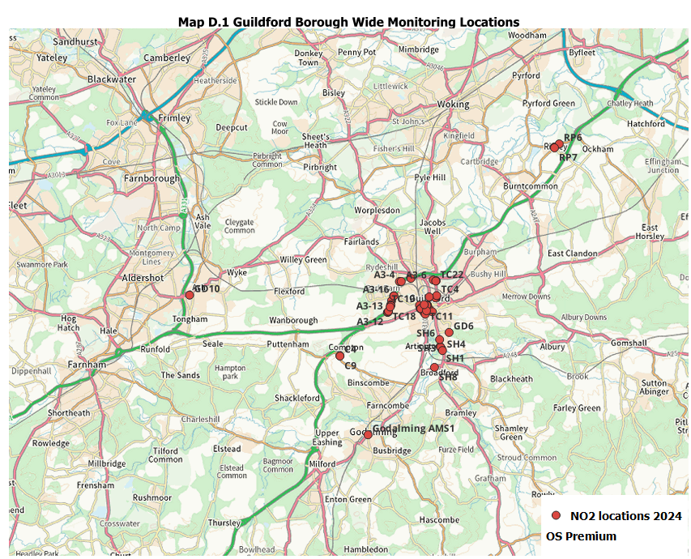
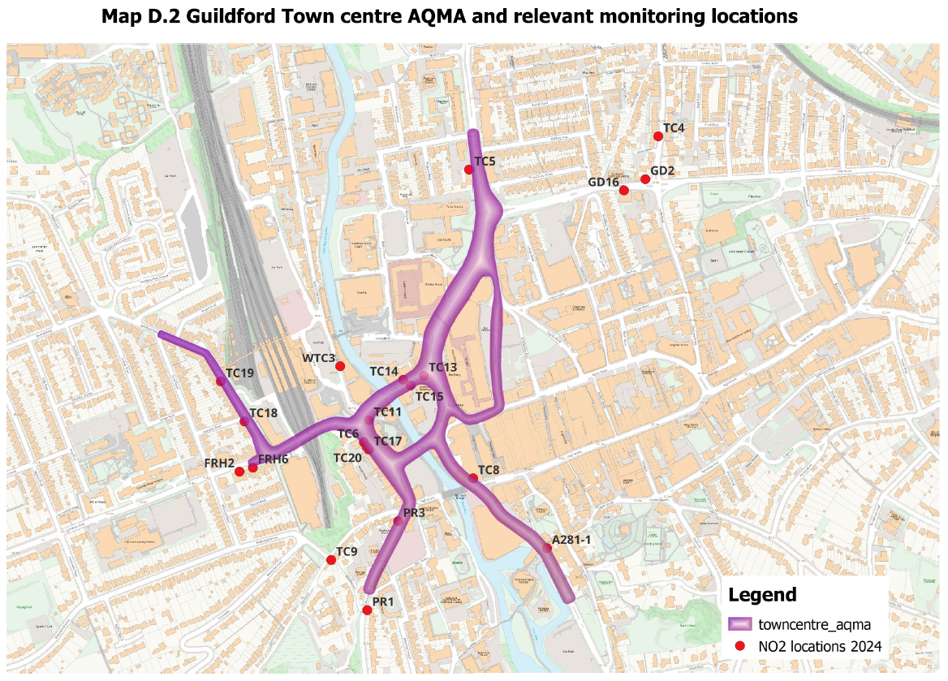
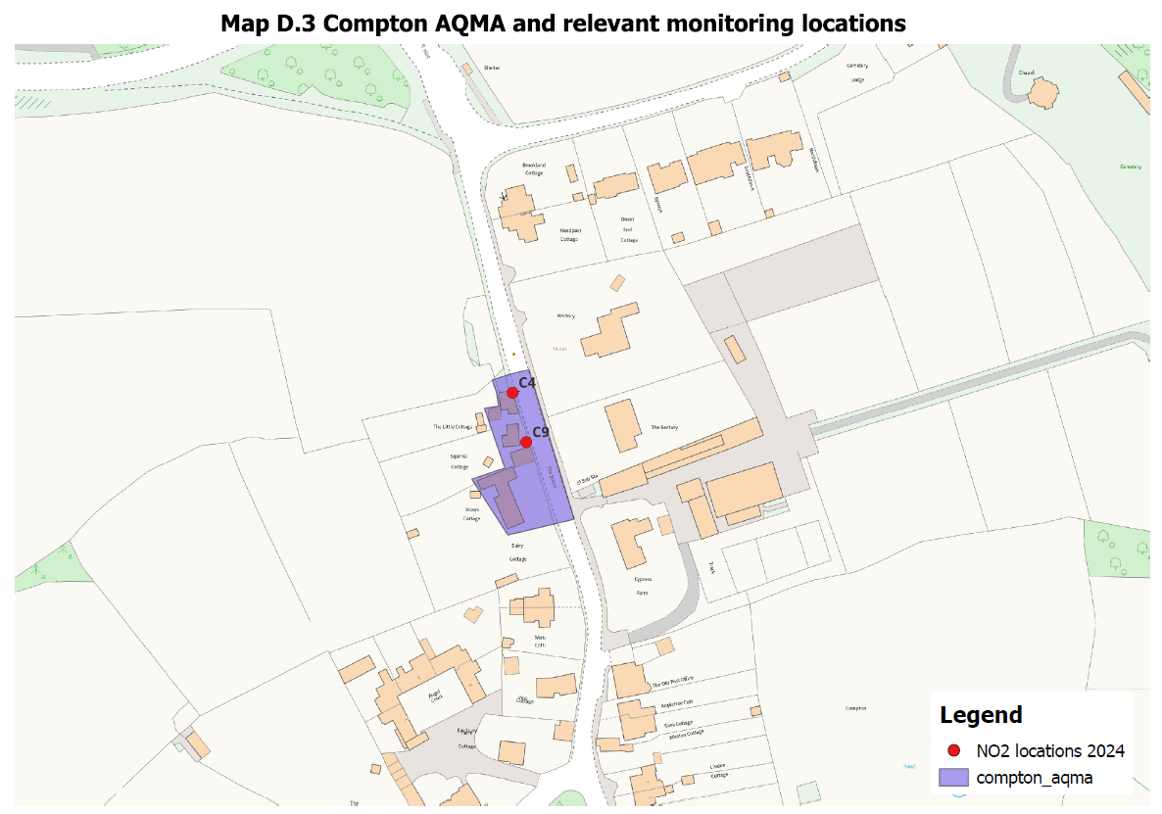
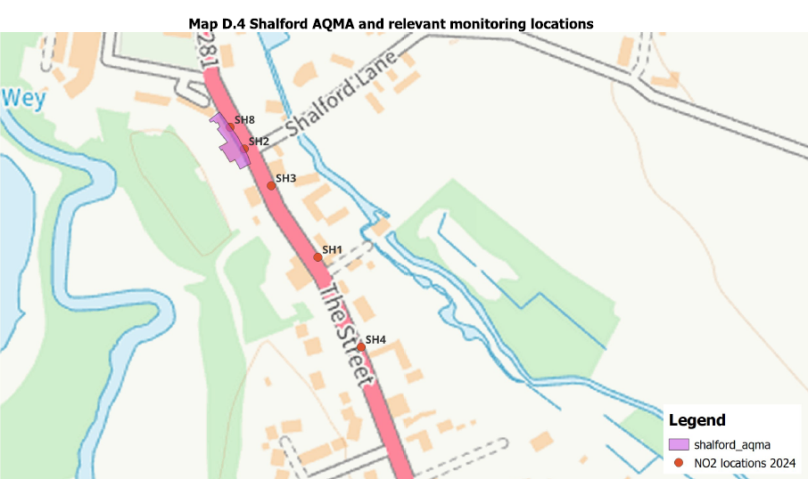
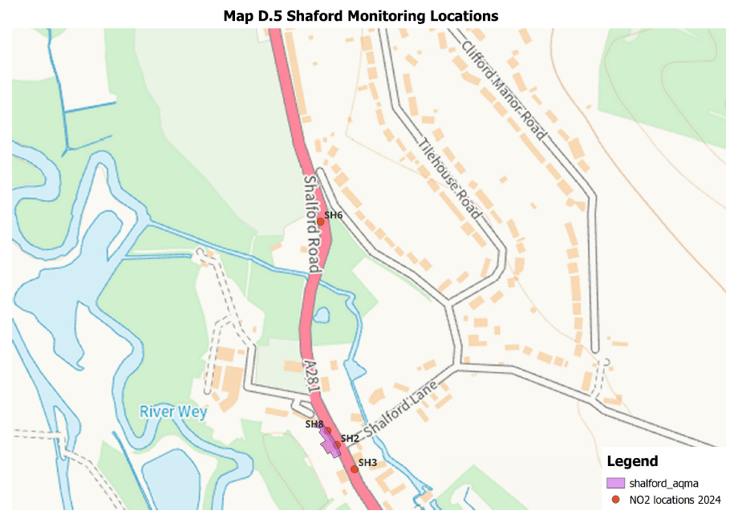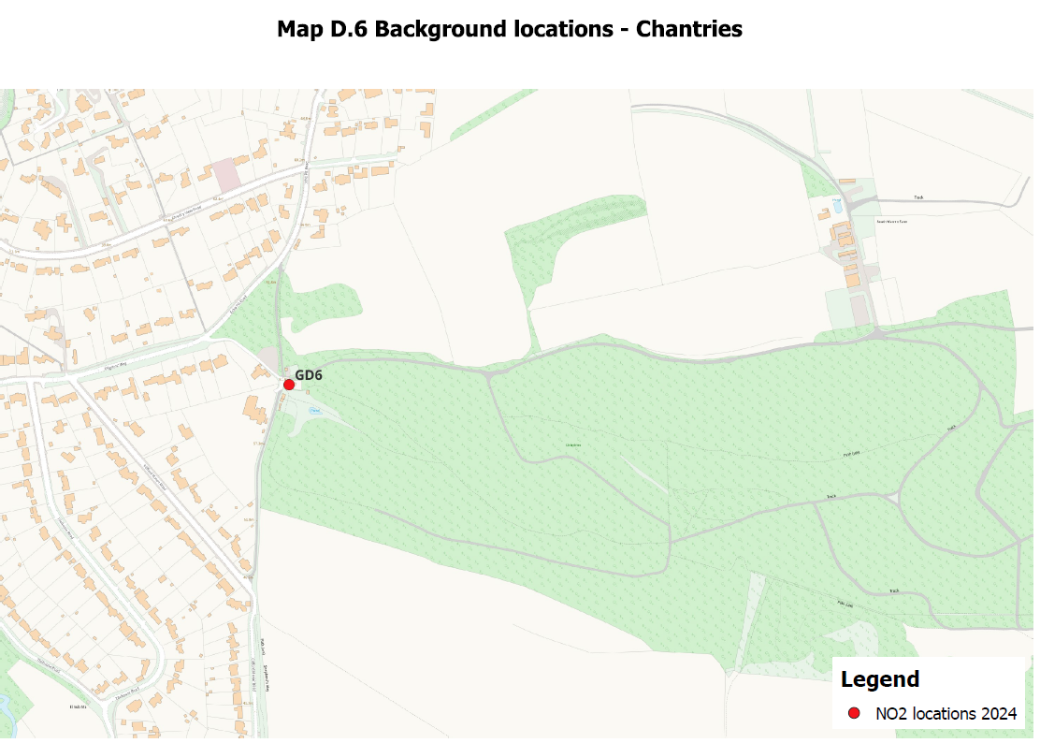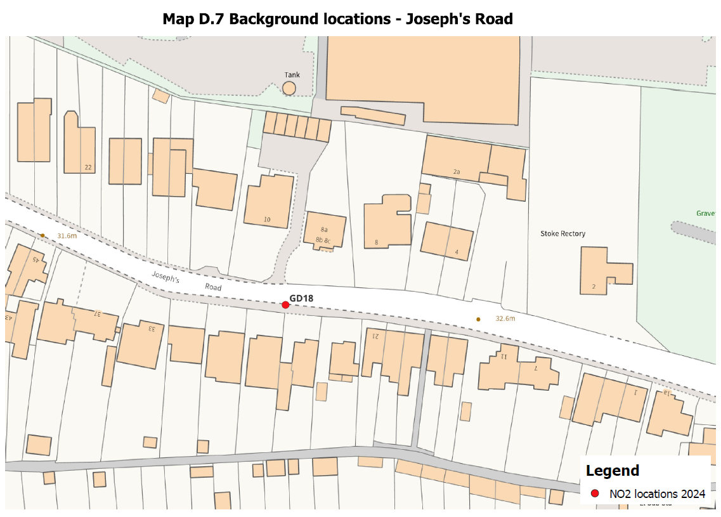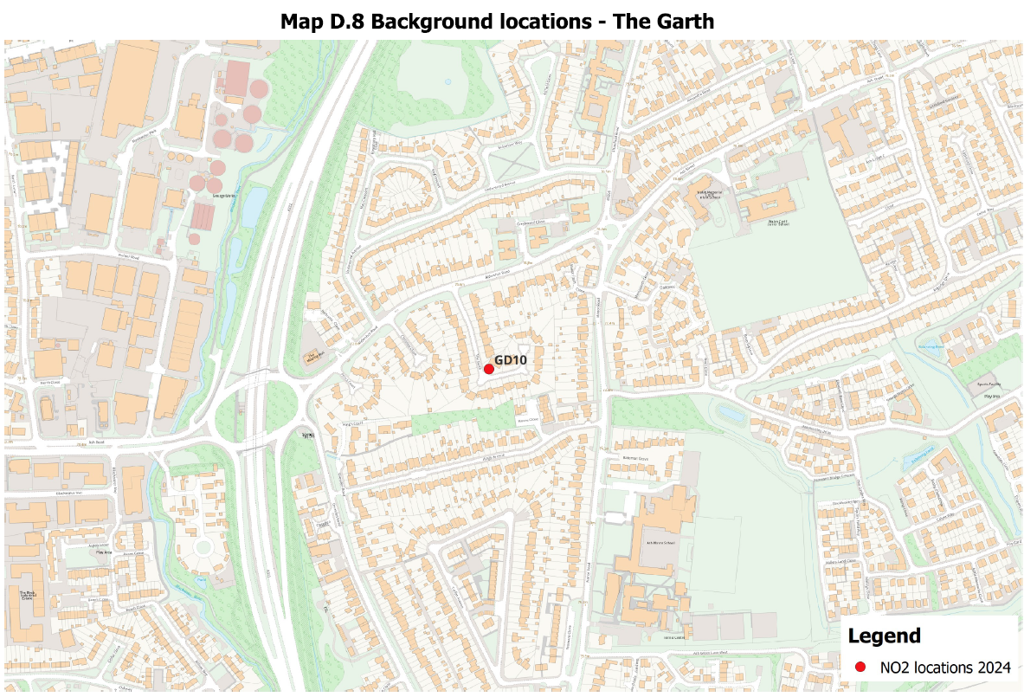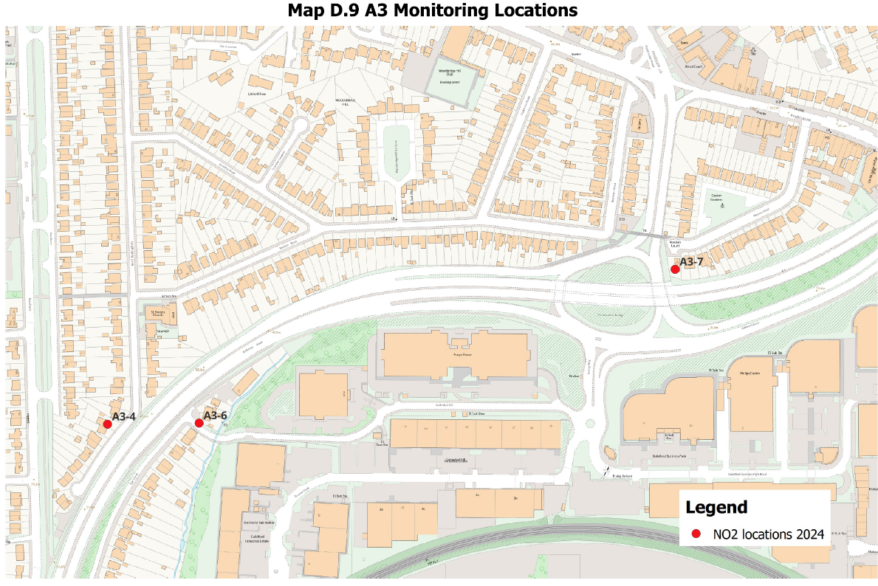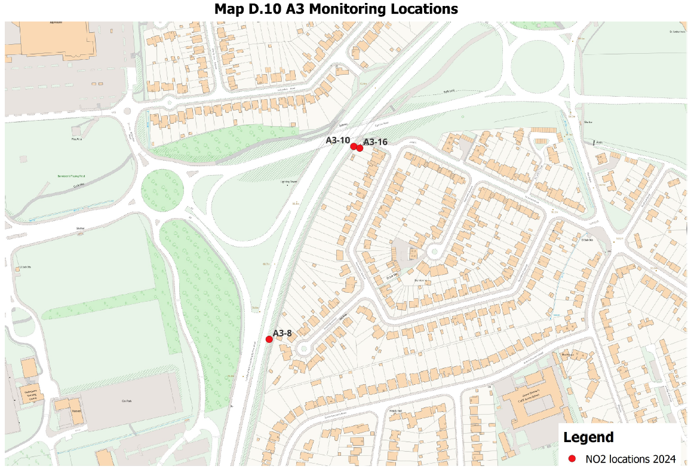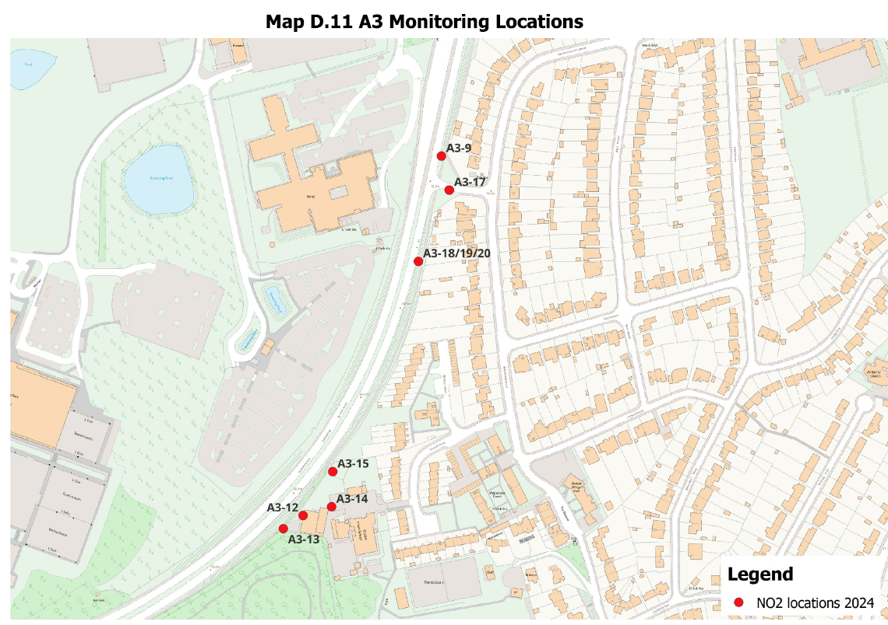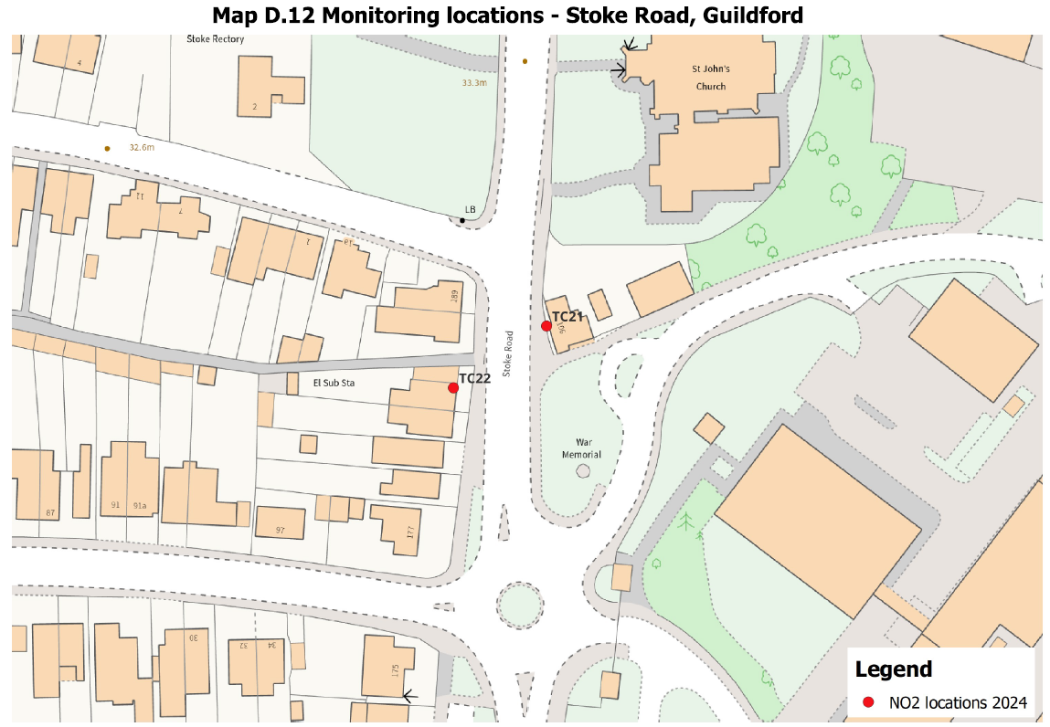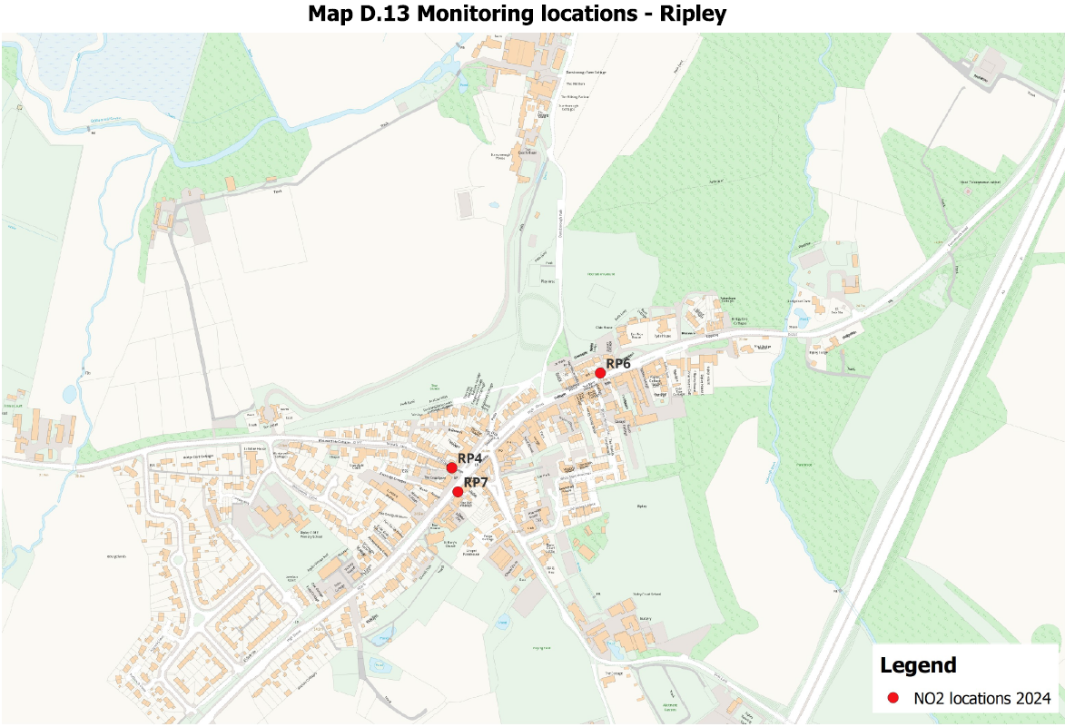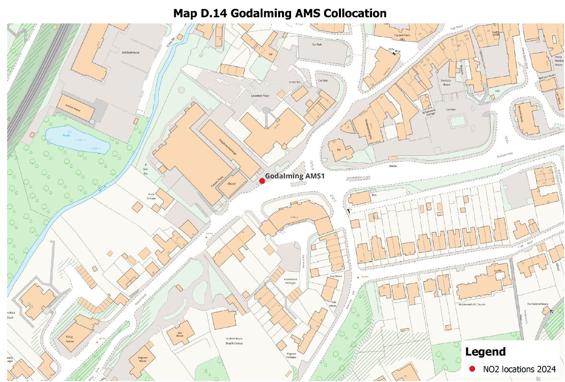

Appendix E: Summary of Air Quality Objectives in England
Table E.1 – Air Quality Objectives in England
Pollutant | Air Quality Objective: Concentration | Air Quality Objective: Measured as
Nitrogen Dioxide (NO₂) | 200µg/m³ not to be exceeded more than 18 times a year | 1-hour mean
Nitrogen Dioxide (NO₂) | 40µg/m³ | Annual mean
Particulate Matter (PM₁₀) | 50µg/m³, not to be exceeded more than 35 times a year | 24-hour mean
Particulate Matter (PM₁₀) | 40µg/m³ | Annual mean
Sulphur Dioxide (SO₂) | 350µg/m³, not to be exceeded more than 24 times a year | 1-hour mean
Sulphur Dioxide (SO₂) | 125µg/m³, not to be exceeded more than 3 times a year | 24-hour mean
Sulphur Dioxide (SO₂) | 266µg/m³, not to be exceeded more than 35 times a year | 15-minute mean

Glossary of Terms
Abbreviation | Description
AQAP | Air Quality Action Plan - A detailed description of measures, outcomes, achievement dates and implementation methods, showing how the local authority intends to achieve air quality limit values’
AQMA | Air Quality Management Area – An area where air pollutant concentrations exceed / are likely to exceed the relevant air quality objectives. AQMAs are declared for specific pollutants and objectives
ASR | Annual Status Report
Defra | Department for Environment, Food and Rural Affairs
DMRB | Design Manual for Roads and Bridges – Air quality screening tool produced by National Highways
LAQM | Local Air Quality Management
NO₂ | Nitrogen Dioxide
NO_{x} | Nitrogen Oxides
PM₁₀ | Airborne particulate matter with an aerodynamic diameter of 10µm or less
PM_{2.5} | Airborne particulate matter with an aerodynamic diameter of 2.5µm or less
QA/QC | Quality Assurance and Quality Control
SO₂ | Sulphur Dioxide

References
- Local Air Quality Management Technical Guidance LAQM.TG22. August 2022. Published by Defra in partnership with the Scottish Government, Welsh Assembly Government and Department of the Environment Northern Ireland.
- Local Air Quality Management Policy Guidance LAQM.PG22. August 2022. Published by Defra in partnership with the Scottish Government, Welsh Assembly Government and Department of the Environment Northern Ireland.
- Chemical hazards and poisons report: Issue 28. June 2022. Published by UK Health Security Agency
- Air Quality Strategy – Framework for Local Authority Delivery. August 2023. Published by Defra.

https://www.healthysurrey.org.uk/about/strategy/surrey-health-and-well-being-strategy-update-2022#section-3
Infrastructure Delivery Plan - Guildford Borough Council
A3 Guildford air quality - National Highways
Infrastructure Delivery Plan - Guildford Borough Council
Air pollutants | National Atmospheric Emissions Inventory
https://surreycc.maps.arcgis.com/apps/webappviewer/index.html?id=43910ffb100248ed972115b7a9b49d20 https://www.guildford.gov.uk/media/32331/Detailed-air-quality-report/pdf/FM1183_Surrey_CERC_Guildford_19Nov19.pdf?m=1594033112567
Nitrogen dioxide (NO2) - GOV.UK
https://democracy.guildford.gov.uk/ieDecisionDetails.aspx?ID=4505
https://www.guildford.gov.uk/article/18932/Report-an-issue-with-air-quality
https://www.hetas.co.uk/ready-to-burn-a-look-at-the-regulations-in-more-detail/
Defra. Air Quality Strategy – Framework for Local Authority Delivery, August 2023
UK Ambient Air Quality Interactive Map (defra.gov.uk)
https://www.gov.uk/government/publications/the-air-quality-strategy-for-england/air-quality-strategy-framework-for-local-authority-delivery
- Guildford Borough Council supports Clean Air Night - Guildford Borough Council
https://laqm.defra.gov.uk/wp-content/uploads/2025/04/AIR-PT-Rounds-55-to-68-January-2023-to-February-2025.pdf Summary of Laboratory Performance in AIR NO2 Proficiency Testing Scheme (February 2023 – February 2025).
The units are in microgrammes of pollutant per cubic metre of air (µg/m³).

