

Guildford Borough Council
Air Quality Strategy 2025 – 2030

March 2025

Executive Summary

This strategy identifies the key air quality issues within our Borough and our approach to maintaining and improving air quality. To achieve this, the Action Plan sets out the actions we will take between 2025 and 2030 to help reduce concentrations of air pollutants and exposure to air pollution.

Foreword

Clean air is essential to the quality of life and good health of everyone who lives, works in or visits our Borough and we are committed to protecting and improving air quality for the benefit of current and future generations.

Minimising air pollution levels will bring lasting benefits, with positive effects on public health, economic development, and population wellbeing.

Only by working collaboratively both across the Council, with external partners and our community can we bring about meaningful improvements in air quality. Partnership working is therefore very much at the heart of this strategy.

We outline how we plan to tackle air quality issues within our control, however, we recognise that there are a large number of policy areas outside of our influence, such as vehicle emissions standards agreed in Europe. We will therefore continue to work with regional and central government on policies and issues beyond our direct influence.

This air quality strategy will contribute to Guildford becoming a healthier, more sustainable, prosperous and desirable place to live, work and visit.

Table of Contents

Executive Summary 2
Foreword 2
1.0 Introduction 4
2.0 The Borough 5
3.0 Policy Context 9
3.1 DEFRA Air quality Strategy: Framework for local authority delivery, 25 August 2023 (Policy paper) 9
3.2 The Council’s Strategic Priorities 10
3.2.1 Local Plan 10
3.3 Health and Wellbeing 11
3.4 Air Quality Monitoring and Assessments 12
4.0 Our Approach and Priorities 12
4.1 Our Approach 12
4.2 Our Key Priorities 13
4.3 Collaborating with Partners 15
5.0 Monitoring and review 16
6.0 Acknowledgements 17
7.0 Glossary of Terms 18
Appendix 1: Air Quality Action Plan Measures 19

1.0 Introduction

Clean air is essential for public health, the environment, and overall well-being.

The health and environmental impacts of poor air quality are well documented, with air pollution affecting mortality from cardiovascular and respiratory conditions including lung cancer.

It particularly affects the most vulnerable in society, children and older people, and those with heart and lung conditions, and there is also often a strong correlation with equalities issues, because areas with poor air quality are also often the less affluent areas.

The Committee on the Medical Effects of Air Pollution have shown that air pollution was estimated to cause 29,000-43,000 deaths a year in the UK. Between 2017 and 2025, the total cost to the NHS and social care of air pollution for where there is more robust evidence for an association, is estimated to be £1.60 billion for PM2.5
and NO2 combined increasing to £5.56 billion if we include other diseases for which there is currently less robust evidence for an association.
The council has statutory responsibilities as set out in Part IV of the Environment Act (1995), as amended by the Environment Act (2021).
The legislation requires that all local authorities regularly review and assess air quality within their areas and if the UK’s air quality standards are exceeding in a particular area, an Air Quality Management Area (AQMA) must be declared and an Air Quality Action Plan (AQAP) drafted with the aim of improving the air quality within the AQMA. This process is called Local Air Quality Management (LAQM). Under the process, the Council also has statutory duty to submit an Annual Status Report (ASR) to Defra, providing yearly updates on monitoring data, initiatives to improve air quality, newly identified issues, and progress made.
The Air Quality Standards Regulations 2010 sets limits, target and long-term objective values for key pollutants in outdoor air including nitrogen oxides, particulate matters etc. In addition, the Environment Act 2021 established new framework for environmental targets for England. The Environmental Targets (fine particulate matter)(England) Regulations 2023 introduced two new targets for fine particulate matter (PM2.5), both to be met by 2040:
- Annual mean concentrations of PM_{2.5} to be 10 µg m-3 or lower
- Population exposure to PM_{2.5} to be reduced by 35% compared to 2018 levels
Both of these target values are legally binding and therefore this air quality strategy aims at identifying key priorities specific to the achievement of PM_{2.5} targets.

This Air Quality Strategy outlines our commitment to improving air quality, reducing emissions, and mitigating the impacts of pollution. It sets out objectives, key actions, and monitoring mechanisms to ensure a sustainable and healthy environment.

2.0 The Borough
Guildford is situated in a valley with the River Wey at the core of the area. Main roads run parallel to the Wey. The areas between the roads and the river are taken up by development, often large individual commercial, civic or entertainment buildings. Historically the town was originally settled by the Saxons, developing as a commercial and defensive centre owing to its position along the route to London, where the great east/west road along the chalk ridge to London dropped sharply down hill and crossed the River Wey.
Several major routes converge into Guildford gyratory which serves as a one way road system through Guildford town centre:
- A3100 (Godalming – Guildford),
- A322 (Bagshot – Guildford), which links M3 to Guildford from northwest.
- A31, Farnham to Guildford
- A281, Horsham to Guildford, passing through Shalford

In addition, the A3 trunk road and the M25 motorway, which form part of National Highway’s Strategic Road Network (SRN), serves the borough. A high proportion of traffic in Guildford comprises of through-traffic on these strategic roads. The A3 Guildford origin destination study concluded that 60% of trips on A3 are external trips with neither origin nor destination within Guildford Borough.

Guildford has a population around 150,000, approximately half of which live within the urban area.
The borough benefits from twelve rail stations, including Guildford rail station, the busiest in the county, which provides access to, and interchange between, three lines. These rail lines fan out to serve our other stations and destinations beyond
including London Waterloo, Woking, Reading, Redhill and Gatwick Airport.

According to Guildford’s Economic Development Strategy, Guildford is home to over 7000 businesses, 80,000 employees, and world leading innovators in high-value sectors such as space and science technology (eg University of Surrey, Surrey Research Park). The local attractions and setting within the Surrey Hills AONB attract over 3 million visitors to the borough every year. It also acknowledges that Guildford is the 7th most congested borough in the entire country, suffering from significant traffic and congestion and public transport connectivity could be stronger.
The important employment hubs include Cathedral Hill Estate, University of Surrey, Surrey Research Park, Royal Surrey Hospital and Guildford Towncentre, all of these serve as key travel destinations.

The single major source of air pollution in Guildford is from road traffic. The figures below show contour plots of annual mean concentrations for NO₂, PM₁₀ and PM_{2.5} for the Year 2017. Apart from roadside concentrations, the levels throughout the borough are generally good.

A source apportionment study for the same year showed that roadside emissions is the major contributor of NO₂ of which diesel cars and light goods vehicles (LGVs) are the major source groups.
For particulate matters (PM₁₀ and PM_{2.5}), 75% of the contributions is from background sources (regional and continental)
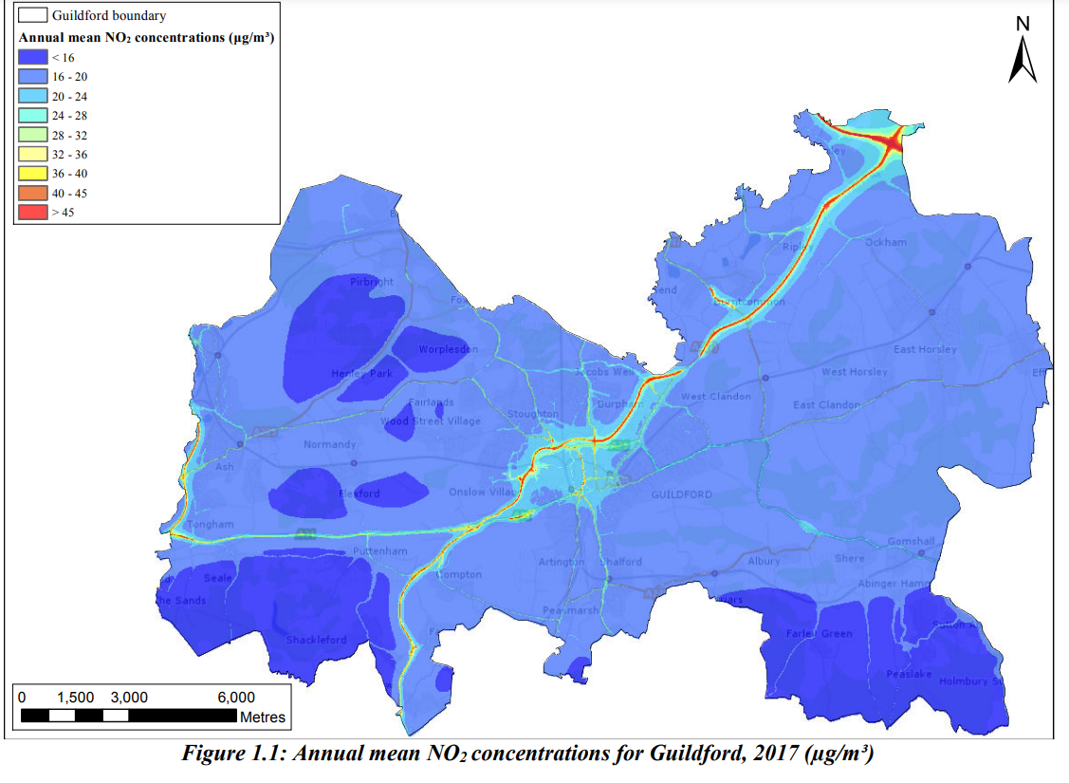
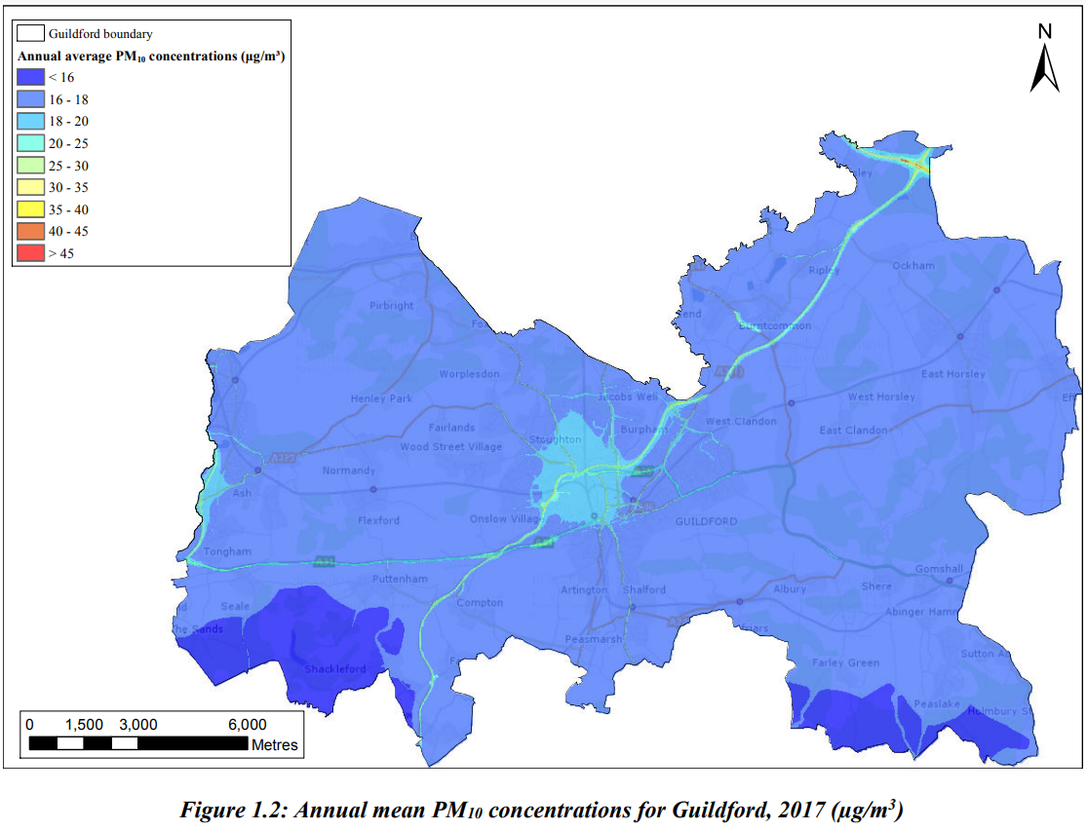
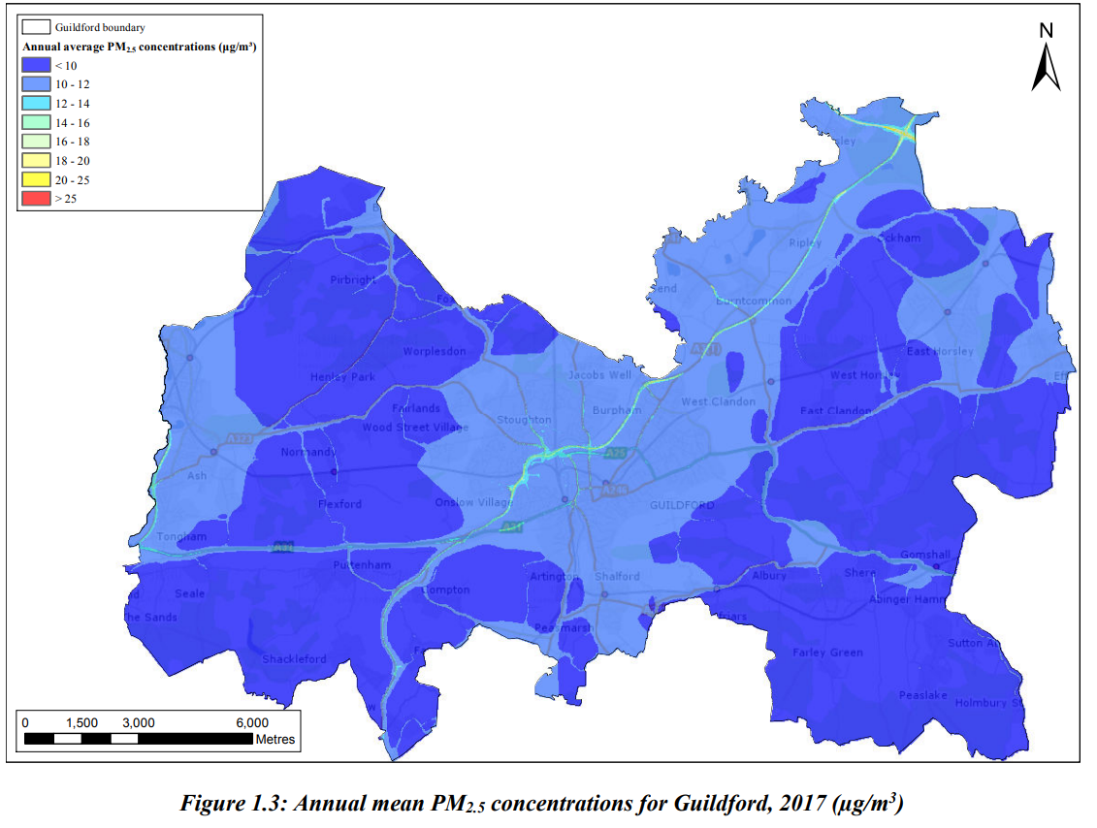

Guildford Borough Council has Smoke Control Areas covering approximately 12 square kilometres of the urban area were established in the 1960/70’s. These areas are still operational and subject to statutory controls. Recent guidance by Defra has encouraged local authorities to consider a revision to either introduce new areas or revoke as appropriate.
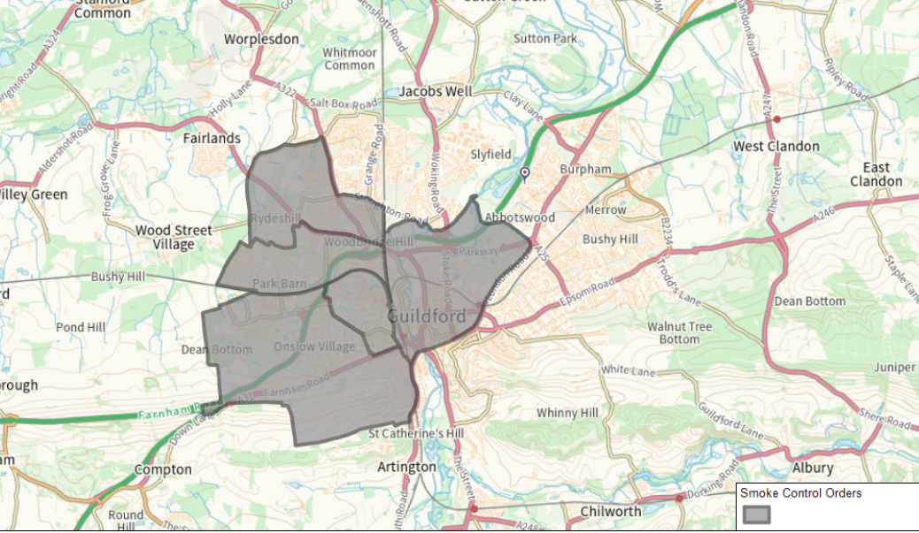

3.0 Policy Context

3.1 DEFRA Air quality Strategy: Framework for local authority delivery, 25 August 2023 (Policy paper)

This document sets out powers, responsibilities and further actions expected from the local authorities to achieve air quality improvements to support national long term air quality goals and compliance with new PM2.5 targets.

Under the National Emission Ceiling Regulations 2018, government has legally binding emission reduction commitments to reduce the amount of five key pollutants (PM_{2.5}; oxides of nitrogen, NO_{x}; sulphur dioxide, SO₂; ammonia, NH₃ and non-methane volatile organic compounds, VOCs)

The priorities of this framework are:
- Planning reforms helping to deliver on air quality.
- Building capacity in local councils through training, guidance and knowledge sharing.
- Reducing emissions from industrial sources through improved enforcement of environmental permits.
- Reducing pollution from domestic burning through smoke control areas and cleaner fuels.
- Raising awareness within local communities of air quality impacts and how to reduce them.
- Boosting active travel and public transport to improve air quality.

3.2 The Council’s Strategic Priorities

3.2.1 Local Plan

Air quality is a consideration in a number of our planning policies and those of our partners. Key policies are:

Guildford Borough Council
- Guildford Borough Transport Strategy, June 2017
- Town Centre Regeneration Strategy, January 2017
- Air Quality Review of Guildford Borough Proposed Submission Local Plan: Strategy and Sites, June 2017
- Guildford Development Strategy
- Guildford Borough Climate Change Action Plan
Guildford Borough Council has an ambitious plan of becoming ‘Net zero’ within scope 1 and 2, across all council services by 2030. Net Zero means no longer adding to the total amount of greenhouse gases in the atmosphere.

Surrey County Council
- Surrey Transport Plan, Strategy Summary, January 2017
7. Surrey Transport Plan – Air Quality Strategy, January 2016

3.3 Health and Wellbeing

Air pollution is an important determinant of health. Poor air quality can cause both short and long-term effects on health. Each year in the UK, around 40,000 deaths are attributable to exposure to outdoor air pollution which plays a role in many of the major health challenges of our day. It has been linked to cancer, asthma, stroke and heart disease, diabetes, obesity, and changes linked to dementia. Air Quality is a priority within Surrey’s Joint Strategic and Need assessment (JSNA). The following figure shows the mortality burden attributable to PM2.5 only:

3.4 Air Quality Monitoring and Assessments

We carry out annual air quality reviews and assessments, which are reported annually in our Annual Status Reports. The ASRs include updates on air quality monitoring and trends, along with progress in air quality initiatives and key priorities for the future. Since the drafting of the last Air Quality Strategy, we have declared three AQMAs. The AQAP for Compton and Shalford AQMAs have been published and adopted. The Towncentre AQMA, which is impacted by 4 busy A-roads entering the Guildford Towncentre will require a feasibility study for implementation of any air quality improvement measure and is currently in the process.

4.0 Our Approach and Priorities

4.1 Our Approach

We recognise that addressing air quality requires a cross service and organisational approach.

A key aim is therefore to establish and maintain good working relationships with key stakeholders within our Borough to achieve our air quality objectives. In particular to:

- Protect the health and well-being of the population.

- Complement and co-ordinate the actions required in Air Quality Management Areas (which may be declared) to improve air quality.

- Provide a framework for action to improve air quality in Guildford.

- Ensure that, wherever possible, our actions do not have an adverse effect on air quality or climate change.

- Complement other countywide and local strategies adopted and supported by local authorities.

- Promote action to minimise the deterioration of air quality.

- Work with the community to help facilitate a modal shift in transport and travel patterns.

4.2 Our Key Priorities

- A clear approach to air quality
- This Air Quality Strategy and Action Plan set out our clear approach to air quality and form the basis of future actions and initiatives.

- Monitoring and reporting of air pollution levels
- Maintain and where necessary expand our nitrogen dioxide passive diffusion tube monitoring network.
- Explore the use of new technology air quality monitoring equipment in collaboration with the University of Surrey.
- Update the Surrey wide air quality modelling study to model changes in nitrogen oxides and particulate matters and thus update public health risks from these pollutants.

- Reducing vehicle emissions
- Reduce emissions from the Council’s vehicle fleet and encourage businesses and other organisations to do the same.
- Work with transport providers including buses and taxis for vehicle improvement and emission reduction
- Work in partnership to facilitate the provision of efficient electric vehicle charging for a wider part of the community and business.
- Promoting anti-idling at junctions, traffic lights, schools and level crossings.
- Promoting travel alternatives such as walking and cycling.
- Facilitating local car clubs.

- Reducing emissions from non-transport sources
- Emissions from Non-road mobile machinery (NRMM) – These are the mobile machineries not intended for transport. Planning regime is used to promote use of low emission NRMM on construction sites.
- Reduction of emissions from Commercial Heat and Power including back up diesel generators by promoting low emission generators
- Environmental Permitting Regulations: Guildford Borough Council has 19 permitted processes in the borough including petrol stations, cement batching facilities, dry cleaners, vehicle respraying facilities, small waste incinerator plants and a crematorium. Environmental Permitting Regulations are in place to control emission to air from these processes.
- Smoke control areas (SCA): Guildford has designated smoke control areas which covers parts of central and west of Guildford. These were established in the late 1960s. With the development extending extensively beyond the smoke control areas and increasing popularity of the wood burners, there is a need to review the current boundary of the SCA. In a SCA, only fuels that are on the list of authorised fuels or ‘smokeless’ fuels, can be burnt, unless an ‘exempt appliance’ is used.

- Planning Framework
Guildford Borough Council Local Plan: Development Management Policies were adopted on 22 March 2023. Policy P9 relates to Air Quality and Air Quality Management Areas, outlining nine actions aimed at mitigating air quality impacts or promoting positive improvements through development.

- Public Information and Raising Awareness

Guildford Borough Council takes a wide range of actions to increase public awareness about air pollution and to promote behavioural change.
The council has used a range of means to inform businesses, employees and residents about air pollution. This includes updating our websites regularly, social media campaigns, public events such as Cleaner Air Day Guildford and Clean Air Night.
A key priority, in collaboration with the Communications Team, is to establish an effective Communication Plan for Air Quality.

4.3 Collaborating with Partners

4.3.1 Designated Air Quality Partners

The Environment Act 2021 introduced a new concept of ‘designated air quality partners’ into the LAQM framework. Air Quality Partners (AQPs) are required to assist local authorities with reasonable requests, such as information within the AQP’s control and knowledge (for example by providing information on a source of air pollution), and contribute to action plans being developed by local authorities. National Highways was included as a relevant public authority (RPA) in the legislation. As a designated relevant public authority NH would be required to collaborate with LAs to take action to improve local air quality where appropriate.

The designated AQPs relevant to this strategy are Surrey County Council (SCC), National Highways, Public Health, the Environment Agency and neighbouring local authorities.

4.3.2 Other Partners

In addition to working with the designated partners, we also work closely with

- Surrey Air Alliance
- Residents, Representatives of the residents, Ward Councillors, schools and nurseries, local businesses and their employees
- NHS Surrey Heartlands
- University of Surrey
- Any other partners as they arise

Success stories of partnership working:

Clean Air Night Campaign: Guildford Borough Council as part of Surrey Air Alliance is committed to support the Clean Air Night campaign in order to raise awareness of the environmental and risks associated with wood burning.

Cleaner Air Day in Guildford

With the help of partners Guildford hosted a successful, informative and educational family fun day. Partners included Global Centre for Clean Air Research (GCARE) Team at University of Surrey, local businesses and developers, Surrey County Council, Zero Carbon Guildford
Residents were encouraged to forgo their cars for the day and experience the benefits of cleaner air. Businesses and partners join to showcase their initiatives, share insights on emission reduction, and offer guidance on minimizing exposure to poor air quality.

Active Travel Program for businesses near A3 in Guildford

The scheme was identified as a measure to bring long term air quality improvement on A3 Guildford. The scheme is fully funded by the National Highways to promote sustainable transport alternatives among local businesses. It is being implemented in partnership with Surrey County Council and Guildford Borough Council.

5.0 Monitoring and review

We will review this Strategy at least every five years.

Progress on delivering the Action Plan will be reported annually to the Overview and Scrutiny Committee and within our published Annual Strategic Review (ASR).

6.0 Acknowledgements

The contributions and commitments from the following individuals and services have been instrumental in the development of this strategy and action plan delivery:

- Housing, Communities and Environment
- Financial Services
- Planning Services
- Major Projects
- Economic Development
- Policy and Development
- Community Services
- Commercial Services
- Legal Services
- Human Resources
- Revenue and Payments Services
- Communications and Customer Services

7.0 Glossary of Terms

Abbreviation | Description
AQSAP | Air Quality Strategy and Action Plan - A detailed description of measures, outcomes, achievement dates and implementation methods, showing how the local authority intends to achieve air quality limit values’
AQMA | Air Quality Management Area – An area where air pollutant concentrations exceed / are likely to exceed the relevant air quality objectives. AQMAs are declared for specific pollutants and objectives
AQS | Air Quality Strategy
ASR | Air quality Annual Status Report
Defra | Department for Environment, Food and Rural Affairs
EU | European Union
GBC | Guildford Borough Council
LAQM | Local Air Quality Management
NO₂ | Nitrogen Dioxide
NO_{x} | Nitrogen Oxides
PM₁₀ | Airborne particulate matter with an aerodynamic diameter of 10µm (micrometres or microns) or less
PM_{2.5} | Airborne particulate matter with an aerodynamic diameter of 2.5µm or less
SCC | Surrey County Council

Appendix 1: Air Quality Action Plan Measures

Measure No. | Action | Lead Department | timeline | Outcome | Costs
1 | Air Quality Monitoring and reporting | Environmental Health | 2025-2030 | An effective monitoring network providing accurate, trusted, and accessible data.  Monitoring data to demonstrate  compliance with statutory limits and  assessing the effectiveness of action plan implementation. | <10,000
2 | AQMA Action Plan, modelling studies, feasibility studies etc | Environmental Health | 2025-2030 | Final AQAP for Town Centre AQMA | £40,000-80,000
3 | Adopt GBC Policy lease car and fleet vehicles procurement | Environmental Services | 2025-2030 | GBC adopt Policy on procuring lease cars and fleet vehicles | Within current resources
4 | Draft and adopt a corporate policy on Motor Vehicle anti-idling | Regulatory Services | 2025 | Reduction in the number of idling vehicles on Council’s premises | Within current resources
5 | Improve sustainable transport opportunities in line with the Guildford Borough Transport Strategy | Planning and Regeneration | 2025-2030 | Increased usage of sustainable or active transport. | Existing and future bids
6 | Facilitate and promote home, mobile, remote and flexible working within the Council | HR & IT | ongoing | Adopt and implement ‘Home, Mobile, Remote and Flexible Working Policy’ 2019  Reduction in mileage claims, increase public transport claims | Implemented/ ongoing cost of maintaining hardware and software
7 | Promote alternative travel to work at the Council | HR & Facilities management | 2025-2030 | Adopt and implement a ‘Staff Travel Plan’ | Using current resources, £4000 for Easit Guildford subscription
8 | Air quality is consideration at pre- application and application stage to allow effective use of planning conditions. | Planning Services and Environmental Health | 2025-2030 | Air quality assessments for large and medium scale developments; good design principles applied in all developments | Within current resource
9 | Working with Public Health and other partners | SCC, Regulatory Services | 2025-2030 | Publishing of JSNA chapter on air quality and public health | Within current resource
10 | Air quality modelling of Surrey for PM10, PM2.5, NO2 | All Surrey Local Authorities | 2026 | Update the modelling study which was completed in 2019 for 2017 base year. | £4000-£6000 per Local Authority (already in budget)
11 | Working collaboratively with Surrey Air Alliance | All Surrey Local Authorities | 2025-2030 | Work on school air quality initiatives; implementation of successful DEFRA bid for EV taxi project; completion of air quality chapter for JSNA (Joint Strategic Need Assessment); clean air night and other public events. | Within current resource
12 | Working with National Highways | National Highways/Regulatory Services | 2025-2030 | Projects in which NH will be a Designated Air Quality Partner | Funded by National Highways
13 | Discourage solid fuel burning and bonfires | Environmental Health; Communications and Web Team |  | reduction in the amount of  smoke, PM10 and PM2.5 emitted | <£5,000
14 | Work with Surrey Trading Standards to regulate the sale of solid fuel | Environmental Health and Trading Standards | 2025-2030 | reduction in the amount of  smoke, PM10 and PM2.5 emitted | Within current resources
15 | Review the boundaries of our smoke control areas; enforcement of non-compliance | Environmental Health | 2025-2030 | A reduction in the amount of smoke; reduction in complaints of smoke from chimney; reduction in particulate emission. | <£5000; within resources
16 | Promoting increase in numbers of low/zero emission vehicles, through Planning, Taxi licensing Policy and other schemes | Environmental Health | 2025-2030 | Increase in number of electric vehicles | Within current resources
17 | Minimise emissions from construction sites via Construction Environmental Management Plan; promote use of low emission NRMM | Planning/Environmental Health | 2025-2030 | Reduced emission from construction related activities | Within current resources
18 | Education in communities to change behaviours; Work with Corporate Events, Communications and Web Team; Work with Surrey Air Alliance on behaviour change campaigns | Community Development and Environmental Health | Ongoing | Improved communications on social media; successful campaigns and events with increased participation of public and partners | Within current resource
19 | Work with businesses to raise awareness of air pollution and encourage them to develop sustainable travel plan/promote alternative transport | Environmental Health; Planning Services; SCC; NH | 2025-2030 | Adoption of sustainable travel plans by businesses in Guildford | Fundings from various sources; Currently A3 Easit is funded by National Highways

https://assets.publishing.service.gov.uk/government/uploads/system/uploads/attachment_data/file/734799/COMEAP_NO2_Report.pdf
https://assets.publishing.service.gov.uk/media/5afef7a0e5274a4be3231bd0/Estimation_of_costs_to_the_NHS_and_social_care_due_to_the_health_impacts_of_air_pollution_-_summary_report.pdf
https://uk-air.defra.gov.uk/assets/documents/Air_Quality_Objectives_Update_20230403.pdf
https://www.legislation.gov.uk/uksi/2023/96/contents/made
file:///C:/Users/Anjana.Papnai/Downloads/Townscape_Assessment_Master_copy(1).pdf
A3 Guildford Report, Guildford Borough Council, Project Number: 606439884, March 2021, https://www.guildford.gov.uk/article/26606/Working-to-improve-air-quality-on-the-A3-in-Guildford
https://www.guildford.gov.uk/media/35494/Guildford-Economic-Development-Strategy-Accessible/pdf/Guildford_Economic_Development_Strategy_Accessible.pdf?m=1684508421333
https://www.guildford.gov.uk/media/32331/Detailed-air-quality-report/pdf/FM1183_Surrey_CERC_Guildford_19Nov19.pdf?m=1594033112567
https://www.gov.uk/government/publications/the-air-quality-strategy-for-england/air-quality-strategy-framework-for-local-authority-delivery
http://www.guildford.gov.uk/newlocalplan/CHttpHandler.askx?id=24636&p=0
https://www.guildford.gov.uk/article/20314/Town-Centre-Regeneration-Strategy
http://www.guildford.gov.uk/newlocalplan/protectinganddesign
https://www.surreycc.gov.uk/_data/assets/pdf_file/0003/109758/STP-Strategy-Summary-Jan17.pdf
https://www.surreycc.gov.uk/_data/assets/pdf_file/0020/90254/Air-Quality-Strat-15th-Update-rebranded.pdf
https://www.guildford.gov.uk/article/19807/Find-out-how-we-monitor-air-quality-and-pollution
https://www.guildford.gov.uk/article/21335/Find-out-about-Guildford-air-quality-management-areas
https://www.guildford.gov.uk/article/25093/What-are-smoke-control-areas
https://www.gov.uk/smoke-control-area-rules
Guildford_LPDMP.pdf
https://www.gov.uk/government/consultations/designation-of-national-highways-as-a-relevant-public-authority/outcome/summary-of-responses-and-government-response
https://www.easit.org.uk/network/easitGUILDFORD%20A3-29
Guildford Borough Transport Strategy 2017

