PREMISES LICENCE APPLICATION FOR SHAWFIELD BREWING

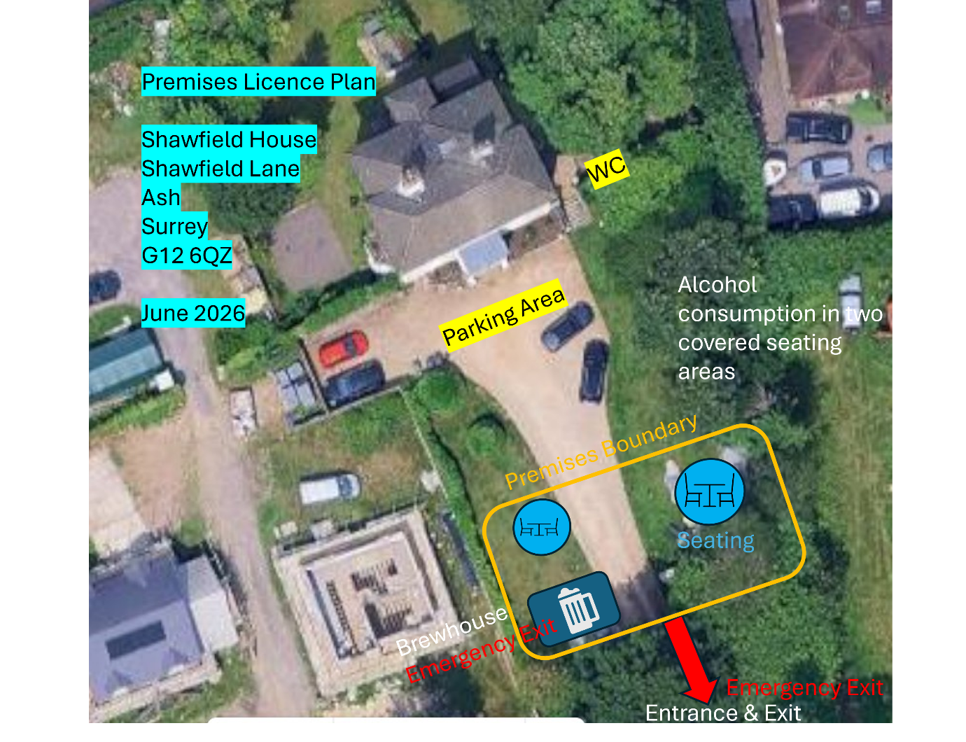
Key Addressable Points
•The extent of the boundary of the building, if relevant, and any external and internal walls of the building and, if different, the perimeter of the premises - The building is 21 by 8 feet and positioned on a concrete hard standing. The building is withing the licenced premises boundary which is 22m by 16m as market by the orange line above
•The location of points of access to and egress from the premises – The res arrow pointing to the entrance and exit in the image above is bidirectional and leads to the gate entrance as explained in the notes below
•If different from b) above, the location of escape routes from the premises – No difference to above.
•In a case where the premises is used for more than one existing licensable activity, the area within the premises used foreach activity – There is only one licensable activity
•In a case where an existing licensable activity relates to the supply of alcohol, the location or locations on the premises which is or are used for the consumption of alcohol – The consumption of alcohol will be in the designated seating areas marked in the image above.
•Fixed structures (including furniture) or similar objects temporarily in a fixed location (but not furniture) which may impact on the ability of individuals on the premises to use exits or escape routes without impediment – There are no fixed structure that would impede the escape from the premises or the only building.
•In a case where the premises includes a stage or raised area, the location and height of each stage or area relative to the floor – There is no stage or raised area,
•In a case where the premises includes any steps, stairs, elevators or lifts, the location of the steps, stairs, elevators or lifts – There are no steps, stairs or lifts on the licenced premises.
•In a case where the premises includes any room or rooms containing toilets or urinals, the location of the room or rooms – This is outside of the premises on the property as marked WC in the image above.
•The location and type of any fire safety and any other safety equipment – This is marked on the schematic on page 3.
•The location of a kitchen, if any, on the premises - There is no kitchen on the premises

Application Notes and Additional Information
The image is orientated to North
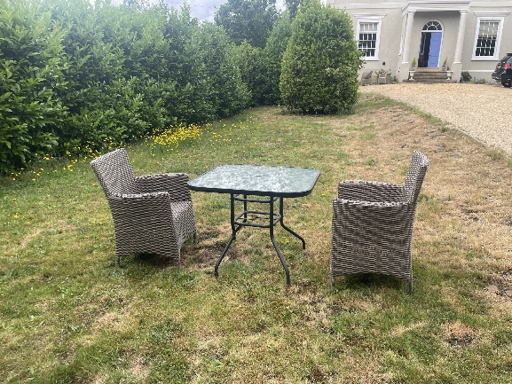
The extent of the boundary of the Licenced Premises is highlighted in orange and is 16m by 22m. To eastern the edge of the larger seating area there is a paved space that is mainly covered by a gazebo. This has a capacity of 12 seats around a large table.
The brewery is the only building which is contained in a 21 by 8 foot shipping container on the western and southern edges of the premises. The fire exit is the main door and when brewing operations are taking place the doors on the western side of the container will be open. 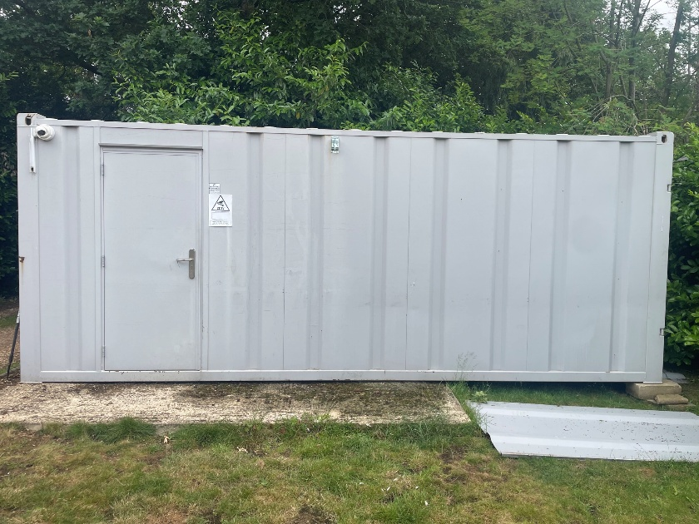

The brewery building is laid out below and is a single room
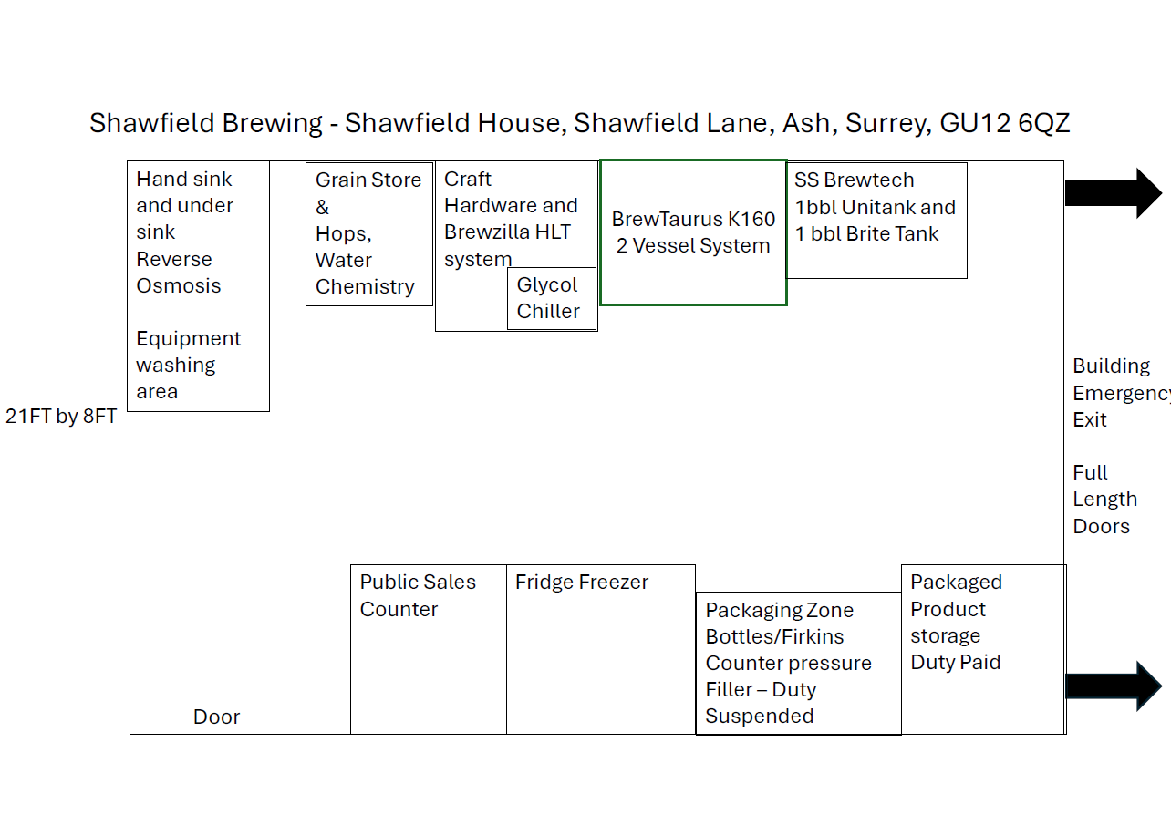

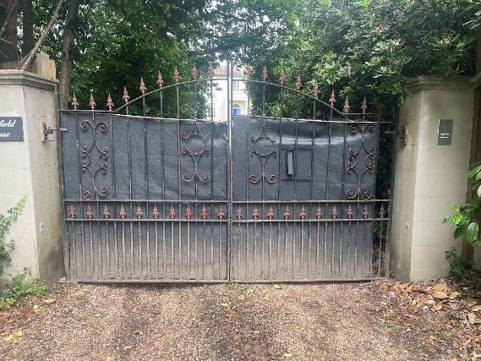
The licenced premises is located through the private gates to the property and this is also the escape route.
The application is solely for the sale of alcohol and consumption from the shipping container and guests will be free to use an open air Tap Room which is located withing the orange premises boundary. Direct customer sales will be made from the container entrance and there is a designated area to the right which is for Duty Paid products.
There are no fixed structures on the premises aside for the brewery container, though the gazebo and seating use high quality products that are the only fixed or semi-fixed structures within the licensed area. There will be no entertainment or licensable food services, so therefore no stage. Otherwise, the ground is plat and even. Where the WC is marked outside of the premise layout there are five steps and a handrail to where the WC would be located.
There is no kitchen on the premises and the container is equipped with fire extinguishers and first aid equipment which are located within the brewery container adjacent to the main entrance.

